

**The Relational Database Design/Modeling/**

**Implementation in SQL Based system**

**WAMP Server with PHPMY ADMIN**

**CS5329- FALL 2016**

**TRAVELWORKS SYSTEM**

**Submitted by:**

**Anusha Vattam**

**Texas State-ID: A04701078**

**Submitted to:**

**Dr. C. J. Hwang**

**Department of Computer Science**

**TABLE OF CONTENT**

**Chapter 1 Introduction…………………………………………………………………………..1**

**1.1 Motivation………………………………………………………………………….....1**

**1.2 Project description, scope……………………………………………………………1**

**1.3 The Software and platform used to implement this application…………………..1**

**Chapter 2 Study of System Functional Requirements…………………………………………3**

**2.1 Introduction…………………………………………………………………………..4**

**2.2 Summary of interview/study…………………………………………………………4**

**2.3 Functional Requirements - Input business forms/screens (Existing and New)......6**

**2.3.1 Input business forms (Exiting System)……………………………………......6**

**2.3.2 Input screen shots (New System)……………………………………………..10**

**2.4 Functional Requirements - Output business forms/screens (Existing and New)..14**

**2.4.1 Output business forms (Exiting System)…………………………………….14**

**2.4.2 Output screen shots (New System)…………………………………………..16**

**Chapter 3 External Schema (User's Views, User’s Schema)………………………………...18**

**3.1 Diagram of overall system model of the project………………………………….18**

**3.2 Design of user interface for user’s views or user’s schema……………………....19**

**3.3 Design of user Reports and Screens of user’s views……………………………....31**

**Chapter 4 Conceptual Schema and Logical Model of the System……………………………37**

**4.1 Descriptions of all relations (entities) and attributes……………………………...37**

**4.2 Functional dependencies and Normalized relations (entities) representing**

**by keys (Primary, Foreign)………………………………………………………...38**

**4.3 Example tuples for all normalized relations……………………………………...42**

**4.4 Descriptions of all required relationships………………………………………....46**

**4.5 E/R Model (Diagram) of the System with relationships and with all entities**

**including pk’s and fk’s……………………………………………………………..47**

**Chapter 5 Data Dictionary or System Catalog………………………………………………..48**

**5.1 Relations, attributes, domains, comments………………………………………...48**

**5.2 Attributes, types, descriptions, restrictions……………………………………….49**

**Chapter 6 Queries with QBE or GUI for RDBMS System Implementation I……………...53**

**6.1 The Software, RDBMS and platform used to implement the relational**

**Database…………………………………………………………………………………53**

**6.2 Database creation or required commands………………………………………...53**

**6.3 Fifteen Nontrivial queries in English with some complexity…………………….62**

**6.4 Required Screens or Programs for the implementation of queries and output**

**for each query………………………………………………………………………63**

**Chapter 7 Queries with QBE or GUI for RDBMS System Implementation II…………….71**

**7.1 The Software, RDBMS and platform used to implement the relational**

**Database………………………………………………………………………………..71**

**7.2 Database creation or required commands………………………………………..72**

**7.3 Fifteen Nontrivial queries in English with some complexity…………………….86**

**7.4 Required Screens or Programs for the implementation of queries and output**

**for each query………………………………………………………………………81**

**Chapter 8 Conclusion…………………………………………………………………………..89**

**Chapter 1 Introduction**

* 1. **Motivation**

Tourism is a quite unique area of business in a sense that a product cannot be observed or manipulated through direct experience prior to purchase. Instead, customers have to purely rely on indirect or virtual experience. Due to that, appealing presentations of travel destinations have always been an important factor of success in tourism. Traditional travel agents are being quite successful in their efforts of creating illustrated catalogues that provide potential customers with a significant amount of information jazzed up with highly aesthetic photos, useful tips, maps and much more.

The prime motivation for this is that it is impossible to have direct experience with the product prior to consumption in the domain of tourism. The Internet provides a powerful environment for the creation of virtual representations of tourism destinations allowing indirect experience that greatly surpasses the possibilities of traditional travel agents. However, the results of the study show that social interaction with travel agents, their expertise and the possibility to save time on search can be of even higher importance. So, we derived the “best of both sides” and suggest the application of an established methodology in the area of multi-agent systems, namely 3D Electronic Institutions, to the tourism domain in order to satisfy the growing demand on human assistance related to online inquiries and to offer customers cutting-edge visualization facilities.

**1.2 Project description**

TravelWorks is an online portal needs a useful database system to store, search, analysis and book travels of customers by a travel agent. Every day agent can receive thousands of customers information and their booking details. How can the agent or staff of their agency can control all these details efficiently and manage every booking service correctly? Establishing one database system can help the agent to solve all of these problems.

This system should help to get a better understanding of the relationship between online booking systems and traditional travel agents. Its main purpose is to derive clues for improving nowadays online tourism solutions in such a way that these systems profit from the expertise of traditional travel agents without losing the flexibility and benefits of the Internet.

They can have a good picture of every booking status such as booking service, status, payment details, dates etc. The agent can check which is the most visited place or customer details.

The database provides information regarding our customer details, bookings payment details. Building the database can help us track and organize the relationships between all the functions and manage all the information about our company efficiently. Once details have been inserted into the data, we will easily find out the results and therefore easily manage the whole process.

**1.3 The Software and platform used to implement this application**

**DBMS:** PHPMYADMIN, MYSQL are used for storing the database of the project. All data are store into the different table.

**WAMPSERVER:** It is an open-source server-side web application framework designed for web development to produce dynamic web pages. It was developed by Microsoft to allow programmers to build dynamic web sites, web applications and web services.

**Chapter 2 Study of System Functional Requirements**

**2.1 Introduction**

**2.1.1 Functional Requirements**

In Software engineering and systems engineering, a **functional requirement** defines a function of a system or its component. A function is described as a set of inputs, the behavior, and outputs.

**Functional Requirements of TravelWorks:**

1) Agent should be able to add new customer to the database.

2) The system shall record customer details.

3) Agent should be able to add new staff to the database.

3) The system shall record the customer’s first name.

4) The system shall record the customer’s first name to the database.

5) The system shall record the booking outcomes to the database.

6) Agent should be able to delete or update add new booking to the database.

7) Agent should be able to see the details of bookings.

8) User should be able to register with the application by providing the details of his Agent ID, First name, last name, Email, Phone, and Password.

9) User should be able to login to the application to order or view a booking.

10) The system shall record the expected travel date and time.

11) The system shall generate a unique confirmation number for each booking.

12) The system shall record the payment.

13) The system shall record the payment type.

**2.1.2 Non-functional Requirements**

Functional requirements define the needs in terms of performance, logical database requirements, design constraints, standards compliance, reliability, availability, security, maintainability, and as well as portability.

**2.1.2.1 Performance**

The performance requirements are as follows:

Accessibility: The application should be accessed from all web browsers supporting java scripts.

Multi User access: The application should not hang when there are more numbers

of users logged in.

**2.1.2.1.2. Reliability**

The average time to failure shall be 12 days. In the event the server does crash, the server will be up and run again within the 2 hours.

**2.1.2.1.3 Availability**

The website should be accessible all the time when user logs in except the maintenance time.

**2.1.2.1.4 Security**

Staff will be able to access their customer information and bookings. Agent will be the administrator who can edit the information for all Booking and for Staff.

**2.1.2.1.5 Maintainability**

Any updates or defect fixes shall be able to be made on server-side computers only without any patches required by the user.

**2.2 Summary of interview/study**

**Database Developer:** What is the purpose of your company?

**Client:** “TravelWorks” – our Travels Management system is to provide the online booking and payment facility for customer’s by travel agents and to provide different services.

**Database Developer:** How many types of users will be using the system?

**Client:** Agent and staff will be using the system; their roles differs based on their priorities to the system.

**Database Developer:** What is the role of Staff?

**Client:** Staff is the user who will be able to record the bookings in the business aspects.

**Database Developer:** Why do you feel that you need a database?

**Client:** Most medium and large businesses rely on databases to store customer information. Because this information is accessible wherever Internet access is available, customers don't have to go to a local banking branch, for example, to access their account information.

Database management systems are important to businesses and organizations because they provide a highly efficient method for handling multiple types of data

**Database Developer:** What role do you play for the company?

**Client:** I work as a database developer, I write queries, retrieve data, maintain data, make sure it doesn’t violate the system constraints, I help maintain the data.

**Database Developer:** What types of reports do you use?

**Client:** To extract data, a query must be run with various tools that call at least one query language. Structured querying language (SQL) is the most popular and well-known querying language. Other query languages include:

* Hyper Text Structured Query Language (HTSQL): This language translates hypertext transfer protocol (HTTP) queries to SQL.
* Poliqarp Query Language: This language searches annotated text.

**Database Developer:** What is your job description?

**Client:** The Database Developer’s role is to develop and maintain databases across the organization, while ensuring high levels of data availability. The Database Developer will in addition evaluate and advise on all technology components, such as software, hardware, and networking capabilities, for database management systems and applications. As part of the role they will be responsible for implementing data dashboards to all levels of the organization.

**2.3 Functional Requirements - Input business forms/screens (Existing and New**

**2.3.1 Input business forms (Existing System)**

1. **Registration Form:**

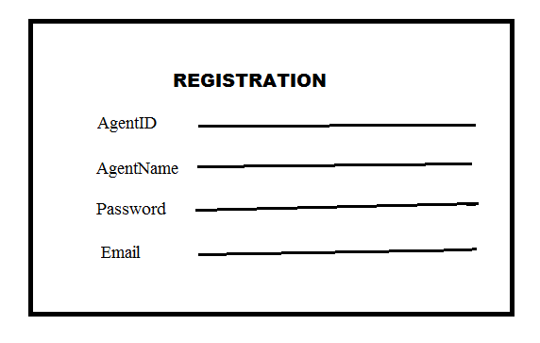

1. **LoginForm**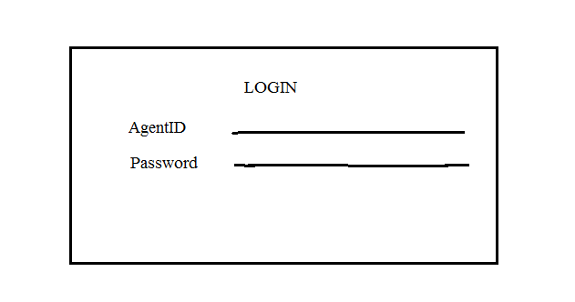

**3)Travel Agency Information Form:**

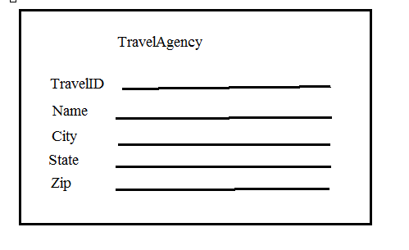

**4)Staff Information Form:**

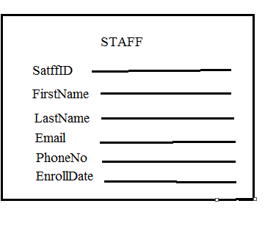

**5)Customer Information Form:**

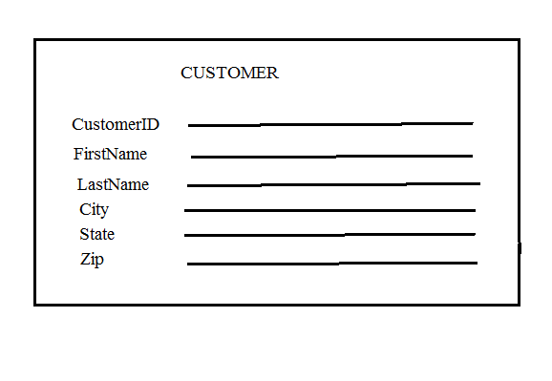

**6)Calendar Information Form:**

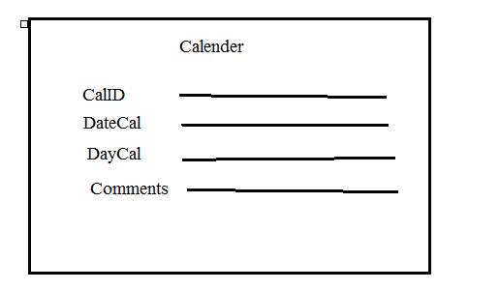

**7)Services Information Form:**

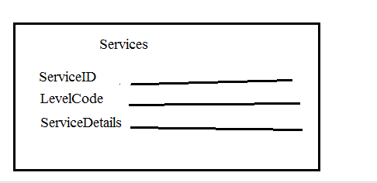

**8)Bookings Service Level Information Form:**

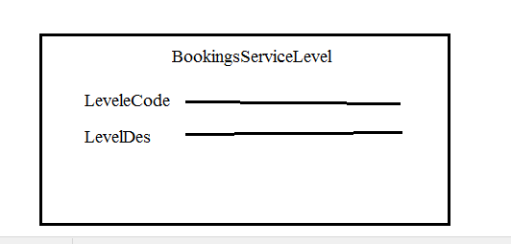

**2.3.2 Input Screen Shots (New System)**

1. **Registration Form:**
2. **Login Form:**
3. **Travel Agency Information Form:**

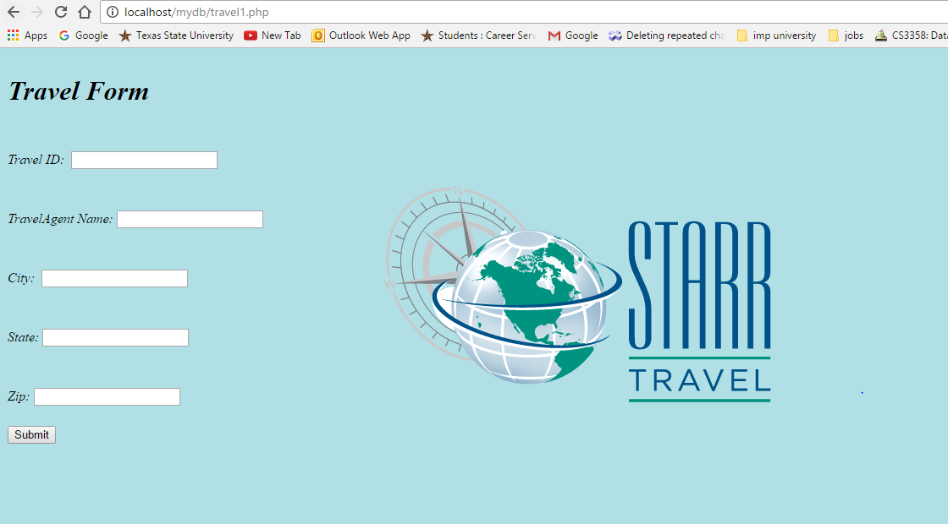

1. **Staff Information Form:**

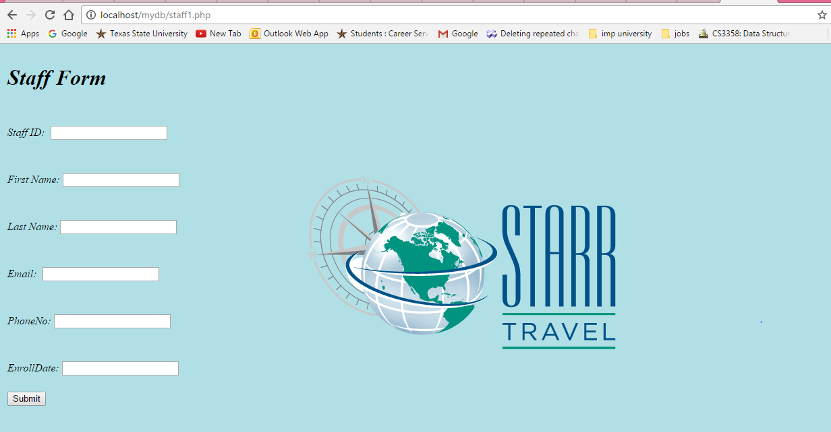

1. **Customer Information Form:**

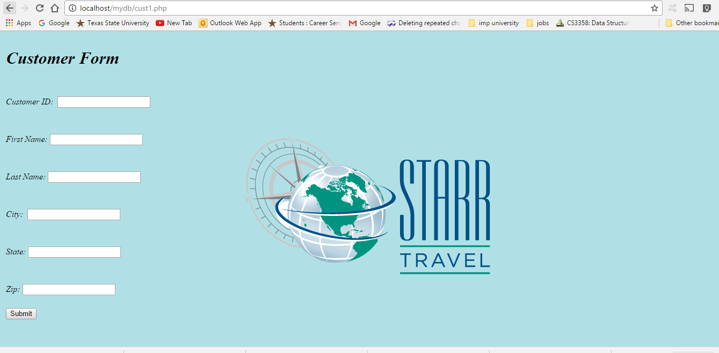

1. **Calendar Information Form:**

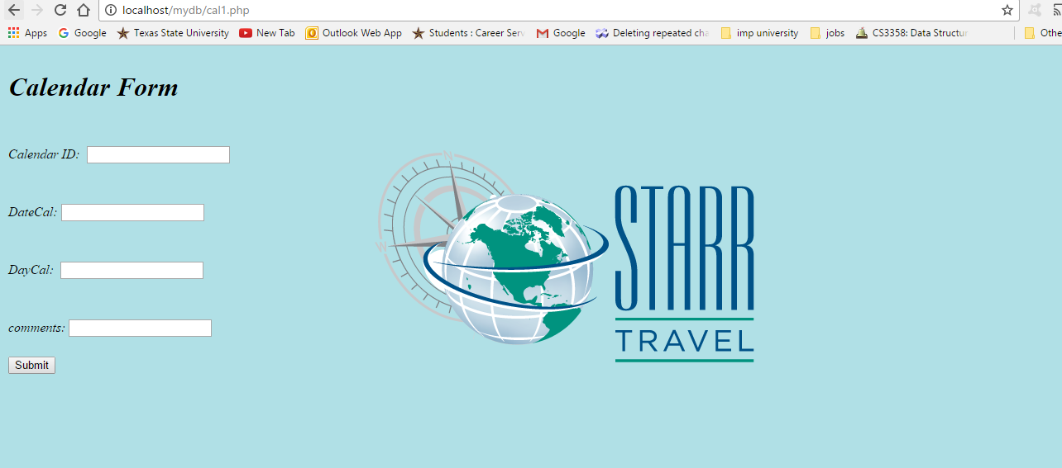

1. **Services Information Form:**

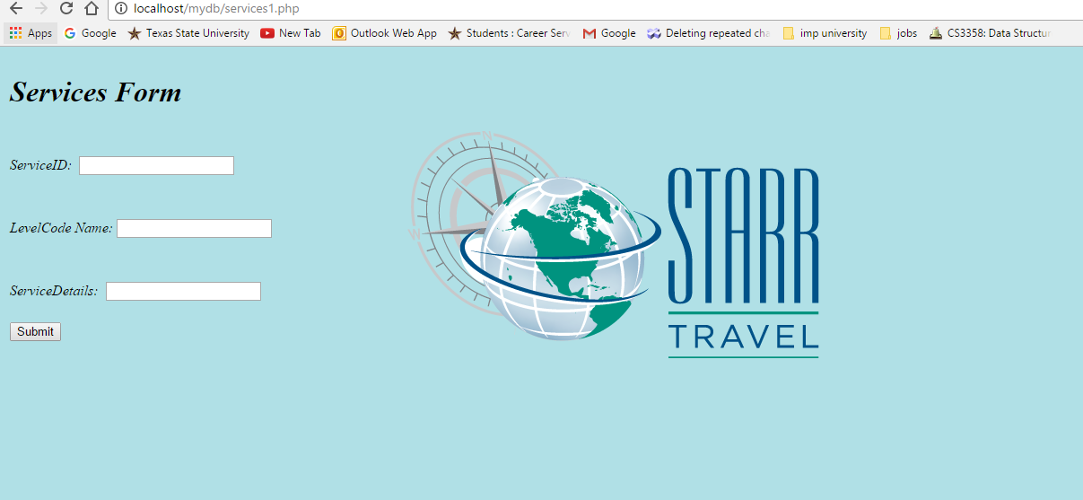

1. **Booking Service Level Information Form:**

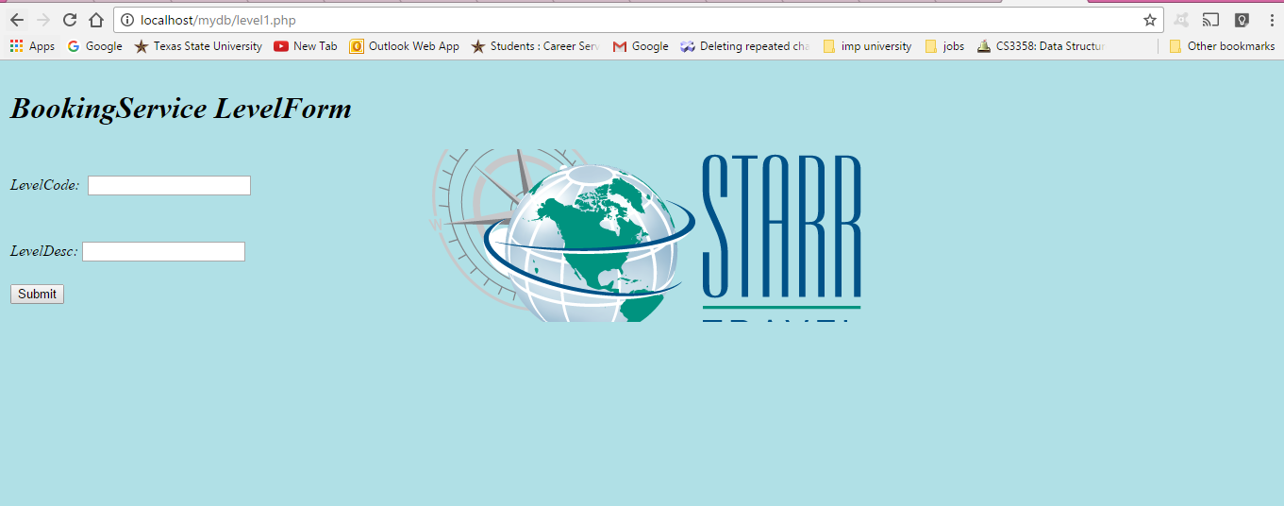

**2.4 Functional Requirements - Output business forms/screens (Existing and New)**

**2.4.1 Output business forms (Existing System)**

1. **Booking Status Form**

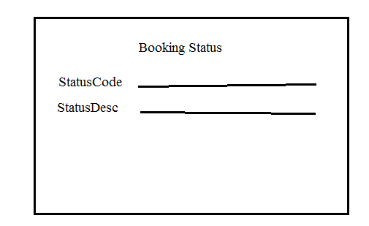

1. **Booking Outcomes Form:**

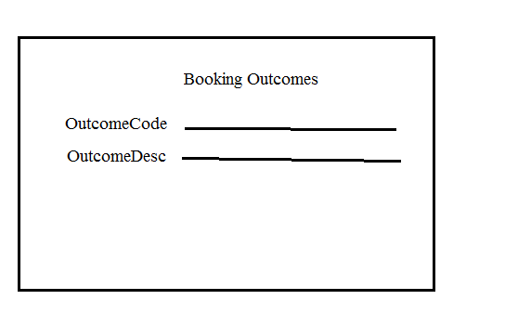

1. **Payments Information Form:**

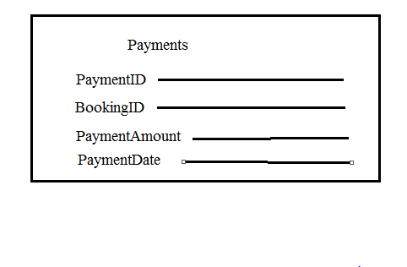

1. **Bookings Information Form:**

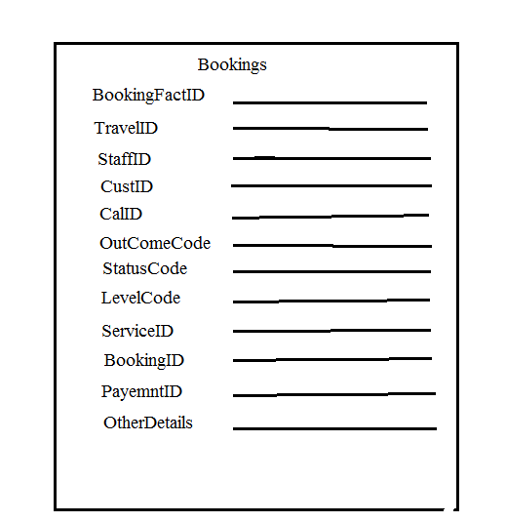

**2.4.2 Output Screen Shots (New System)**

1. **Booking Status Form:**

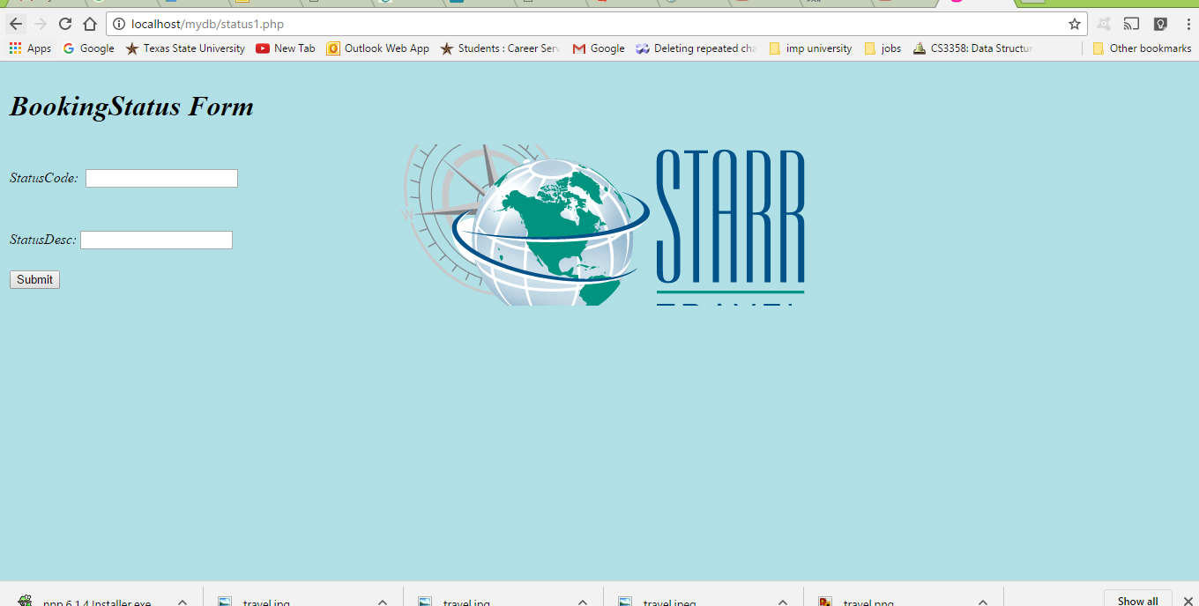

1. **Booking Outcomes Form:**

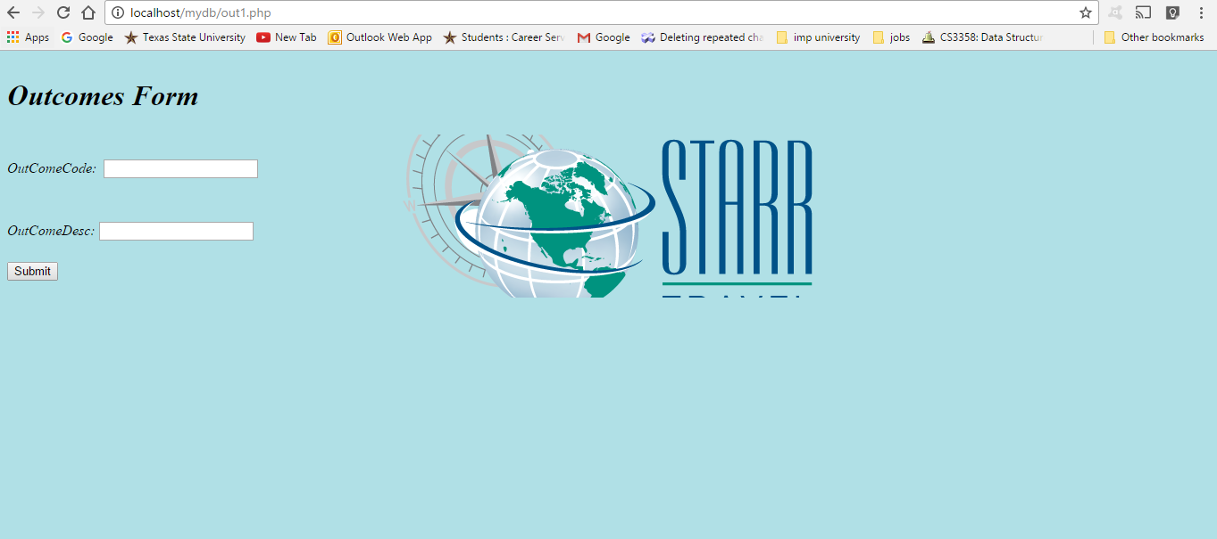

1. **Payments Information Form:**

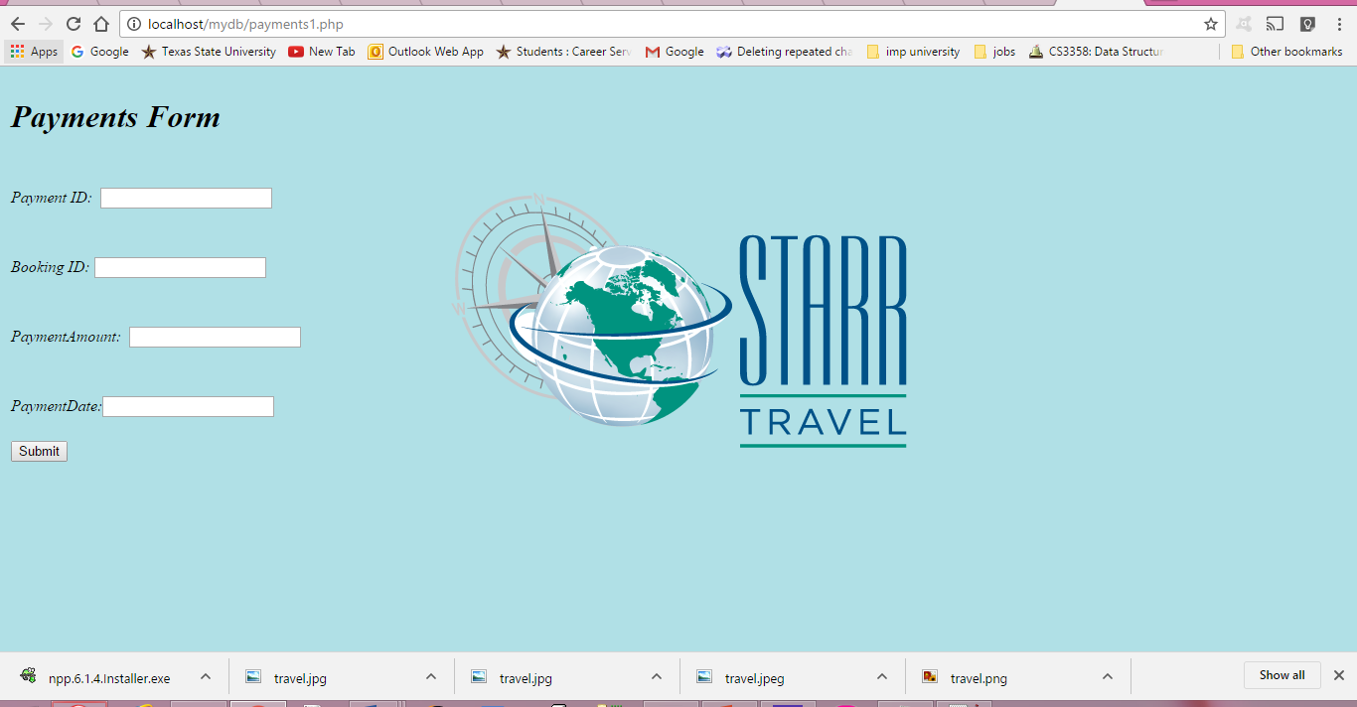

1. **Bookings Information Form:**

**Chapter 3 External Schema (User's Views, User’s Schema)**

**3.1 Diagram of overall system model of the project**

**3.2 Design of user interface for user’s views or user’s schema**

1. **Main Page**
2. **Registration Page (A)**
3. **Registration Page (B)**
4. **Login Page (A)**
5. **Login Page (B)**
6. **Travel page (A)**



1. **Travel Page (B)**

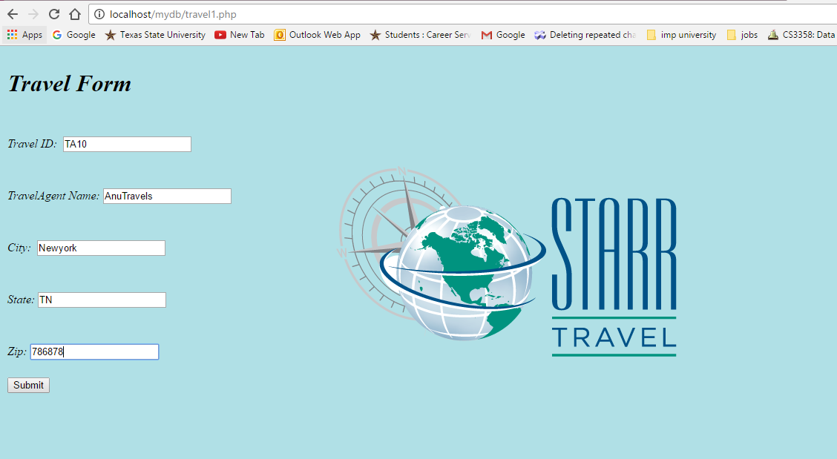

1. **Staff Page (A)**



1. **Staff Page (B)**

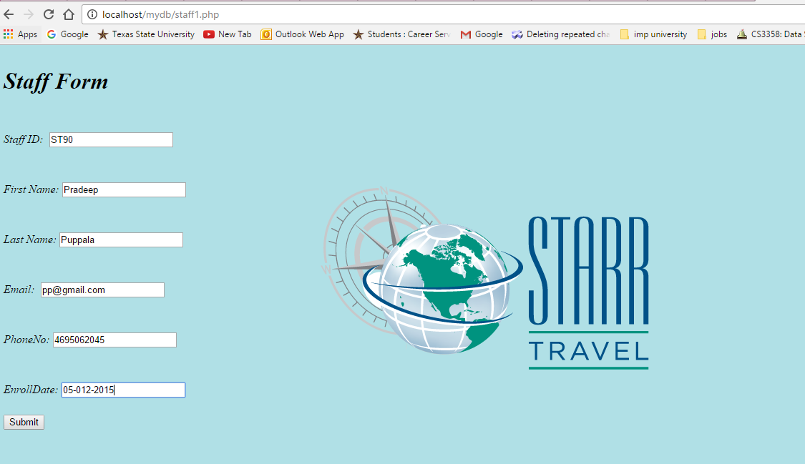

1. **Customer Page (A)**



1. **Customer Page (B)**

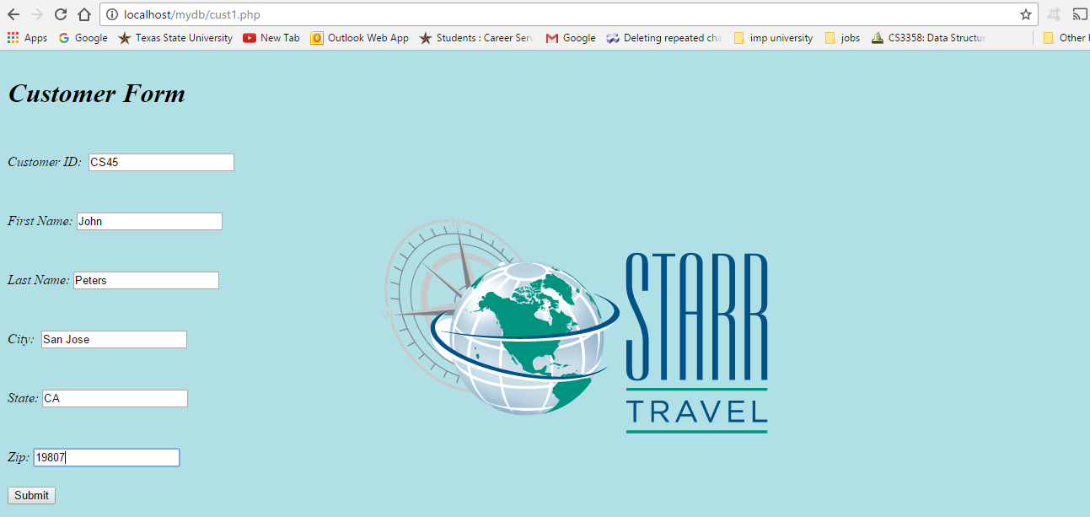

1. **Calendar Page (A)**



1. **Calendar Page (B)**

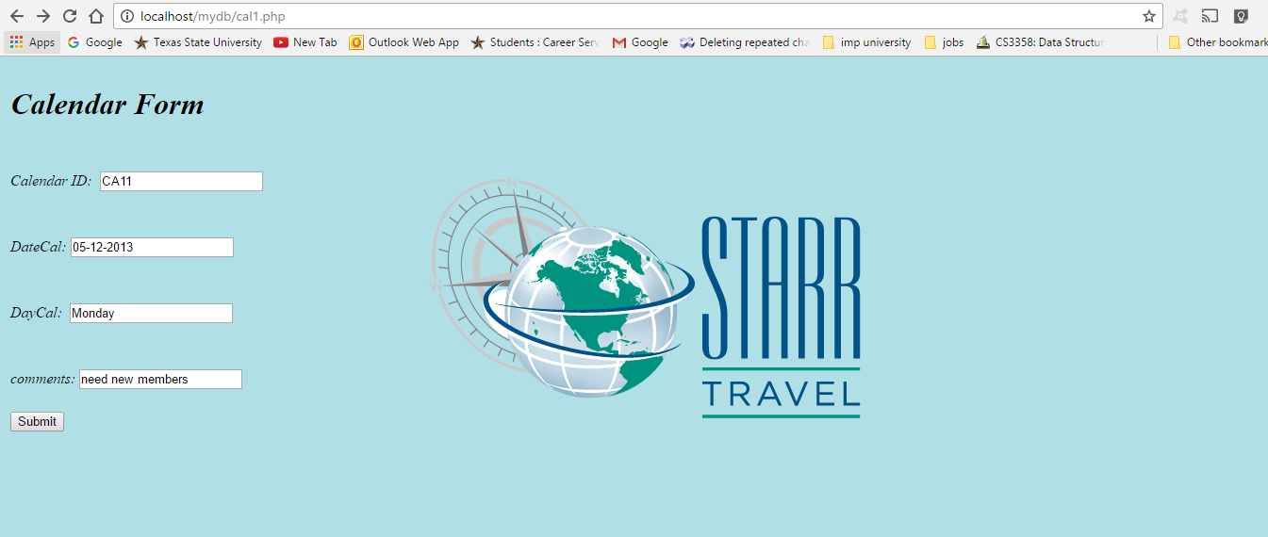

1. **Booking Outcome Page (A)**



1. **Booking Outcome Page (B)**

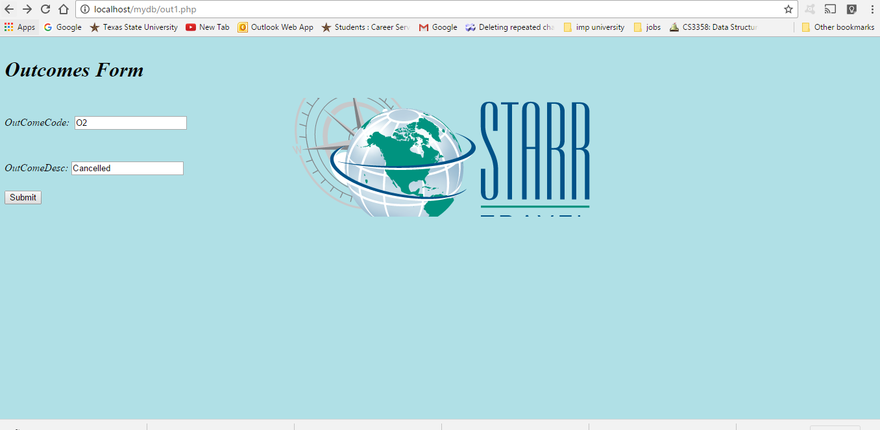

1. **Booking Status Detail Page (A)**



1. **BookingStatus Detail Page (B)**

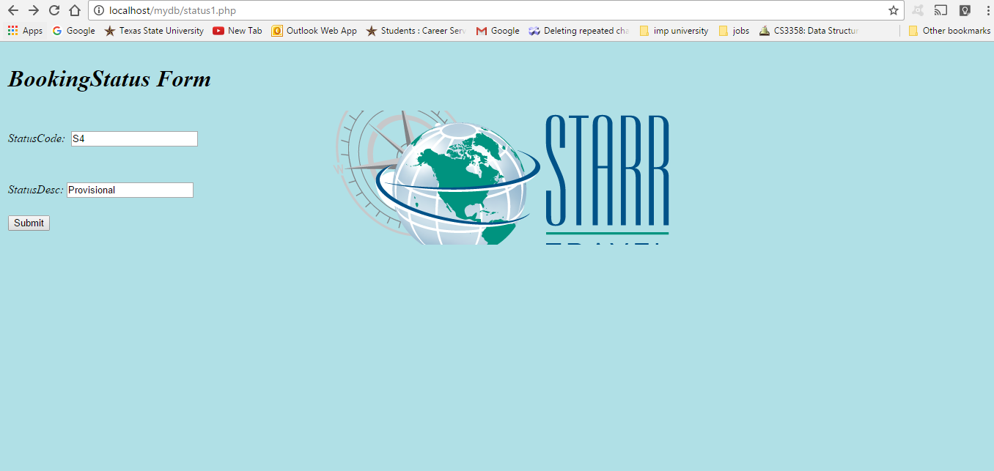

1. **Services Page (A)**



1. **Services Page (B)**

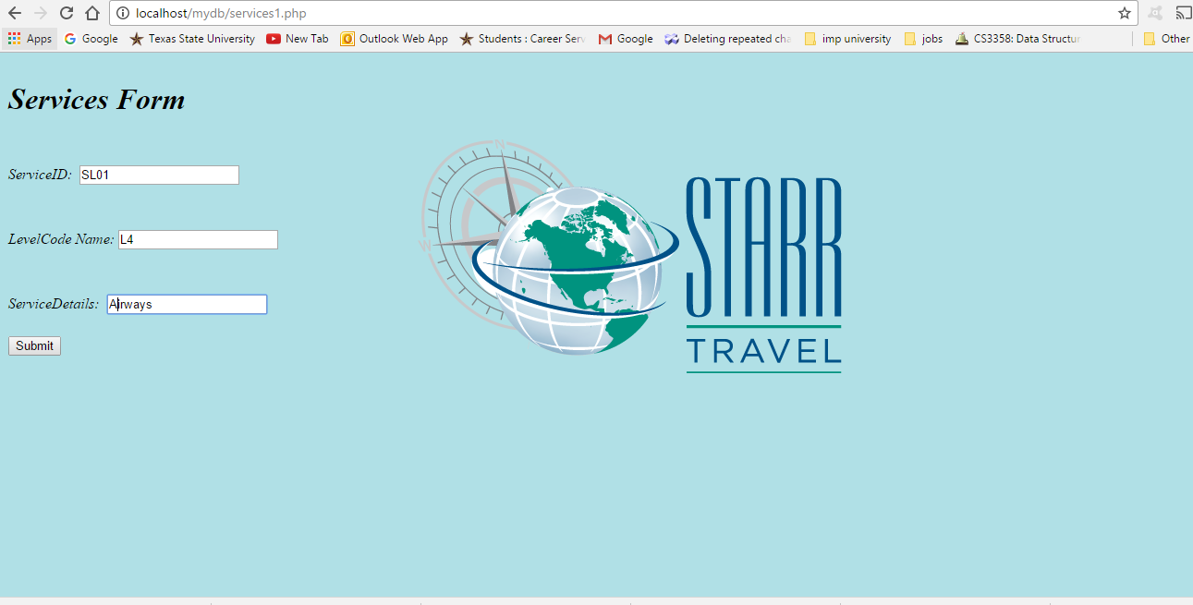

1. **Service Bookings Page (A)**

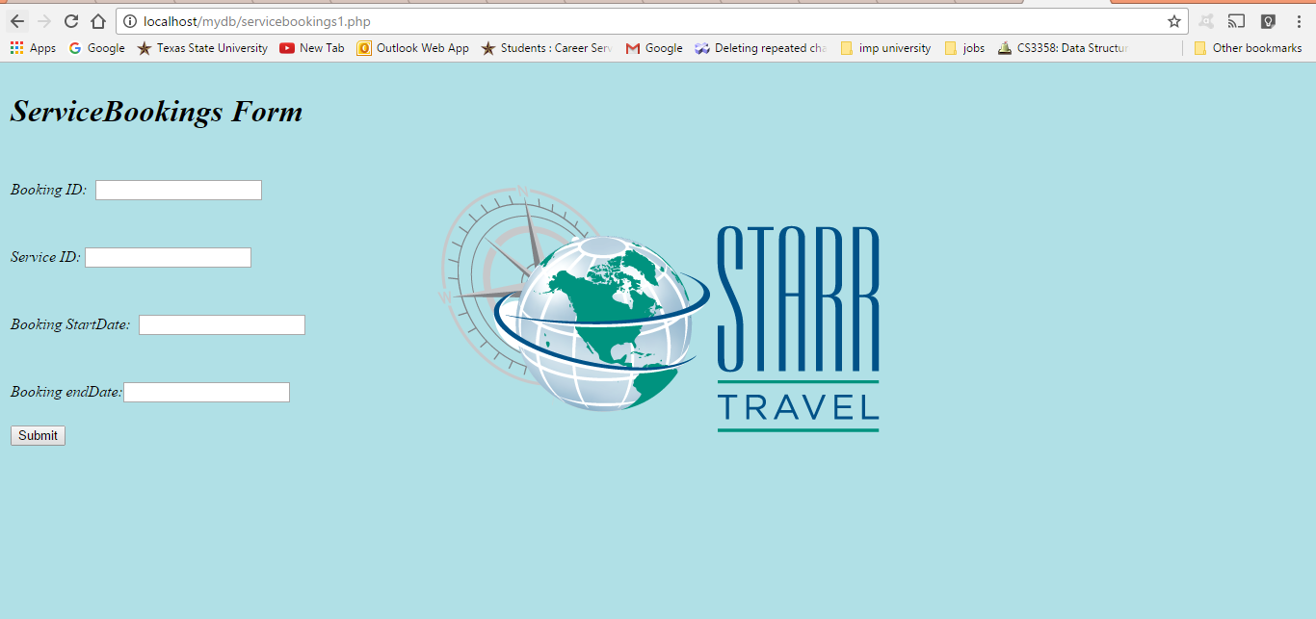

1. **Service Bookings Page (B)**

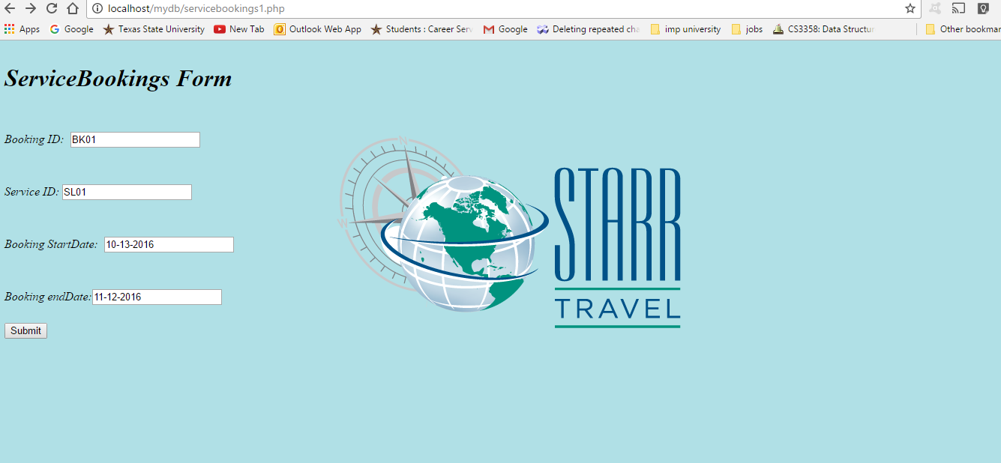

1. **Payments Page (A)**



1. **Payments Page (B)**

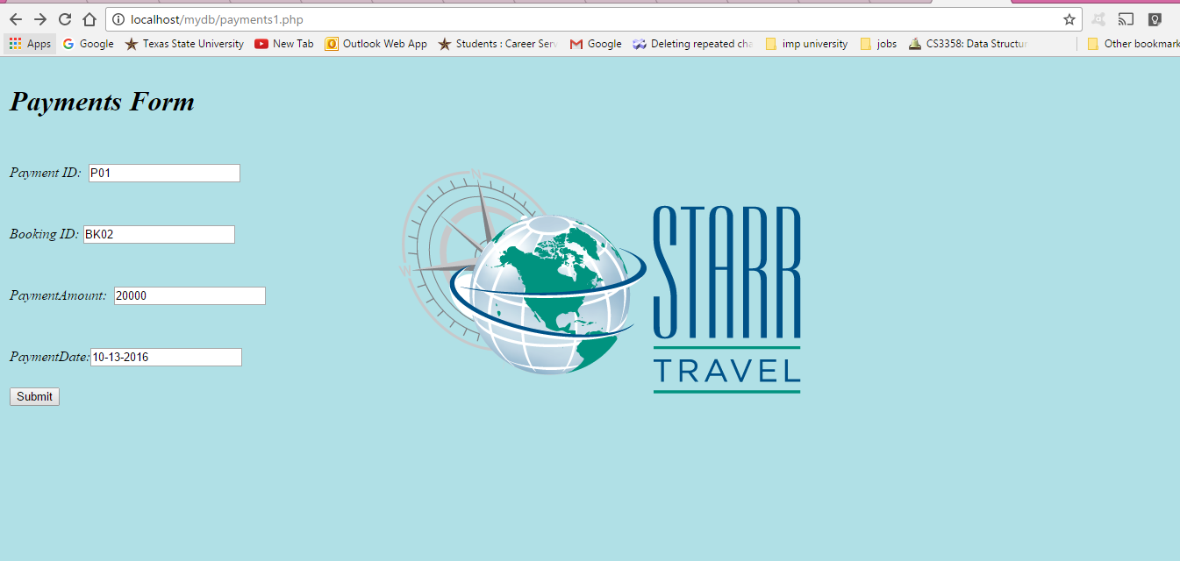

**24)BookingServiceLevel Page(A)**



**25)Booking Service Level Page(B)**

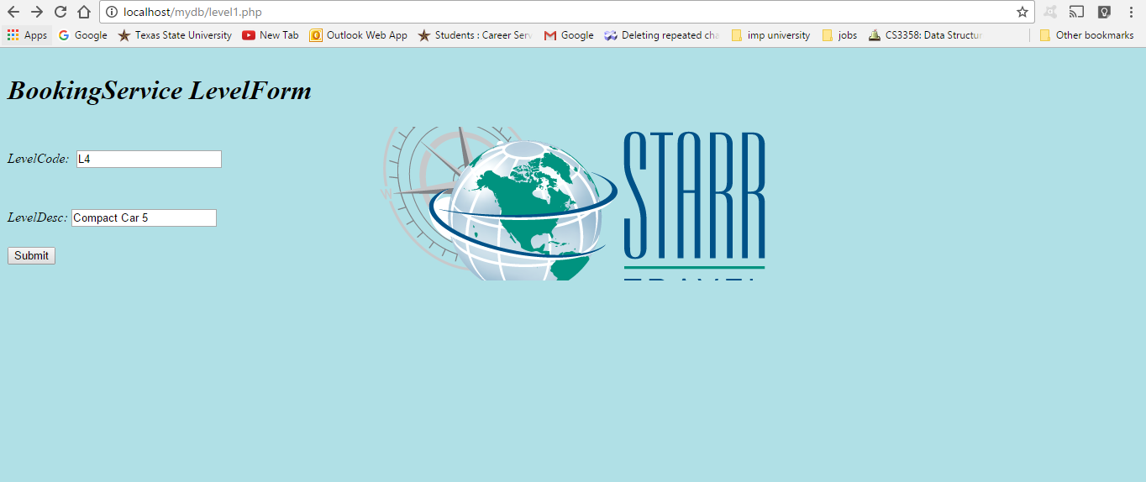

**Bookings Page (A)**

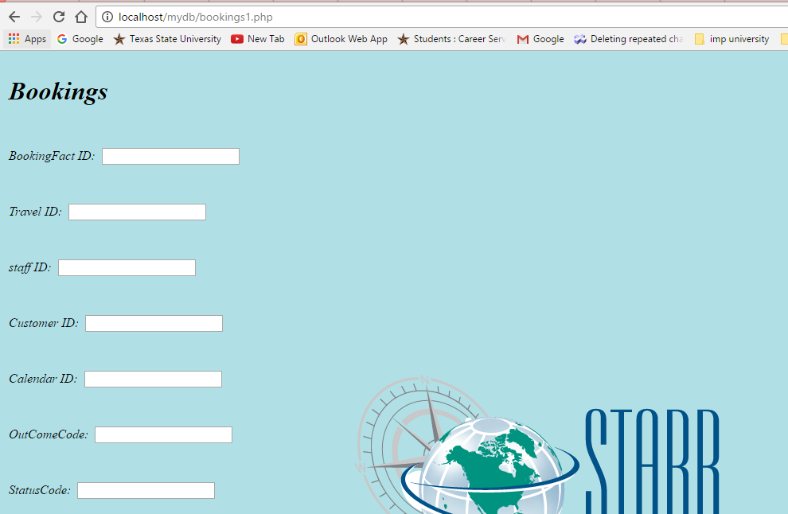

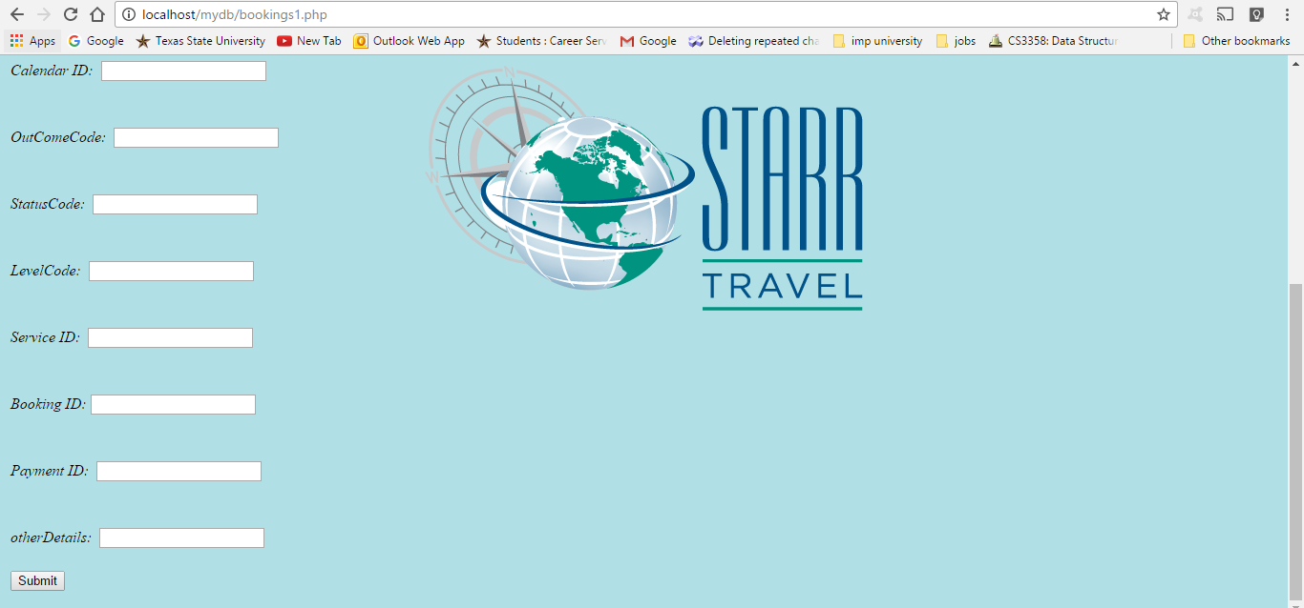

**Bookings Page (B)**

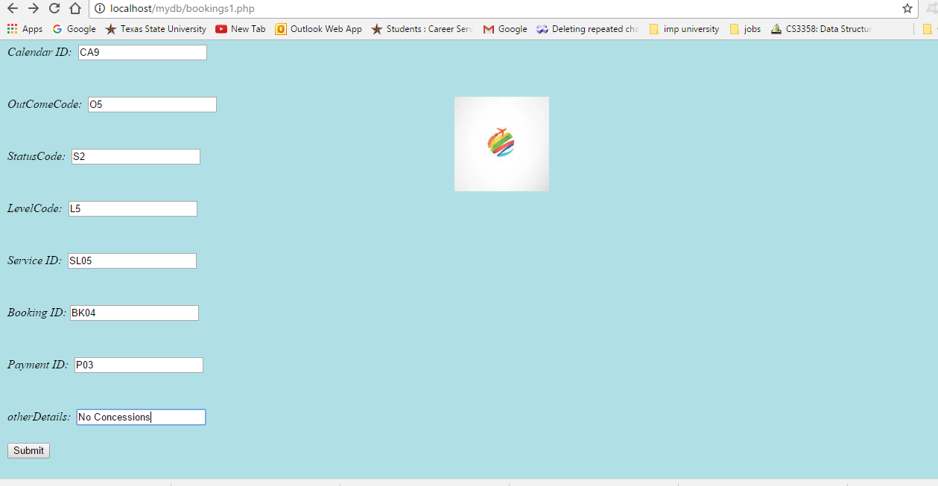

**3.3 Design of user Reports and Screens of user’s views**

1. **Travel Detail Report**

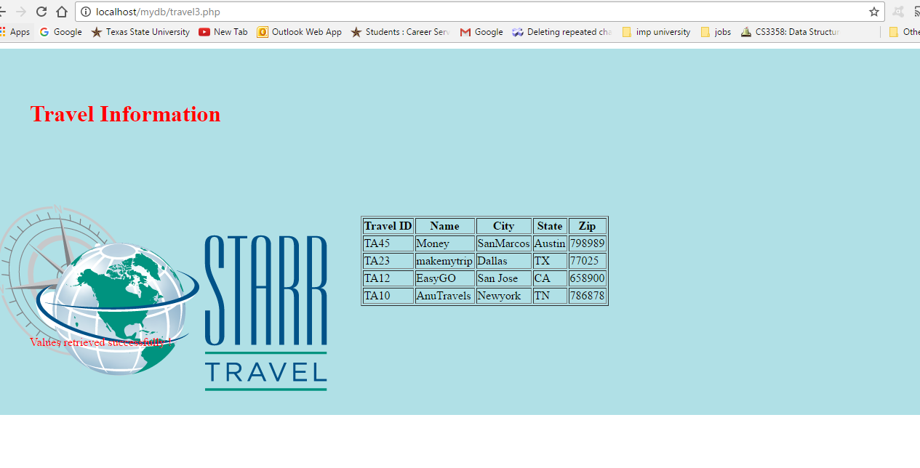

1. **Staff Detail Report**

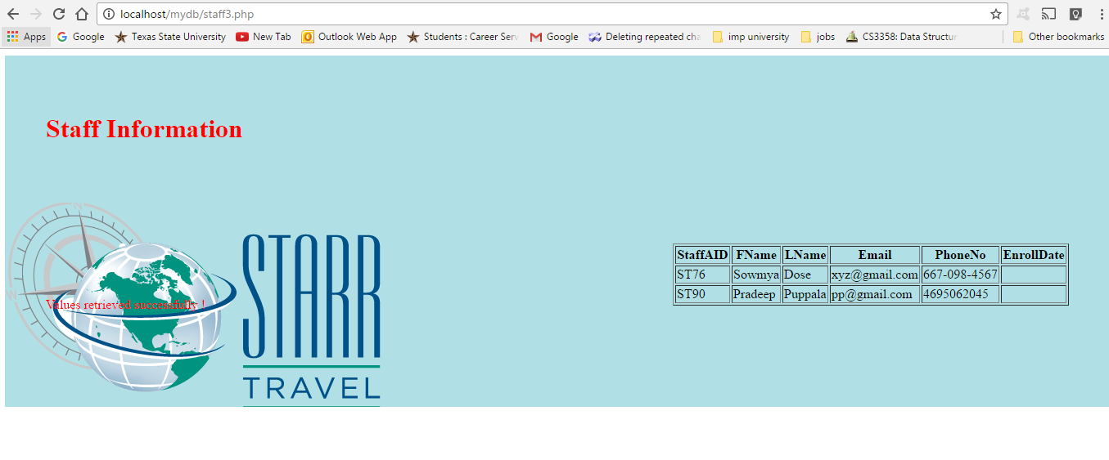

1. **Customer Detail Report**

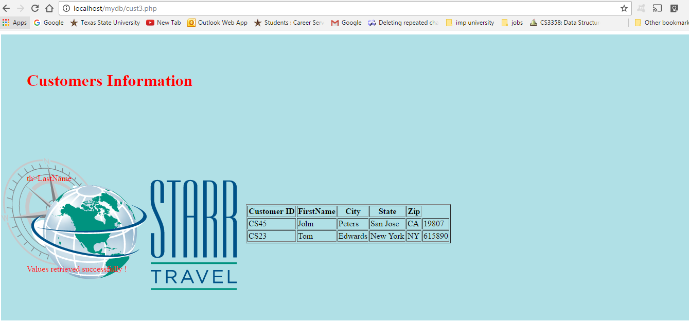

1. **Calendar Detail Report**

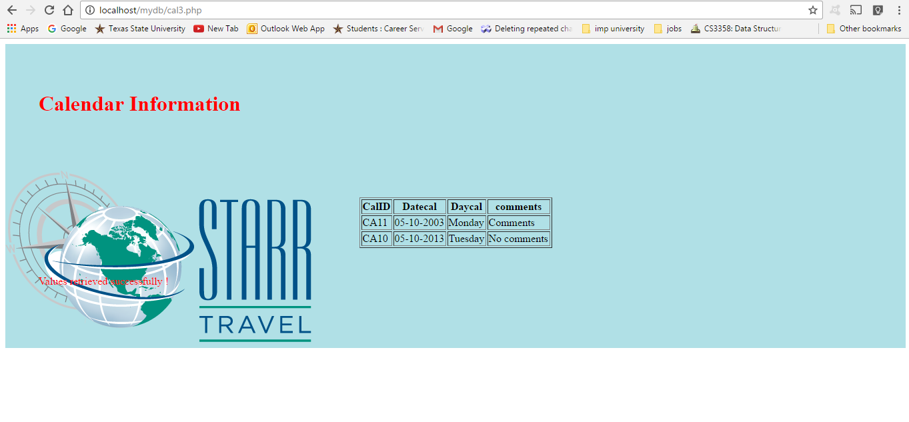

1. **Booking OutComes Detail Report**

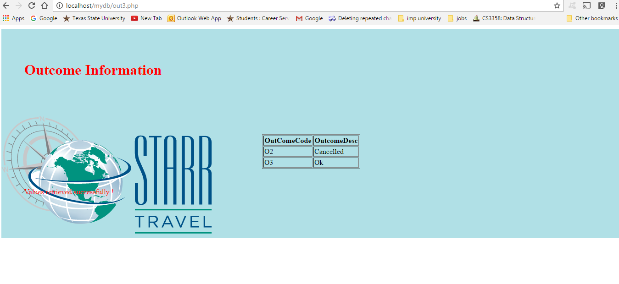

1. **BookingStatus Detail Report**

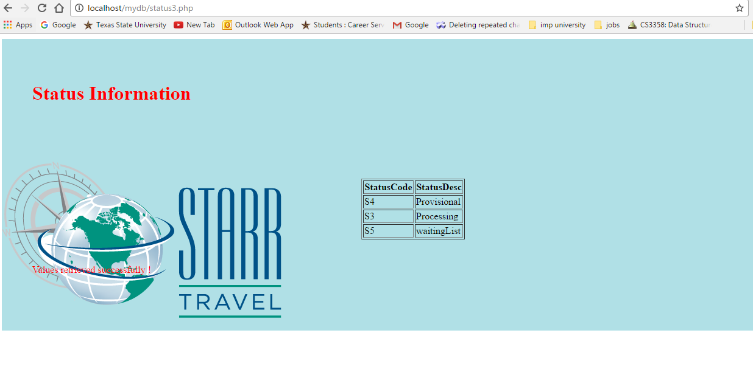

1. **Services Detail Report**

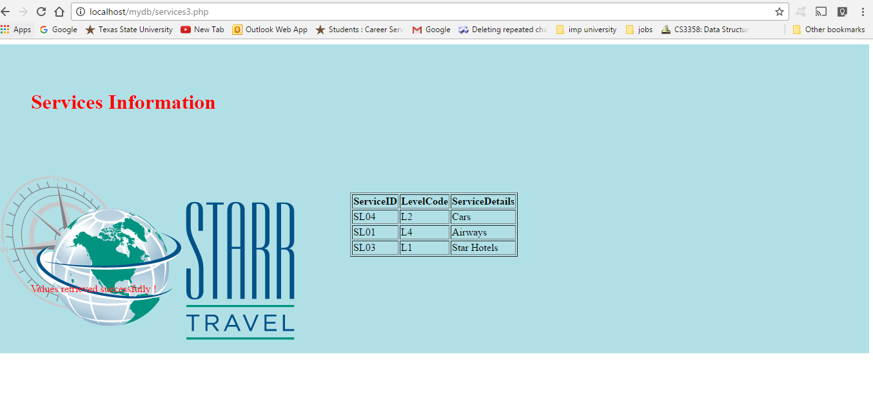

1. **Service Bookings Report**

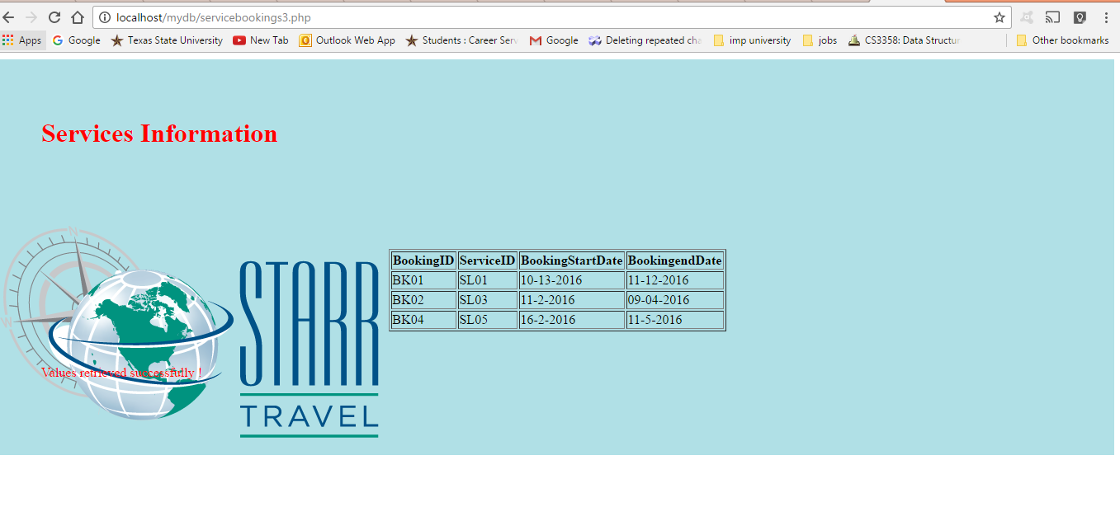

1. **Payments Detail Report**

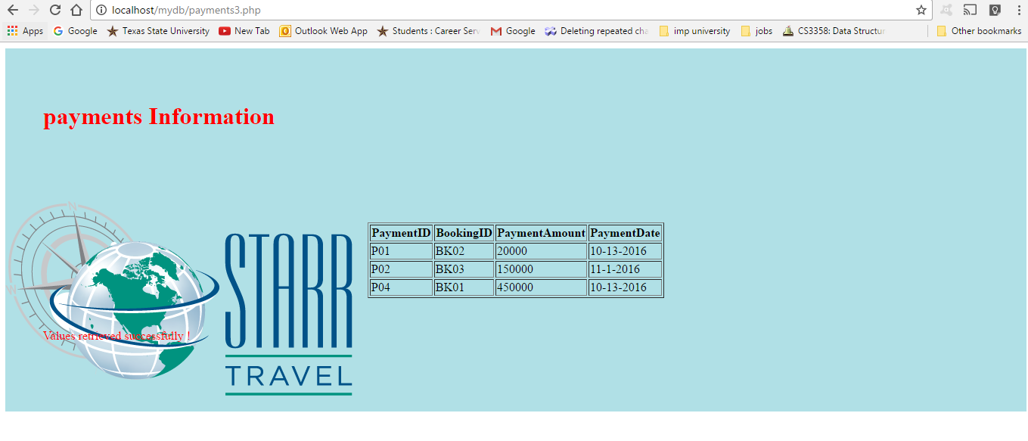

1. **Booking Service Level Detail Report**

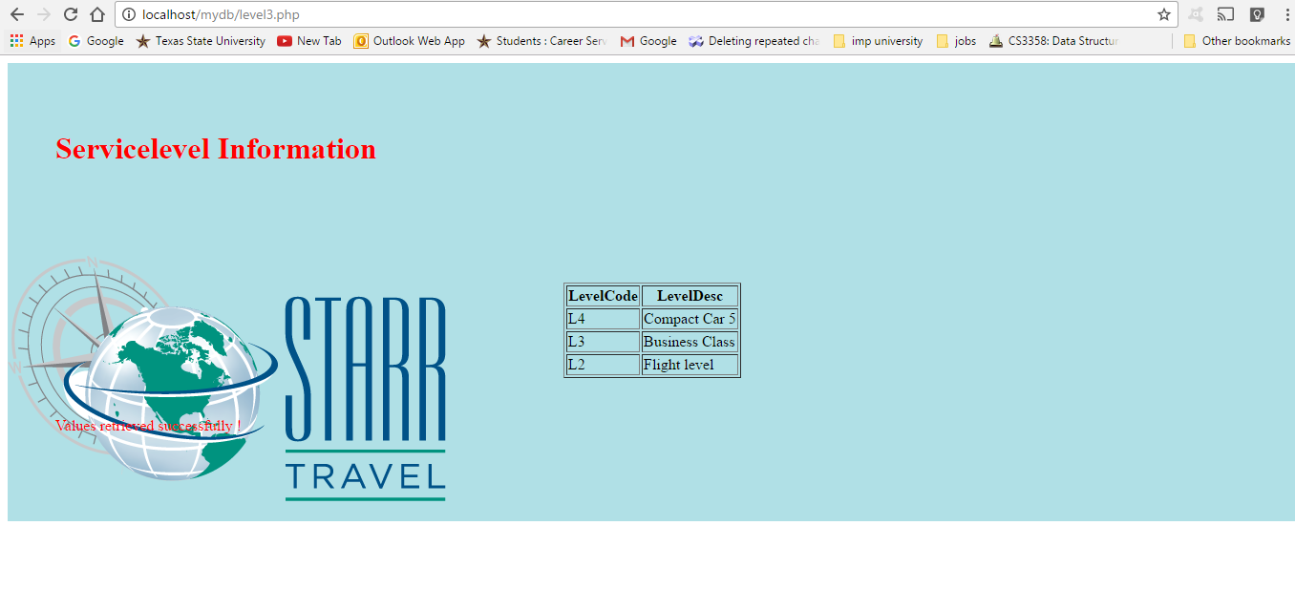

**11) Bookings Detail Report**

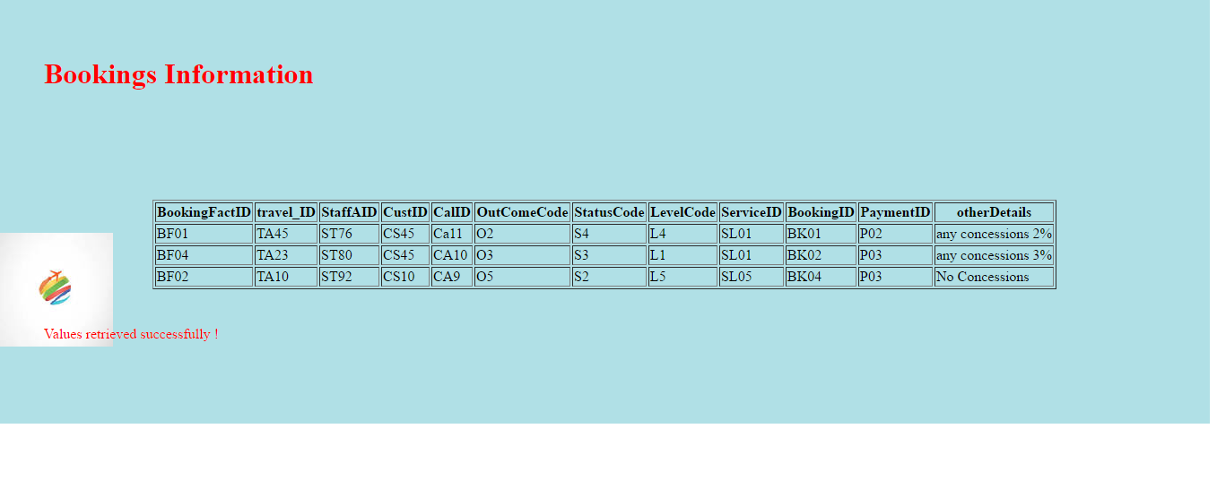

**Chapter 4 Conceptual Schema and Logical Model of the System**

**4.1 Descriptions of all relations (entities) and attributes**

**Relations Identified For this Project:**

1. **Customer**
2. **Employee**
3. **CustomerHistory**
4. **CourierCompany**
5. **Ordert**
6. **Product**
7. **OrderDetail**
8. **Supplier**
9. **ProductDetail**
10. **SupplyDetail**

**Database Design**

|  |  |
| --- | --- |
| **Table** | **Attribute** |
| **Customer** | **CustID , FName , LName ,City ,State ,Zip** |
| **Employee** | **EmpID , FName , LName, Email , PhoneNo , EnrollDate , Salary , Degree , Position** |
| **CutomerHistory** | **CustID ,PurchaseDate ,Rate ,Comment** |
| **CourierCompany** | **CourID, CustID ,EmpID, Destination, Price, DeliveryDate** |
| **Ordert** | **OrderID, CustID, EmpUD, Name,OrdDate, City, State, Zip** |
| **Product** | **ProID ,Date ,Amount ,Stock** |
| **OrderDetail** | **OrDetNo ,OrderID, ProID,CourID ,Quantity, DeliveryFee ,TotalPrice, ArrivalDate** |
| **Supplier** | **SupID ,SupName ,Phone , email ,Destination** |
| **ProductDetail** | **ProID, SupID, Description, Amount ,Stock, ProType** |
| **SupplierDetail** | **SupID, ProID, EmpID, email, Phone** |

**4.2 Functional dependencies and Normalized relations (entities) representing**

**by keys (Primary, Foreign)**

1. **Customer Information**

|  |  |
| --- | --- |
| **Attributes** | **Functional Dependency** |
| **CustID** | **Primary Key** |
| **FName** |  |
| **LName** |  |
| **City** |  |
| **State** |  |
| **Zip** |  |

1. **Employee Information**

|  |  |
| --- | --- |
| **Attributes** | **Functional Dependency** |
| **EmpID** | **Primary Key** |
| **FName** |  |
| **LName** |  |
| **Email** |  |
| **Phone** |  |
| **EnrollDate** |  |
| **Salary** |  |
| **Degree** |  |
| **Position** |  |

1. **Product Information**

|  |  |
| --- | --- |
| **Attributes** | **Functional Dependency** |
| **ProID** | **Primary Key** |
| **Date** |  |
| **Amount** |  |
| **Stock** |  |

1. **Supplier Information**

|  |  |
| --- | --- |
| **Attributes** | **Functional Dependency** |
| **SupID** | **Primary Key** |
| **SupName** |  |
| **Phone** |  |
| **email** |  |
| **Destination** |  |

1. **Customer History Information**

|  |  |
| --- | --- |
| **Attributes** | **Functional Dependency** |
| **CustID** | **Primary Key Foreign Key (CustID) References Customer(CustID)** |
| **PurchaseDate** |  |
| **Rate** |  |
| **Comment** |  |

1. **Courier Company Information**

|  |  |
| --- | --- |
| **Attributes** | **Functional Dependency** |
| **CourID** | **Primary Key** |
| **CustID** | **Primary Key Foreign Key (CustID) References Customer(CustID)** |
| **EmpID** | **Primary Key Foreign Key (EmpID) References Employee(EmpID)** |
| **Destination** |  |
| **Price** |  |
| **DeliveryDate** |  |

1. **Ordert Information**

|  |  |
| --- | --- |
| **Attributes** | **Functional Dependency** |
| **OrderID** | **Primary Key** |
| **CustID** | **Primary Key Foreign Key (CustID) References Customer(CustID)** |
| **EmpID** | **Primary Key Foreign Key (EmpID) References Employee(EmpID)** |
| **Name** |  |
| **OrdDate** |  |
| **City** |  |
| **State** |  |
| **Zip** |  |

1. **Order Detail Information**

|  |  |
| --- | --- |
| **Attributes** | **Functional Dependency** |
| **OrDetNo** | **Primary Key** |
| **OrderID** | **Primary Key Foreign Key (OrderID) References Ordert(OrderID)** |
| **ProID** | **Primary Key Foreign Key (ProID) References Product(ProID)** |
| **CourID** | **Primary Key Foreign Key (CourID) References CourierCompany(CourID)** |
| **Quantity** |  |
| **DeliveryFee** |  |
| **TotalPrice** |  |
| **ArrivalDate** |  |

1. **Product Detail Information**

|  |  |
| --- | --- |
| **Attributes** | **Functional Dependency** |
| **ProID** | **Primary Key** |
| **SupID** | **Primary Key Foreign Key (SupID) References Supplier(SupID)** |
| **Description** |  |
| **Amount** |  |
| **Stock** |  |
| **ProType** |  |

1. **Supplier Detail Information**

|  |  |
| --- | --- |
| **Attributes** | **Functional Dependency** |
| **SupID** | **Primary Key** |
| **EmpID** | **Primary Key Foreign Key (EmpID) References Employee(EmpID)** |
| **ProID** | **Primary Key Foreign Key (ProID) References Product(ProID)** |
| **Email** |  |
| **Phone** |  |

**4.3 Example tuples for all normalized relations.**

1. **Customer information**

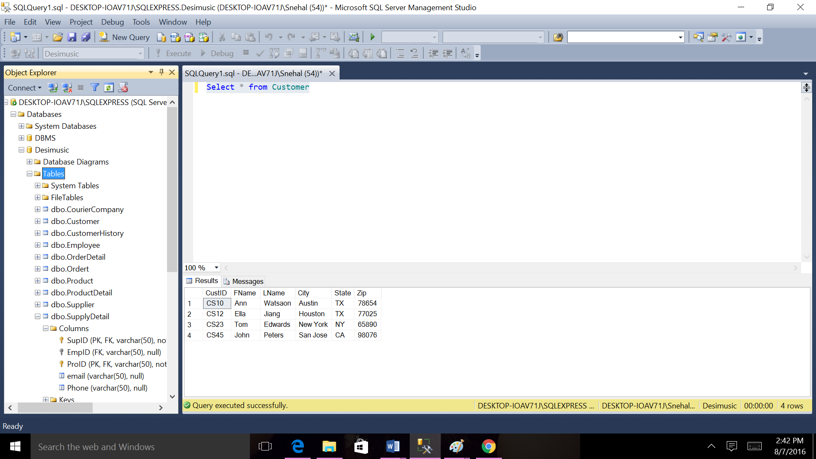

1. **Employee information**

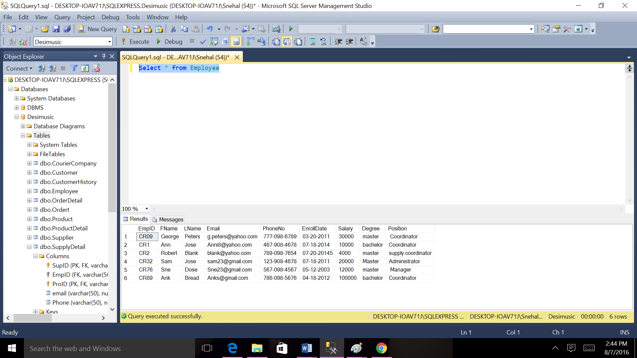

1. **Courier company information**

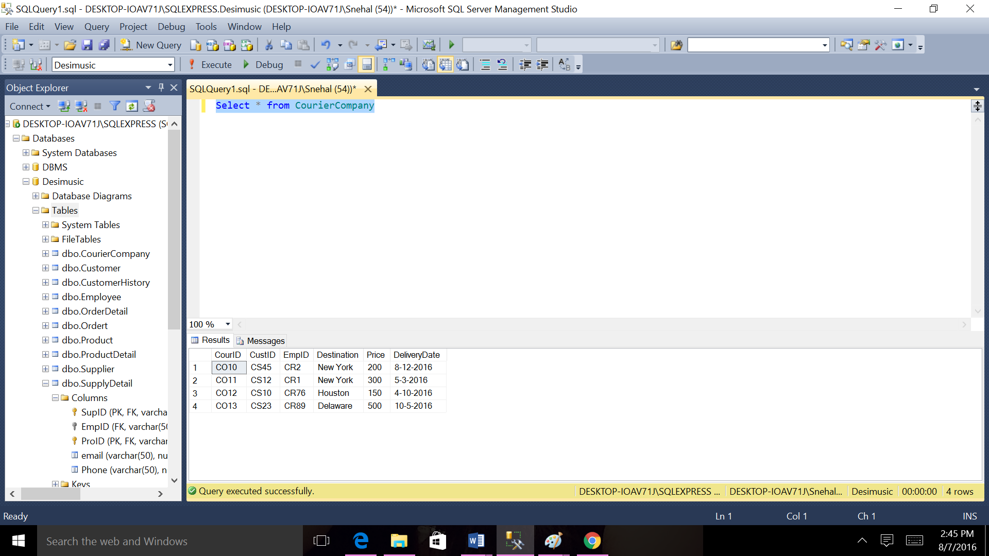

1. **Customer history report**

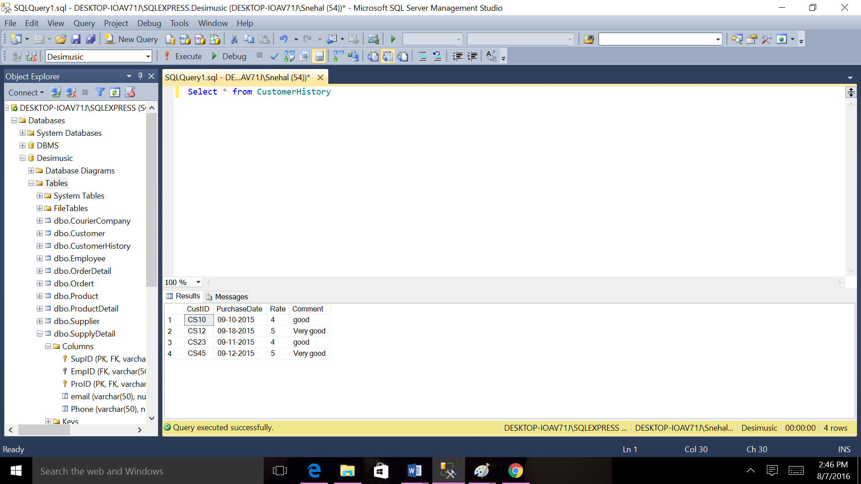

1. **Order information**

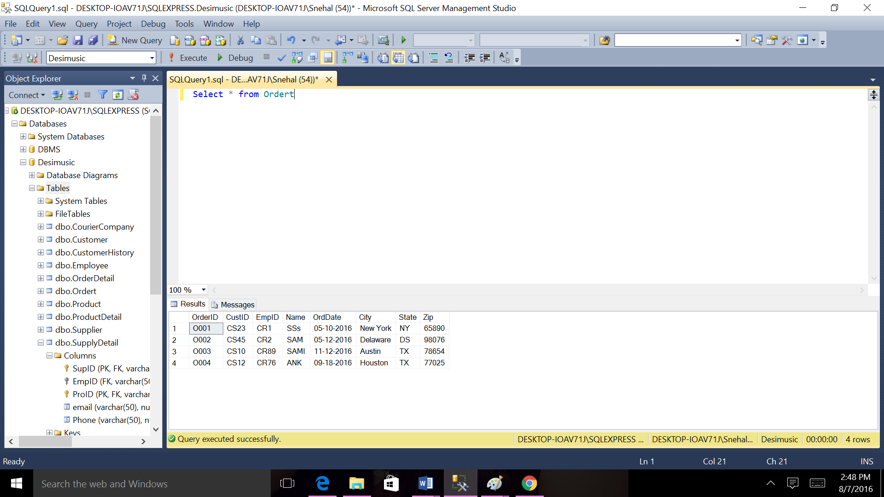

1. **Supplier information**

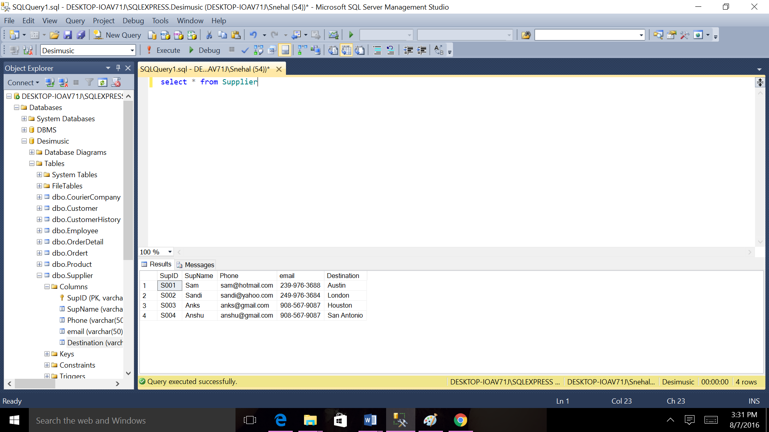

1. **Product information**

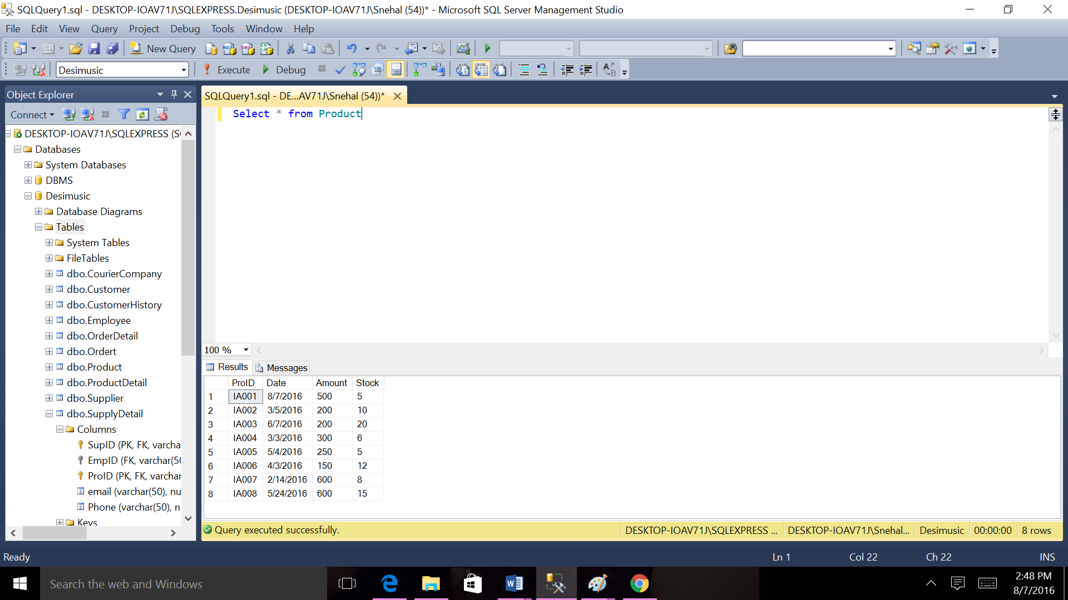

1. **Order detail report**

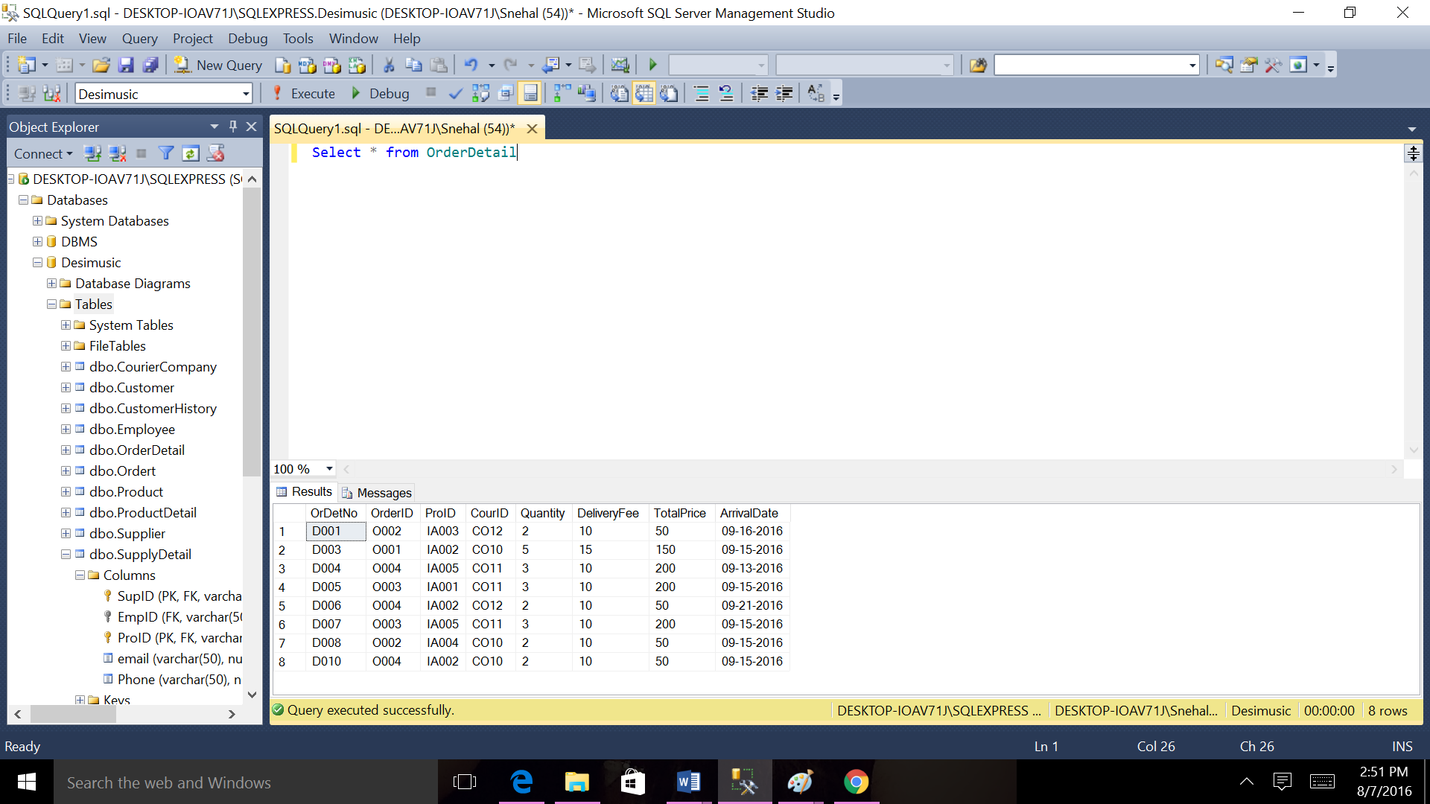

1. **Product detail information**

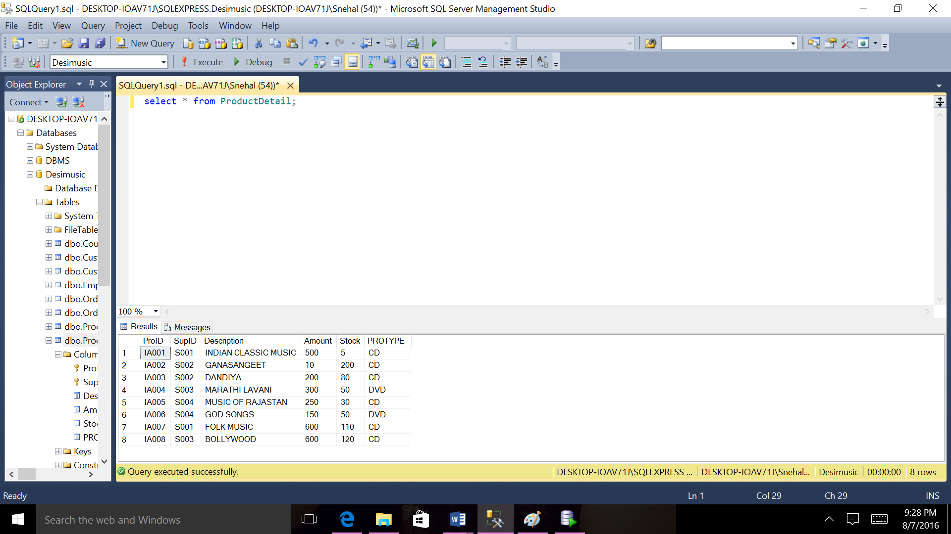

1. **Supply detail information**

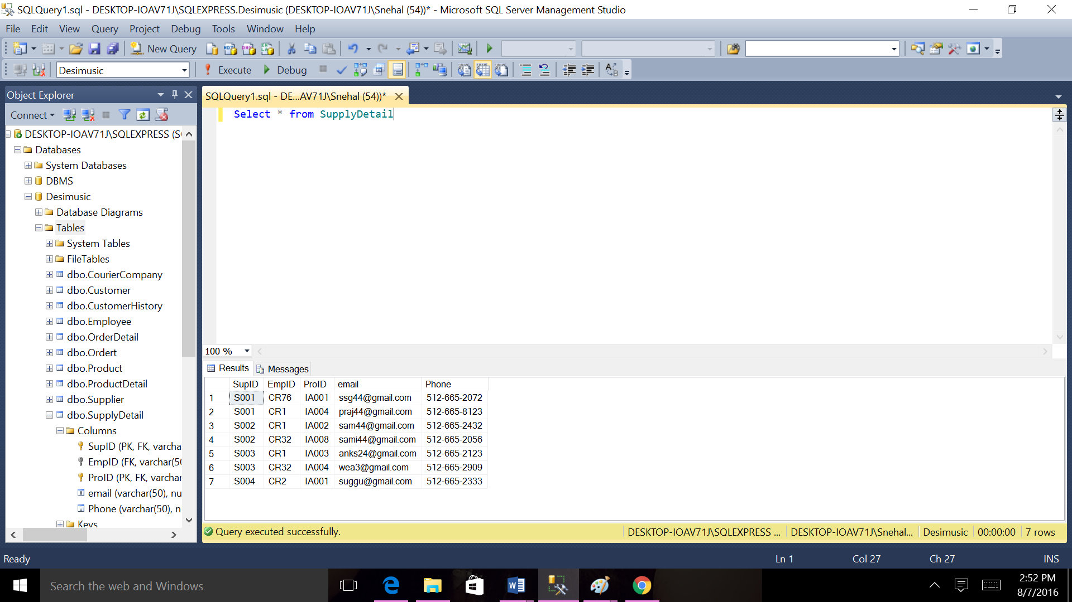

**4.4 Descriptions of all required relationships**

|  |  |
| --- | --- |
| **Table** | **Relationship** |
| **Customer-CustomerHistory** | **One-to-Many. One Customer has multiple Customer history of multiple product. CustID attributes in Customer table corresponds to the matching record in CustomerHistory table.** |
| **Customer-Order** | **One-to-Many. One Customer has multiple order records of product. CustID attributes in Customer table corresponds to the matching record in Order table.** |
| **Employee-Order** | **One-to-Many. One Employee can see multiple order records of product. EmpID attributes in Employee table corresponds to the matching record in Order table.** |
| **Product-ProductDetail** | **One-to-Many. One Product has multiple Product Details with different customer. ProID attributes in Product table corresponds to the matching record in Product Detail table.** |
| **Supplier-ProductDetail** | **One-to-Many. One Supplier has multiple Product Details with different customer. SupID attributes in Supplier table corresponds to the matching record in Product Detail table.** |
| **Supplier-SupplierDetail** | **One-to-Many. One supplier has multiple supply Details with different customer. SupID attributes in Product table corresponds to the matching record in Supply Detail table.** |
| **Employee-SupplyDetail** | **One-to-Many. One Employe has multiple supply Details with different customer. EmpID attributes in Employee table corresponds to the matching record in Supply Detail table.** |
| **Product-SupplyDetail** | **One-to-Many. One Product has multiple supply Details with different customer and employee. ProID attributes in Product table corresponds to the matching record in Supply Detail table.** |
| **Ordert-OrderDetail** | **One-to-Many. One Order has multiple Order Details with different customer. OrderID attributes in Ordert table corresponds to the matching record in Order Detail table.** |
| **Product-ProductDetail** | **One-to-Many. One Product has multiple product Details with different customer. ProID attributes in Product table corresponds to the matching record in Product Detail table.** |
| **CourierCompany-ProductDetail** | **One-to-Many. CourierCompany has multiple product Details with different customer. CourID attributes in CourierCompany table corresponds to the matching record in Product Detail table.** |
| **Customer-CourierCompany** | **One-to-Many. Customer has multiple Courier Details with different Product. CustID attributes in Customer table corresponds to the matching record in CourierCompany table.** |
| **Employee-CourierCompany** | **One-to-Many. Employee has multiple Courier Details with different Product and Customer. EmpID attributes in Employee table corresponds to the matching record in CourierCompany table.** |

**4.5 E/R Model (Diagram) of the System with relationships and with all entities**

**including pk’s and fk’s.**

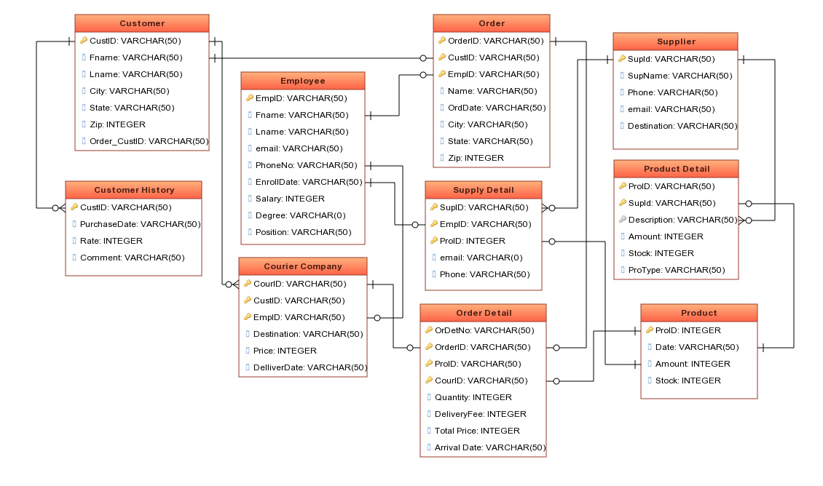

**Chapter 5 Data Dictionary or System Catalog**

**5.1 Relations, attributes, domains, comments**

|  |  |  |
| --- | --- | --- |
| **Table** | **Attribute** | **Comments** |
| **Customer** | **CustID , FName , LName ,City ,State ,Zip** | **Table to store Customer information.** |
| **Employee** | **EmpID , FName , LName, Email , PhoneNo , EnrollDate , Salary , Degree , Position** | **Table to store Employee information.** |
| **CutomerHistory** | **CustID ,PurchaseDate ,Rate ,Comment** | **Table to store Customer History information.** |
| **CourierCompany** | **CourID, CustID ,EmpID, Destination, Price, DeliveryDate** | **Table to store Courier Company information.** |
| **Ordert** | **OrderID, CustID, EmpUD, Name,OrdDate, City, State, Zip** | **Table to store order information.** |
| **Product** | **ProID ,Date ,Amount ,Stock** | **Table to store Product information.** |
| **OrderDetail** | **OrDetNo ,OrderID, ProID,CourID ,Quantity, DeliveryFee ,TotalPrice, ArrivalDate** | **Table to store order detail information.** |
| **Supplier** | **SupID ,SupName ,Phone , email ,Destination** | **Table to store Supplier information.** |
| **ProductDetail** | **ProID, SupID, Description, Amount ,Stock, ProType** | **Table to store Product detail information.** |
| **SupplierDetail** | **SupID, ProID, EmpID, email, Phone** | **Table to store Supplier detail information.** |

**5.2 Attributes, types, descriptions, restrictions**

1. **Customer**

|  |  |  |  |
| --- | --- | --- | --- |
| **Attributes** | **Type** | **Description** | **Restriction** |
| **CustID** | **VARCHAR(50)** | **Customer Id uniquely identifies each record .Primary Key.** | **NOT NULL** |
| **FName** | **VARCHAR(50)** | **Store first name of customer** |  |
| **LName** | **VARCHAR(50)** | **Store last name of customer** |  |
| **City** | **VARCHAR(50)** | **Store the city of customer** |  |
| **State** | **VARCHAR(50)** | **Store the state of customer** |  |
| **Zip** | **INTEGER** | **Store the zip of customer** |  |

1. **Customer History**

|  |  |  |  |
| --- | --- | --- | --- |
| **Attributes** | **Type** | **Description** | **Restriction** |
| **CustID** | **VARCHAR(50)** | **Customer Id uniquely identifies each record. Primary Key. Foreign Key** | **NOT NULL** |
| **PurchaseDate** | **VARCHAR(50)** | **Store purchase date of customer** |  |
| **Rate** | **INTEGER** | **Store rate of customer** |  |
| **Comment** | **VARCHAR(50)** | **Store the comments of customer** |  |

1. **Supplier**

|  |  |  |  |
| --- | --- | --- | --- |
| **Attributes** | **Type** | **Description** | **Restriction** |
| **SupID** | **VARCHAR(50)** | **Suppliert Id uniquely identifies each record .Primary Key.** | **NOT NULL** |
| **SupName** | **VARCHAR(50)** | **Store the name of the supplier** |  |
| **Phone** | **VARCHAR(50)** | **Store the phone of the supplier** |  |
| **email** | **VARCHAR(50)** | **Store the email of the supplier** |  |
| **Destination** | **VARCHAR(50)** | **Store the Destination of the supplier** |  |

1. **Employee**

|  |  |  |  |
| --- | --- | --- | --- |
| **Attributes** | **Type** | **Description** | **Restriction** |
| **EmpID** | **VARCHAR(50)** | **Employee Id uniquely identifies each record .Primary Key.** | **NOT NULL** |
| **FName** | **VARCHAR(50)** | **Store first name of employee** |  |
| **LName** | **VARCHAR(50)** | **Store last name of employee** |  |
| **Email** | **VARCHAR(50)** | **Store the email of employee** |  |
| **phone No** | **VARCHAR(50)** | **Store the phone no of employee** |  |
| **EnrollDate** | **VARCHAR(50)** | **Store the enroll date of employee** |  |
| **Salary** | **INTEGER** | **Store the salary of employee** |  |
| **Degree** | **VARCHAR(50)** | **Store the degree of employee** |  |
| **Position** | **VARCHAR(50)** | **Store the position of employee** |  |

1. **Order**

|  |  |  |  |
| --- | --- | --- | --- |
| **Attributes** | **Type** | **Description** | **Restriction** |
| **OrderID** | **VARCHAR(50)** | **Order Id uniquely identifies each record .Primary Key.** | **NOT NULL** |
| **CustID** | **VARCHAR(50)** | **Store cutomer Id of order Primary Key. Foreign Key** | **NOT NULL** |
| **EmpID** | **VARCHAR(50)** | **Store employee Id of order Primary Key. Foreign Key** | **NOT NULL** |
| **Name** | **VARCHAR(50)** | **Store the name of order** |  |
| **OrdDate** | **VARCHAR(50)** | **Store the order date of order** |  |
| **City** | **VARCHAR(50)** | **Store the city of order** |  |
| **State** | **VARCHAR(50)** | **Store the state of order** |  |
| **Zip** | **INTEGER** | **Store the zip of order** |  |

1. **Courier Company**

|  |  |  |  |  |
| --- | --- | --- | --- | --- |
| **Attributes** | **Type** | **Description** | **Restriction** | |
| **CourID** | **VARCHAR(50)** | **Courier Id uniquely identifies each record .Primary Key.** | | **NOT NULL** | |
| **CustID** | **VARCHAR(50)** | **Store customer ID courier. Primary Key. Foreign Key** | | **NOT NULL** | |
| **EmpID** | **VARCHAR(50)** | **Store employee ID courier. Primary Key. Foreign Key** | | **NOT NULL** | |
| **Destination** | **VARCHAR(50)** | **Store the destination of courier** | |  | |
| **Price** | **INTEGER** | **Store the price of courier** | |  | |
| **DeliveryDate** | **VARCHAR(50)** | **Store the delivery date of courier** | |  | |

1. **Order Detail**

|  |  |  |  |
| --- | --- | --- | --- |
| **Attributes** | **Type** | **Description** | **Restriction** |
| **OrDetNo** | **VARCHAR(50)** | **Order detail Id uniquely identifies each record .Primary Key.** | **NOT NULL** |
| **OrderID** | **VARCHAR(50)** | **Store order Id of order detail Primary Key. Foreign Key** | **NOT NULL** |
| **ProID** | **VARCHAR(50)** | **Store product Id of order detail Primary Key. Foreign Key** | **NOT NULL** |
| **CourID** | **VARCHAR(50)** | **Store the cour Id of order detail Primary Key. Foreign Key** | **NOT NULL** |
| **Quantity** | **INTEGER** | **Store the quantity of order detail** |  |
| **DeliveryFee** | **INTEGER** | **Store the delivery date of order detail** |  |
| **TotalPrice** | **INTEGER** | **Store the total price of order detail** |  |
| **Arrival Date** | **VARCHAR(50)** | **Store the arrival date of order detail** |  |

1. **Product**

|  |  |  |  |
| --- | --- | --- | --- |
| **Attributes** | **Type** | **Description** | **Restriction** |
| **ProID** | **VARCHAR(50)** | **Product Id uniquely identifies each record .Primary Key.** | **NOT NULL** |
| **Date** | **VARCHAR(50)** | **Store the date of product** |  |
| **Amount** | **INTEGER** | **Store the amount of product** |  |
| **Stock** | **INTEGER** | **Store the stock of product** |  |

1. **Product Detail**

|  |  |  |  |
| --- | --- | --- | --- |
| **Attributes** | **Type** | **Description** | **Restriction** |
| **ProID** | **VARCHAR(50)** | **Product Id uniquely identifies each record .Primary Key. Foreign Key** | **NOT NULL** |
| **SupID** | **VARCHAR(50)** | **Store the supplier id of product detail Primary Key. Foreign Key** | **NOT NULL** |
| **Description** | **VARCHAR(50)** | **Store the description of product detail** |  |
| **Amount** | **INTEGER** | **Store the amount of product detail** |  |
| **Stock** | **INTEGER** | **Store the stock of product detail** |  |
| **ProType** | **VARCHAR(20)** | **Store the product type of product detail** |  |

1. **Supply Detail**

|  |  |  |  |
| --- | --- | --- | --- |
| **Attributes** | **Type** | **Description** | **Restriction** |
| **SupID** | **VARCHAR(50)** | **Product Id uniquely identifies each record. Primary Key. Foreign Key** | **NOT NULL** |
| **EmpID** | **VARCHAR(50)** | **Store the employee Id of supplier detail Primary Key. Foreign Key** | **NOT NULL** |
| **ProID** | **VARCHAR(50)** | **Store the product Id of supplier detail Primary Key. Foreign Key** | **NOT NULL** |
| **email** | **VARCHAR(50)** | **Store the email of the supplier detail** |  |

**Chapter 6 Queries with QBE or GUI for RDBMS System Implementation I**

**6.1 The Software, RDBMS and platform used to implement the relational database**

**SQL SERVER**

In [computing](https://en.wikipedia.org/wiki/Computing), **Microsoft SQL Server** is a [relational database management system](https://en.wikipedia.org/wiki/Relational_database_management_system) developed by [Microsoft](https://en.wikipedia.org/wiki/Microsoft). As a [database server](https://en.wikipedia.org/wiki/Database_server), it is a [software product](https://en.wikipedia.org/wiki/Software_product) with the primary function of storing and retrieving dfrrttt5 data as requested by other [software applications](https://en.wikipedia.org/wiki/Software_application) - which may run either on the same computer or on another computer across a network

**TOOL USED**

SQL Server Management Studio (SSMS) is an integrated environment for accessing, configuring, managing, administering, and developing all components of SQL Server.

**6.2 Database creation or required commands**

**Create table statements:**

1. **Customer**

CREATE TABLE Customer(CustID VARCHAR(50), FName VARCHAR (50) , LName VARCHAR (50),City VARCHAR (50),State VARCHAR (50),Zip INTEGER,CONSTRAINT PK_cust PRIMARY KEY (CustID));

1. **Employee**

CREATE TABLE Employee(EmpID VARCHAR(50), FName VARCHAR (50), LName VARCHAR(50), Email VARCHAR (50), PhoneNo VARCHAR (50), EnrollDate VARCHAR(20), Salary INTEGER, Degree VARCHAR(50), Position VARCHAR(50), CONSTRAINT PK_emp PRIMARY KEY (EmpID) );

1. **Customer History**

CREATE TABLE CustomerHistory(CustID VARCHAR(50),PurchaseDate VARCHAR(50),Rate INTEGER ,Comment VARCHAR (50), CONSTRAINT PK_CUHI PRIMARY KEY (CustID),CONSTRAINT FK_CUHI FOREIGN KEY (CustID) REFERENCES Customer(CustID) ON DELETE NO ACTION ON UPDATE CASCADE);

1. **Courier Company**

CREATE TABLE CourierCompany (CourID VARCHAR(50),CustID VARCHAR(50),EmpID VARCHAR (50),Destination VARCHAR(50),Price INTEGER,DeliveryDate VARCHAR(50), CONSTRAINT PK_COURI PRIMARY KEY (CourID),CONSTRAINT FK_COUD FOREIGN KEY (CustID) REFERENCES Customer(CustID) ON DELETE NO ACTION ON UPDATE CASCADE,CONSTRAINT FK_COURI FOREIGN KEY (EmpID) REFERENCES Employee(EmpID) ON DELETE NO ACTION ON UPDATE CASCADE);

1. **Order**

CREATE TABLE Ordert (OrderID VARCHAR(50),CustID VARCHAR(50),EmpID VARCHAR(50), Name VARCHAR (50), OrdDate VARCHAR (50), City VARCHAR (50) , State VARCHAR (50),Zip INTEGER,CONSTRAINT PK_OR PRIMARY KEY (OrderID), CONSTRAINT FK_OR FOREIGN KEY (CustID) REFERENCES Customer(CustID) ) ON DELETE NO ACTION ON UPDATE CASCADE, CONSTRAINT FK_ORD FOREIGN KEY (EmpID) REFERENCES Employee(EmpID) ) ON DELETE NO ACTION ON UPDATE CASCADE);

1. **Product**

CREATE TABLE Product(ProID VARCHAR(50),ProDate VARCHAR (50),Amount VARCHAR(50),Stock INTEGER,CONSTRAINT PK_PRO PRIMARY KEY (ProID));

1. **OrderDetail**

CREATE TABLE OrderDetail(OrDetNo VARCHAR (20),OrderID VARCHAR(50),ProID VARCHAR(50),CourID VARCHAR(50), Quantity INTEGER, DeliveryFee INTEGER, TotalPrice INTEGER, ArrivalDate VARCHAR (50),CONSTRAINT PK_ORD PRIMARY KEY (OrDetNo,OrderID, ProID,CourID),CONSTRAINT FK_ORD1 FOREIGN KEY (OrderID) REFERENCES Ordert(OrderID) ON DELETE NO ACTION ON UPDATE CASCADE,CONSTRAINT FK_ORDTAI FOREIGN KEY (ProID) REFERENCES Product(ProID) ON DELETE NO ACTION ON UPDATE CASCADE,CONSTRAINT FK_OR1 FOREIGN KEY (CourID) REFERENCES CourierCompany(CourID) ON DELETE NO ACTION ON UPDATE CASCADE);

1. **Supplier**

CREATE TABLE Supplier(SupID VARCHAR(50),SupName VARCHAR (50), Phone VARCHAR (50), email VARCHAR (50),Destination VARCHAR (100),CONSTRAINT PK_Supp PRIMARY KEY (SupID));

1. **Product Detail**

CREATE TABLE ProductDetail(ProID VARCHAR(50),SupID VARCHAR(50),Description VARCHAR (50),Amount INTEGER,Stock INTEGER,PROTYPE VARCHAR(50), CONSTRAINT PK_Prod PRIMARY KEY (ProID, SupID),CONSTRAINT FK_PROD FOREIGN KEY (ProID) REFERENCES Product(ProID) ) ON DELETE NO ACTION ON UPDATE CASCADE, CONSTRAINT FK_PRODA FOREIGN KEY (SupID) REFERENCES Supplier(SupID) ON DELETE NO ACTION ON UPDATE CASCADE);

1. **Supplier Detail**

CREATE TABLE SupplyDetail(SupID VARCHAR(50),EmpID VARCHAR(50),ProID VARCHAR(50), email VARCHAR(50),Phone VARCHAR(50),CONSTRAINT PK_sup PRIMARY KEY (SupID, ProID),CONSTRAINT FK_sup FOREIGN KEY (SupID) REFERENCES Supplier(SupID) ON DELETE NO ACTION ON UPDATE CASCADE,CONSTRAINT FK_supI FOREIGN KEY (EmpID) REFERENCES Employee(EmpID) ON DELETE NO ACTION ON UPDATE CASCADE,CONSTRAINT FK_supa FOREIGN KEY (ProID) REFERENCES Product(ProID) ON DELETE NO ACTION ON UPDATE CASCADE);

**Insert table statements:**

1. **Customer**

INSERT INTO Customer (CustID , FName , LName ,City ,State ,Zip )VALUES ('CS45', 'John', 'Peters', 'San Jose', 'CA', '98076');

INSERT INTO Customer (CustID , FName , LName ,City ,State ,Zip)VALUES ('CS23', 'Tom', 'Edwards', 'New York', 'NY', '65890');

INSERT INTO Customer (CustID , FName , LName ,City ,State ,Zip)VALUES ('CS12', 'Ella', 'Jiang', 'Houston', 'TX', '77025');

INSERT INTO Customer (CustID , FName , LName ,City ,State ,Zip)VALUES ('CS10', 'Ann', 'Watsaon', 'Austin', 'TX', '78654');

1. **Customer History**

INSERT INTO CustomerHistory(CustID ,PurchaseDate ,Rate ,Comment) VALUES ('CS45', '09-12-2015', 5.0, 'Very good');

INSERT INTO CustomerHistory(CustID ,PurchaseDate ,Rate ,Comment)VALUES ('CS23', '09-11-2015', 4.5, 'good');

INSERT INTO CustomerHistory(CustID ,PurchaseDate ,Rate ,Comment)VALUES ('CS10', '09-10-2015', 4.5, 'good');

INSERT INTO CustomerHistory(CustID ,PurchaseDate ,Rate ,Comment)VALUES ('CS12', '09-18-2015', 5.0, 'Very good');

1. **Employee**

INSERT INTO Employee (EmpID , FName , LName, Email , PhoneNo , EnrollDate , Salary , Degree , Position)VALUES ('CR76', 'Sne', 'Dose', 'Sne23@gmail.com', '567-098-4567', '05-12-2003', 12000, 'master',' Manager');

INSERT INTO Employee (EmpID , FName , LName, Email , PhoneNo , EnrollDate , Salary , Degree , Position)VALUES ('CR89', 'Ank', 'Bread', 'Anks@gmail.com', '786-098-5676', '04-18-2012', 100000, 'bachelor', 'Coordinator');

INSERT INTO Employee (EmpID , FName , LName, Email , PhoneNo , EnrollDate , Salary , Degree , Position)VALUES ('CR09', 'George', 'Peters', 'g.peters@yahoo.com', '777-098-6789', '03-20-2011', 30000, 'master', ' Coordinator');

INSERT INTO Employee (EmpID , FName , LName, Email , PhoneNo , EnrollDate , Salary , Degree , Position)VALUES ('CR32', 'Sam', 'Jose', 'sam23@gmail.com', '123-908-4678', '07-18-2011', 20000, 'Master', 'Administrator');

INSERT INTO Employee (EmpID , FName , LName, Email , PhoneNo , EnrollDate , Salary , Degree , Position)VALUES ('CR1', 'Ann', 'Jose', 'Anni8@yahoo.com', '467-908-4678', '07-18-2014', 10000, 'bachelor', 'Coordinator');

INSERT INTO Employee (EmpID , FName , LName, Email , PhoneNo , EnrollDate , Salary , Degree , Position)VALUES ('CR2', 'Robert', 'Blank', 'blank@yahoo.com', '789-098-7654', '07-20-20145', 4000, 'master', 'supply coordinator');

1. **Courier Company**

INSERT INTO CourierCompany (CourID ,CustID ,EmpID ,Destination ,Price DeliveryDate) VALUES ('CO10', 'CS45', 'CR2', 'New York',200,'8-12-2016');

INSERT INTO CourierCompany (CourID ,CustID ,EmpID ,Destination ,Price , DeliveryDate)

VALUES ('CO11', 'CS12', 'CR1', 'New York',300, '5-3-2016');

INSERT INTO CourierCompany (CourID ,CustID ,EmpID ,Destination ,Price , DeliveryDate)

VALUES ('CO12', 'CS10', 'CR76','Houston', 150,'4-10-2016');

INSERT INTO CourierCompany (CourID ,CustID ,EmpID ,Destination ,Price , DeliveryDate)

VALUES ('CO13', 'CS23', 'CR89', 'Delaware',500, '10-5-2016');

1. **Order**

INSERT INTO Ordert(OrderID ,CustID,EmpID,Name,OrdDate ,City, State,Zip)VALUES ('O002', 'CS45','CR2','SAM','05-12-2016', 'Delaware', 'DS', '98076');

INSERT INTO Ordert (OrderID ,CustID,EmpID,Name,OrdDate ,City, State,Zip)VALUES ('O001' , 'CS23','CR1','SSs' ,'05-10-2016', 'New York', 'NY', '65890');

INSERT INTO Ordert (OrderID ,CustID,EmpID,Name,OrdDate ,City, State,Zip) VALUES ('O004', 'CS12','CR76','ANK','09-18-2016', 'Houston', 'TX', '77025');

INSERT INTO Ordert (OrderID ,CustID,EmpID,Name,OrdDate ,City, State,Zip)VALUES ('O003', 'CS10','CR89','SAMI','11-12-2016', 'Austin', 'TX', '78654');

1. **Product**

INSERT INTO Product (ProID ,Date ,Amount , Stock) VALUES ('IA001','8/7/2016', 500, 5);

INSERT INTO Product (ProID ,Date ,Amount, Stock)VALUES ('IA002','3/5/2016' , 200, 10);

INSERT INTO Product (ProID ,Date ,Amount , Stock) VALUES ('IA004','3/3/2016', 300, 6);

INSERT INTO Product (ProID ,Date ,Amount , Stock)VALUES ('IA005','5/4/2016', 250, 5);

INSERT INTO Product (ProID ,Date ,Amount , Stock)VALUES ('IA003','6/7/2016', 200,20);

INSERT INTO Product (ProID ,Date ,Amount, Stock)VALUES ('IA006','4/3/2016', 150, 12);

INSERT INTO Product (ProID ,Date ,Amount , Stock)VALUES ('IA007','2/14/2016', 600,8);

INSERT INTO Product (ProID ,Date ,Amount , Stock)VALUES ('IA008','5/24/2016', 600,15);

1. **OrderDetail**

INSERT INTO OrderDetail(OrDetNo ,OrderID ,ProID,CourID , Quantity , DeliveryFee ,TotalPrice , ArrivalDate)VALUES ('D001', 'O002', 'IA003', 'CO12', 2, 10, 50,'09-16-2016');

INSERT INTO OrderDetail(OrDetNo ,OrderID ,ProID,CourID , Quantity , DeliveryFee ,TotalPrice , ArrivalDate) VALUES ('D003', 'O001', 'IA002', 'CO10', 5,15,150, '09-15-2016');

INSERT INTO OrderDetail(OrDetNo ,OrderID ,ProID,CourID , Quantity , DeliveryFee ,TotalPrice , ArrivalDate) VALUES ('D004', 'O004', 'IA005', 'CO11', 3,10,200, '09-13-2016');

INSERT INTO OrderDetail(OrDetNo ,OrderID ,ProID,CourID , Quantity , DeliveryFee ,TotalPrice , ArrivalDate)VALUES ('D006', 'O004', 'IA002', 'CO12', 2, 10, 50, '09-21-2016');

INSERT INTO OrderDetail(OrDetNo ,OrderID ,ProID,CourID , Quantity , DeliveryFee ,TotalPrice , ArrivalDate)VALUES ('D005', 'O003', 'IA001', 'CO11', 3,10,200, '09-15-2016');

INSERT INTO OrderDetail(OrDetNo ,OrderID ,ProID,CourID , Quantity , DeliveryFee ,TotalPrice , ArrivalDate)VALUES ('D008', 'O002', 'IA004', 'CO10', 2, 10, 50, '09-15-2016');

INSERT INTO OrderDetail(OrDetNo ,OrderID ,ProID,CourID , Quantity , DeliveryFee ,TotalPrice , ArrivalDate)VALUES ('D007', 'O003', 'IA005', 'CO11', 3,10,200, '09-15-2016');

INSERT INTO OrderDetail(OrDetNo ,OrderID ,ProID,CourID , Quantity , DeliveryFee ,TotalPrice , ArrivalDate)VALUES ('D010', 'O004', 'IA002', 'CO10', 2, 10, 50, '09-15-2016');

1. **Supplier**

INSERT INTO Supplier (SupID ,SupName ,Phone , email ,Destination) VALUES ('S001', 'Sam', 'sam@hotmail.com', '239-976-3688','Austin');

INSERT INTO Supplier (SupID ,SupName ,Phone , email, Destination) VALUES ('S002','Sandi', 'sandi@yahoo.com', '249-976-3684','London');

INSERT INTO Supplier (SupID ,SupName ,Phone , email ,Destination) VALUES ('S003','Anks', 'anks@gmail.com', '908-567-9087','Houston');

INSERT INTO Supplier (SupID ,SupName ,Phone , email ,Destination) VALUES ('S004', 'Anshu', 'anshu@gmail.com', '908-567-9087','San Antonio');

1. **Product Detail**

INSERT INTO ProductDetail(ProID ,SupID,Description ,Amount ,Stock, PROTYPE) VALUES ('IA001','S001','INDIAN CLASSIC MUSIC', 500,5, 'CD');

INSERT INTO ProductDetail (ProID ,SupID,Description ,Amount ,Stock, PROTYPE)VALUES ('IA002','S002','GANASANGEET' ,10, 200, 'CD');

INSERT INTO ProductDetail (ProID ,SupID,Description ,Amount ,Stock, PROTYPE) VALUES ('IA004','S003','MARATHI LAVANI', 300, 50,'DVD');

INSERT INTO ProductDetail (ProID ,SupID,Description ,Amount ,Stock, PROTYPE)VALUES ('IA005','S004','MUSIC OF RAJASTAN', 250,30, 'CD');

INSERT INTO ProductDetail (ProID ,SupID,Description ,Amount ,Stock, PROTYPE)VALUES ('IA003','S002','DANDIYA', 200, 80,'CD');

INSERT INTO ProductDetail (ProID ,SupID,Description ,Amount ,Stock, PROTYPE)VALUES ('IA006','S004','GOD SONGS', 150,50, 'DVD');

INSERT INTO ProductDetail (ProID ,SupID,Description ,Amount ,Stock, PROTYPE)VALUES ('IA007','S001','FOLK MUSIC', 600,110, 'CD');

INSERT INTO ProductDetail (ProID ,SupID,Description ,Amount ,Stock, PROTYPE)VALUES ('IA008','S003','BOLLYWOOD', 600,120, 'CD');

1. **Supplier Detail**

INSERT INTO SupplyDetail (SupID, ProID, EmpID,email,Phone)VALUES ('S001', 'IA001', 'CR76','ssg44@gmail.com','512-665-2072');

INSERT INTO SupplyDetail (SupID, ProID, EmpID,email,Phone)VALUES ('S003', 'IA003', 'CR1','anks24@gmail.com','512-665-2123');

INSERT INTO SupplyDetail (SupID, ProID, EmpID,email,Phone)VALUES ('S002', 'IA002', 'CR1','sam44@gmail.com','512-665-2432');

INSERT INTO SupplyDetail (SupID, ProID, EmpID,email,Phone)VALUES ('S001', 'IA004', 'CR1','praj44@gmail.com','512-665-8123');

INSERT INTO SupplyDetail (SupID, ProID, EmpID,email,Phone)VALUES ('S004', 'IA001', 'CR2','suggu@gmail.com','512-665-2333');

INSERT INTO SupplyDetail (SupID, ProID, EmpID,email,Phone)VALUES ('S003', 'IA004', 'CR32','wea3@gmail.com','512-665-2909');INSERT INTO SupplyDetail (SupID, ProID, EmpID,email,Phone)VALUES ('S002', 'IA008', 'CR32','sami44@gmail.com','512-665-2056');

**6.3 Fifteen Nontrivial queries in English with some complexity**

1. Find employee who has employee Id CR76 from Courier Company
2. list all the cities of the couriers( no repeat)
3. List the products whose stock is below 100.
4. List Customers’ numbers and names who is in Texas
5. List from order detail who has order detail number O002 and product Id IA002.
6. Order the products by their amount By descending order.
7. List all the employees’ numbers and salaries ordered by salaries
8. Order the products by their product Id By Ascending order.
9. Select OrderDetail for all Order where quantity are greater than 2.
10. Select ProductDetail for all Product where price is greater than 200.
11. List all the employees’ numbers and the number of the supply projects they are in charge of this.
12. List the product numbers whose stocks are greather than 50 or the purchase price are less than 100.
13. Calculate average rate for all customer.
14. List the order information ordered by date who has state texas.
15. List all the orders’ number which contain product IA003 or IA005

**6.4 Required Screens or Programs for the implementation of queries and output for each query**

1. **Find employee who has employee Id CR76 from Courier Company.**

SELECT * FROM CourierCompany WHERE EmpId='CR76';

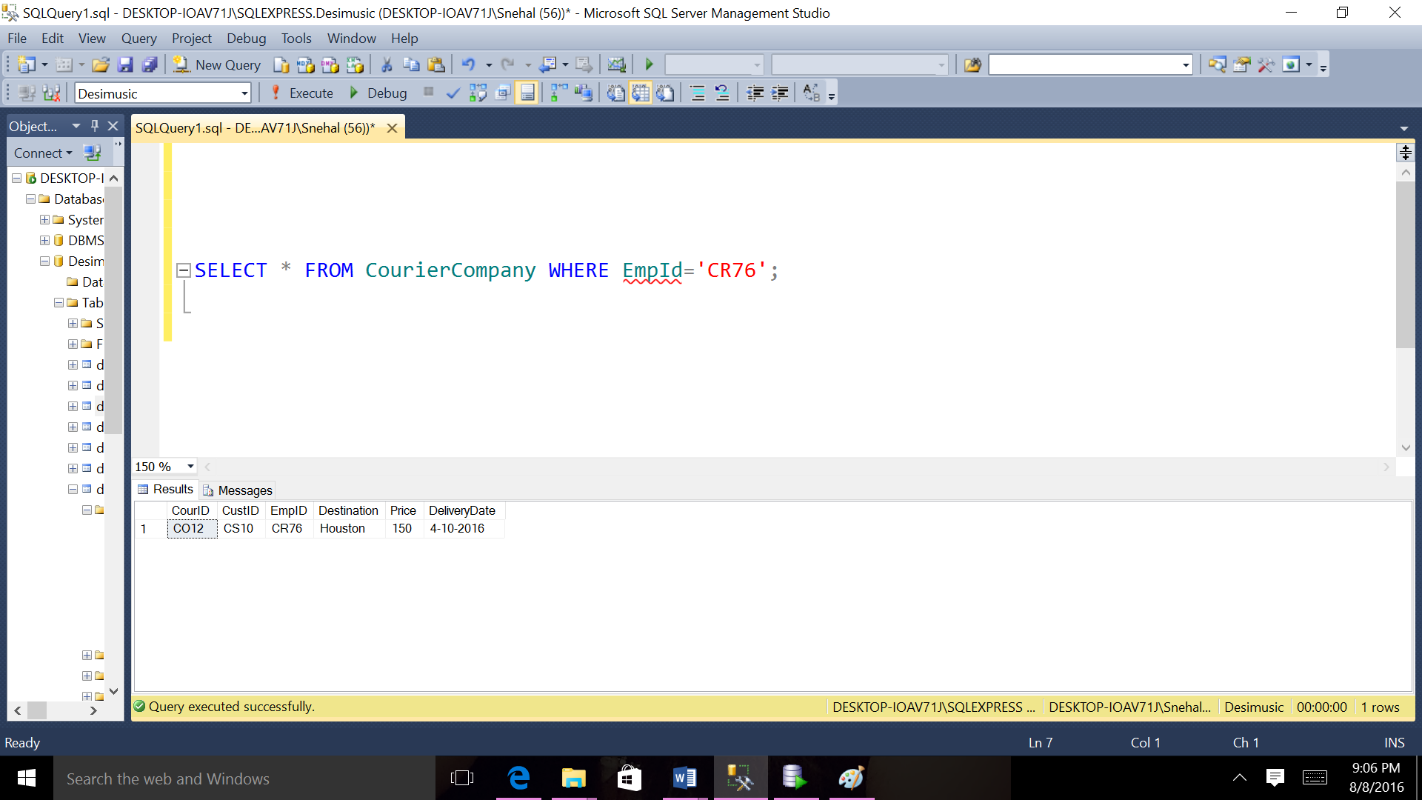

1. **List all the cities of the couriers( no repeat)**

SELECT City FROM Customer GROUP BY City;

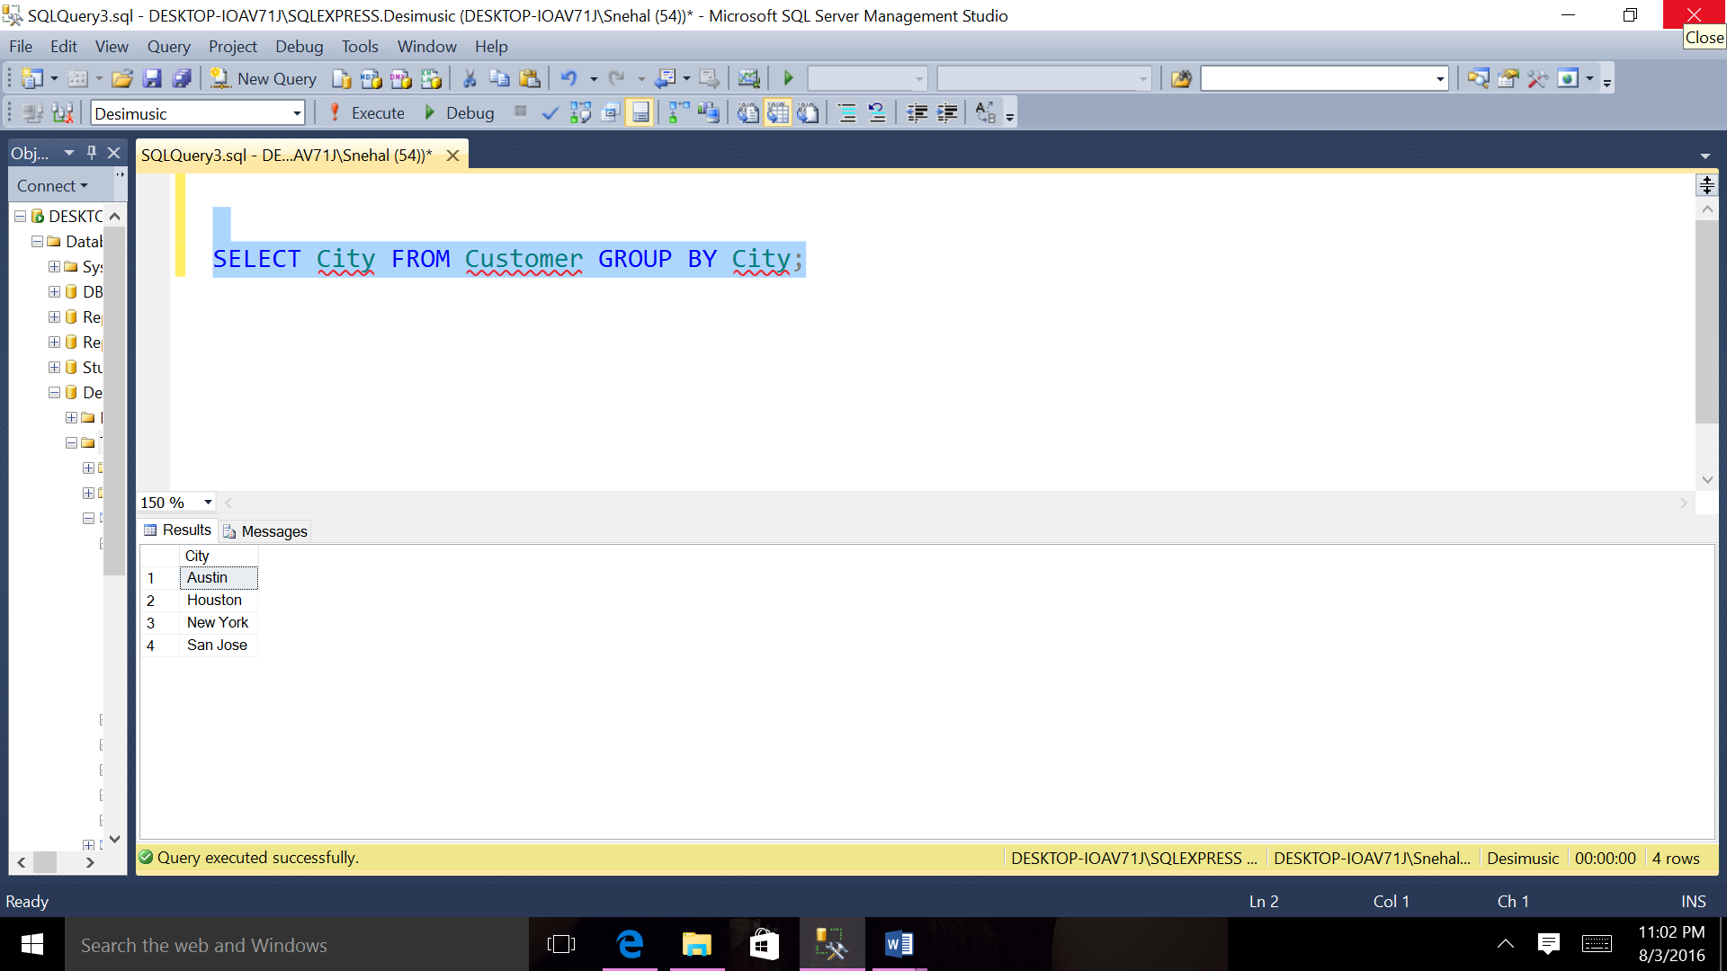

1. **List the products whose stock is below 100.**

SELECT ProID, Stock FROM ProductDetail

WHERE Stock < 100;

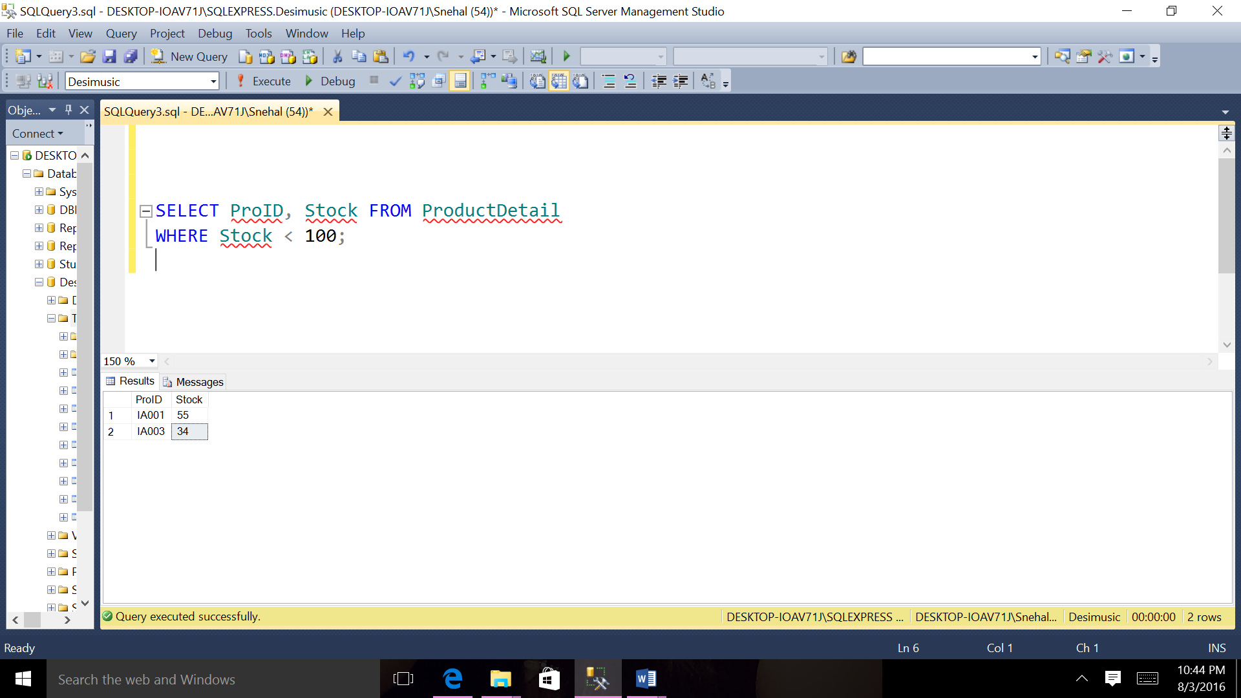

1. **List Customers’ numbers and names who is in Texas**

SELECT CustID, FName, LName FROM Customer WHERE State = 'TX';

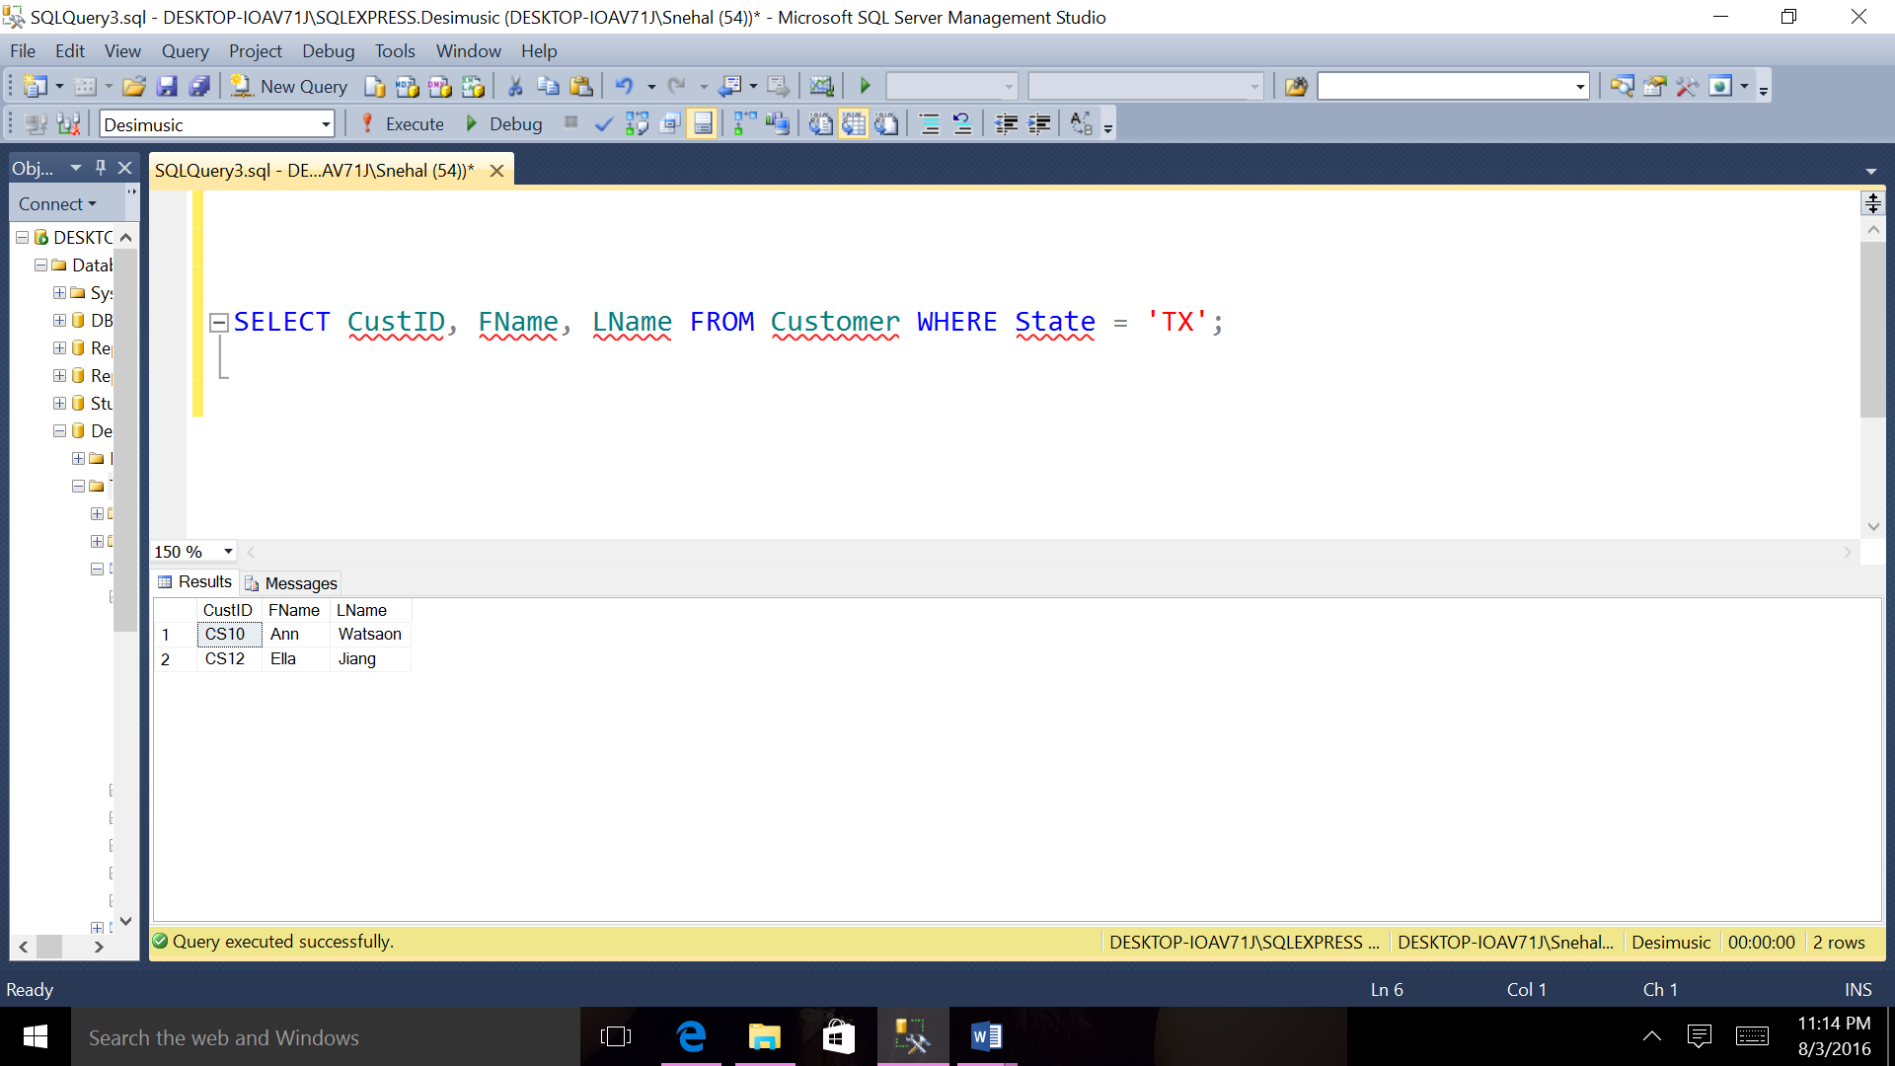

1. **List from order detail who has order detail number O002 and product Id IA001.**

SELECT * FROM OrderDetail WHERE OrDetNo='D002' AND ProID='IA001';

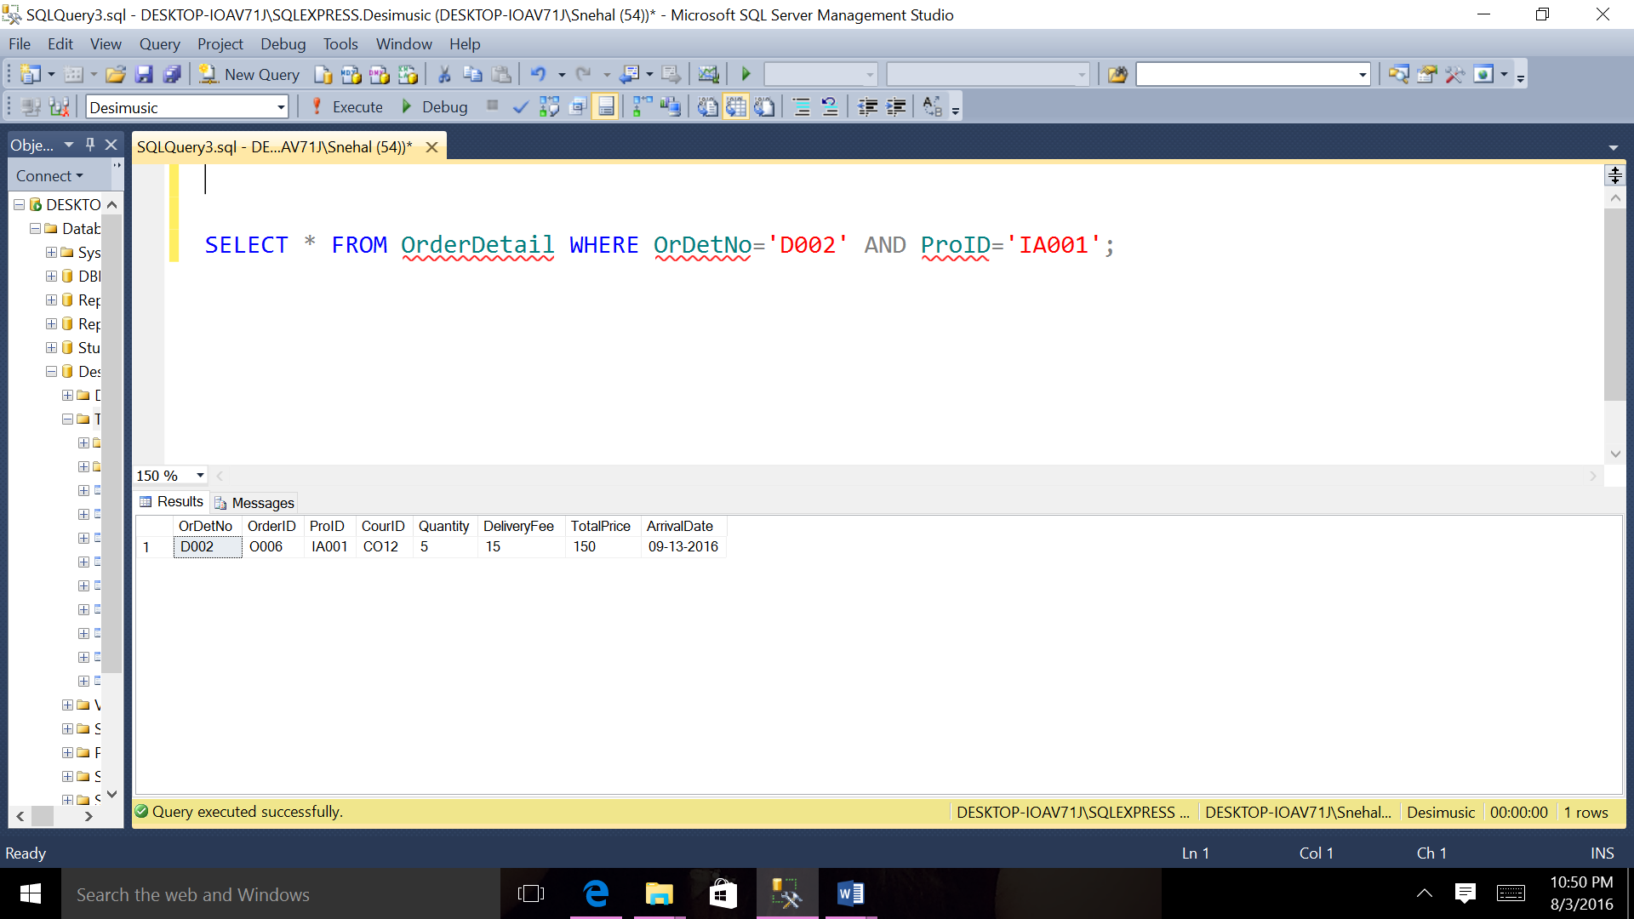

1. Order the products by their amount By descending order.

SELECT * FROM Product ORDER BY Amount DESC;

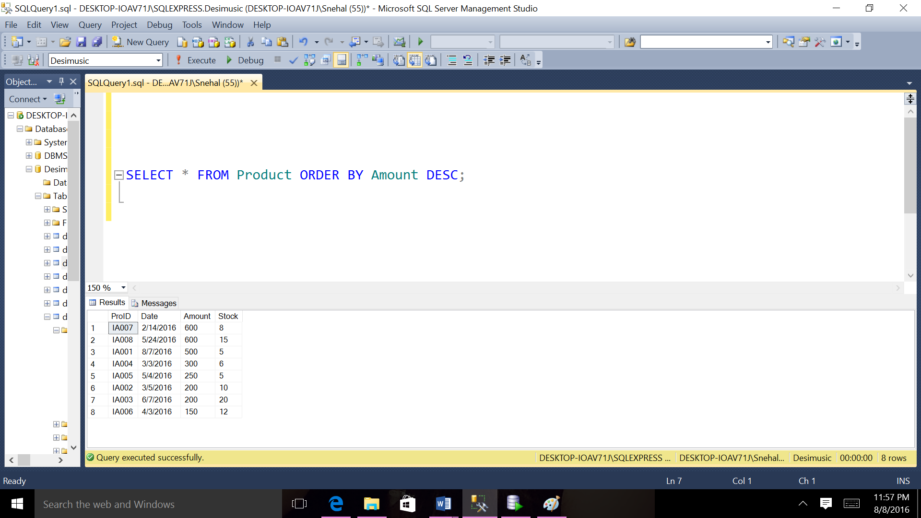

1. **List all the employees’ numbers and salaries ordered by salaries**

SELECT EmpID, salary FROM Employee ORDER BY salary;

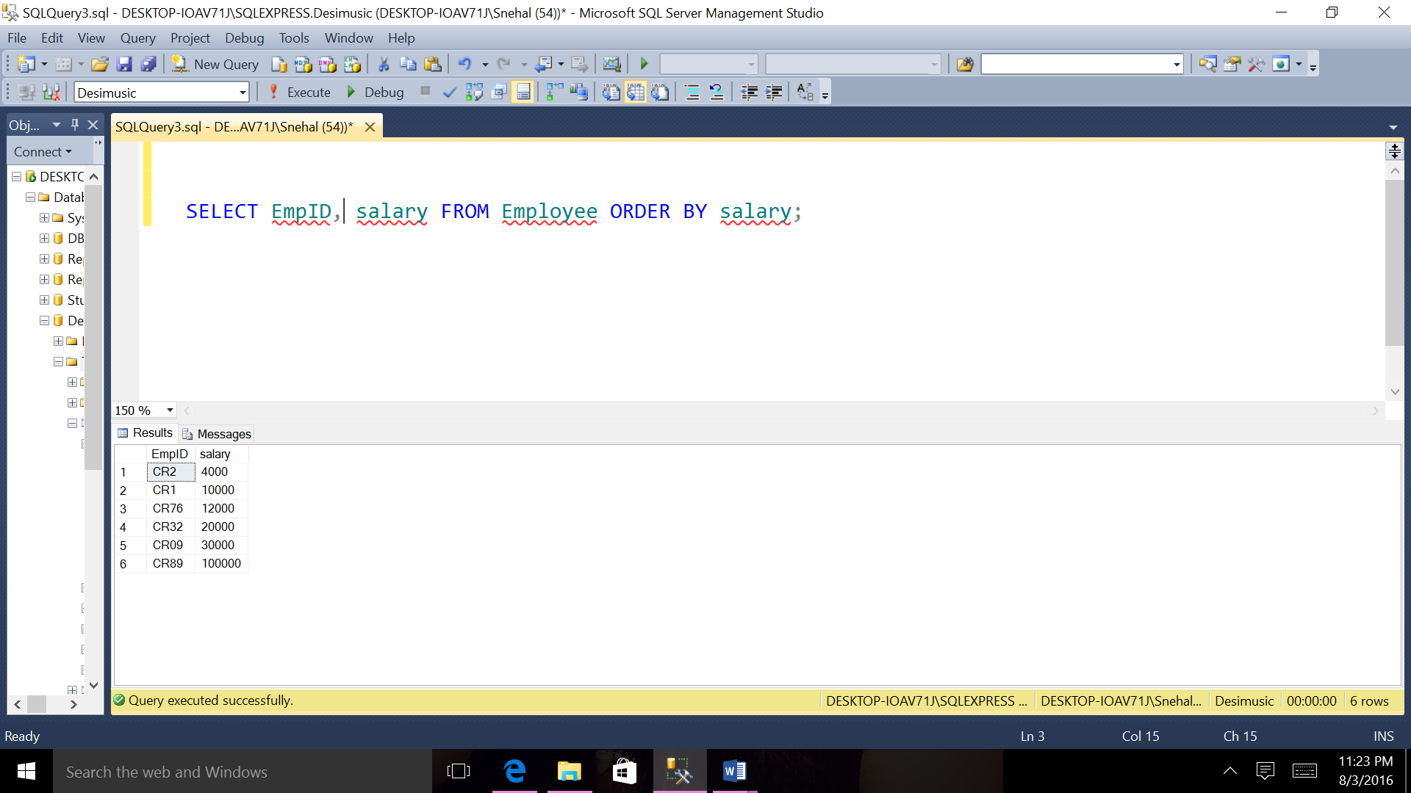

1. Order the products by their product Id By Ascending order.

SELECT * FROM Product ORDER BY ProID ASC;

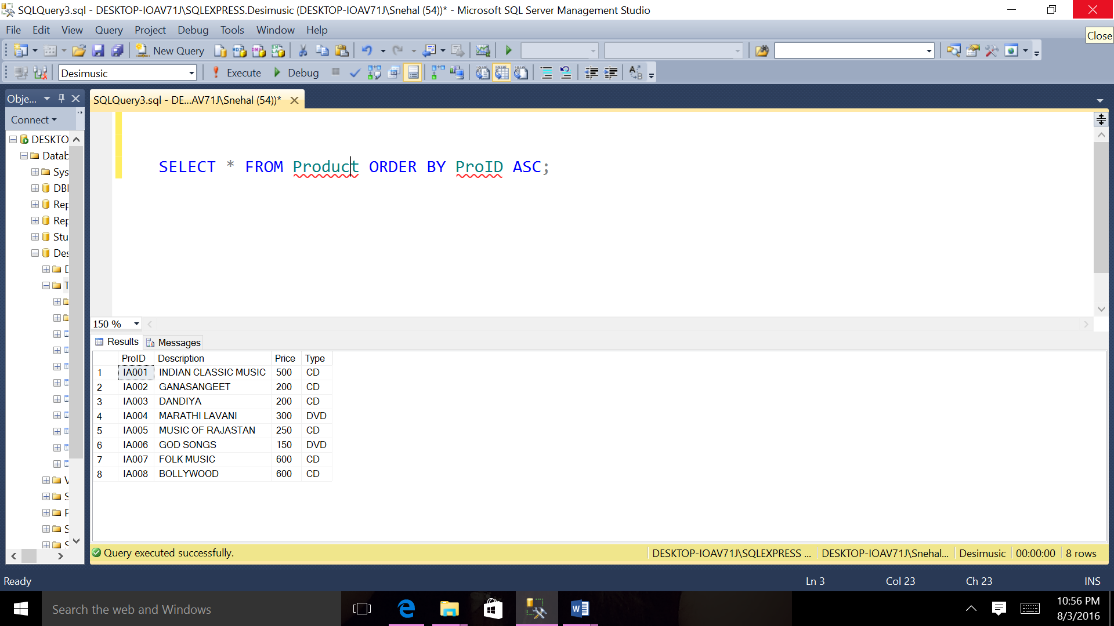

1. **Select OrderDetail for all Order where quantity are greater than 2.**

SELECT * FROM OrderDetail od JOIN Ordert o On od.OrderID=o.OrderID

WHERE Quantity>2;

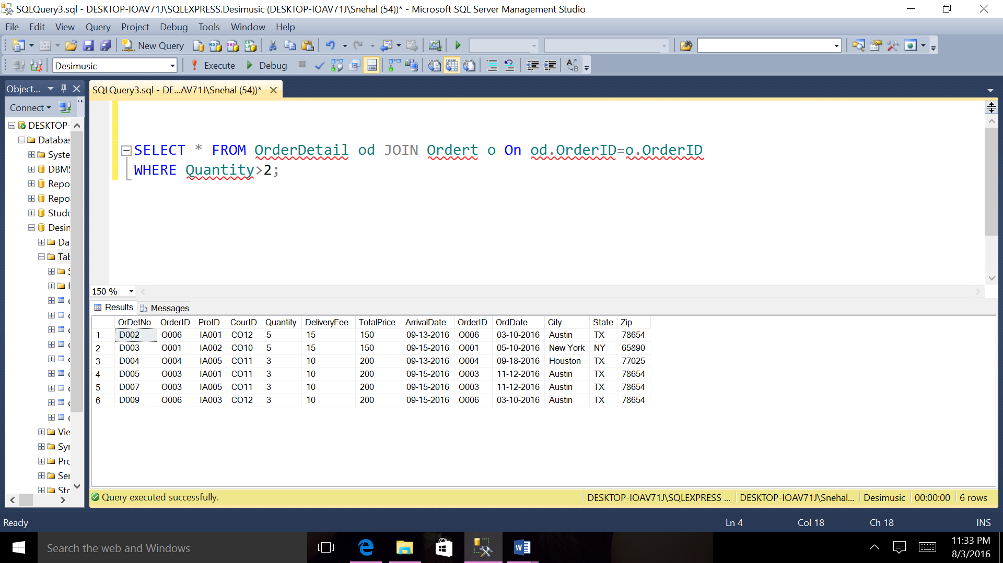

1. **Select ProductDetail for all Product where price is greater than 200.**

SELECT * FROM ProductDetail pd JOIN Product p On pd.ProID=p.ProID

WHERE price>200;

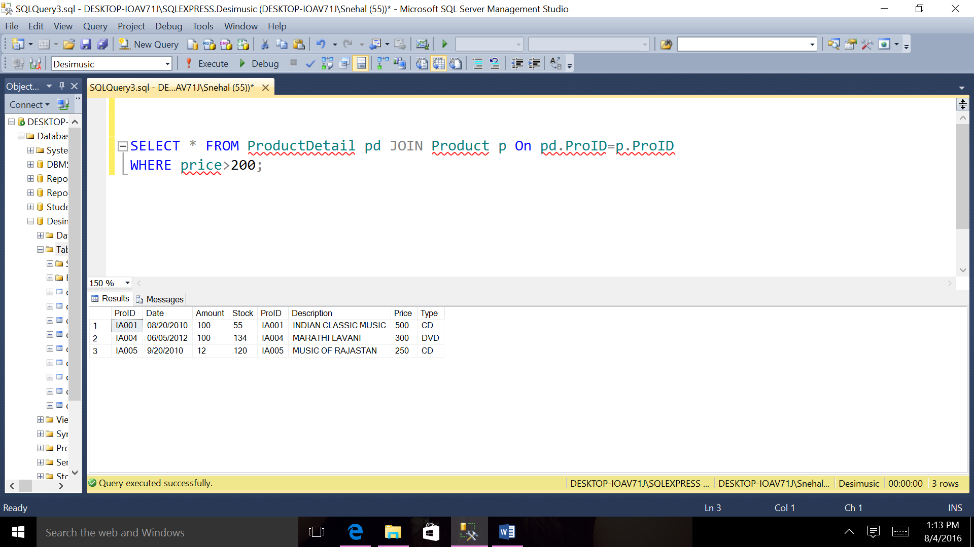

1. **List all the employees’ numbers and the number of the supply projects they are in charge of this.**

SELECT EmpID, COUNT(*)AS Mycount FROM SupplyDetail GROUP BY EmpID;

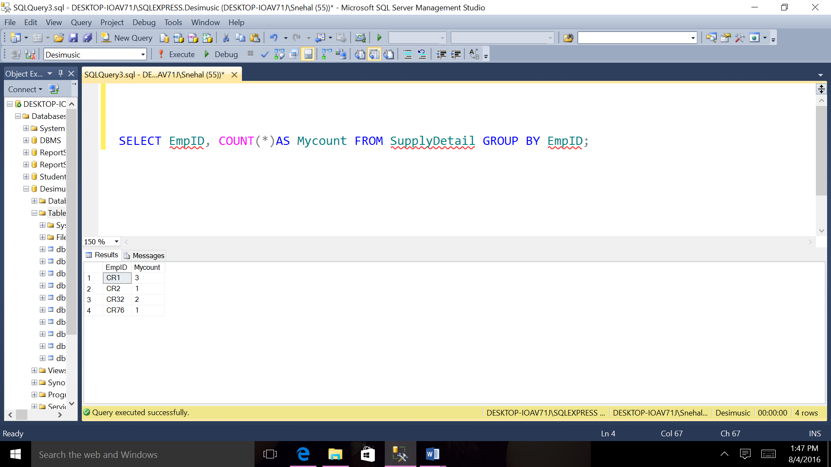

1. **List the product numbers whose stocks are greather than 50 or the purchase price are less than 100.**

SELECT ProID, amount, stock FROM ProductDetail WHERE Stock > 50 OR amount < 90;

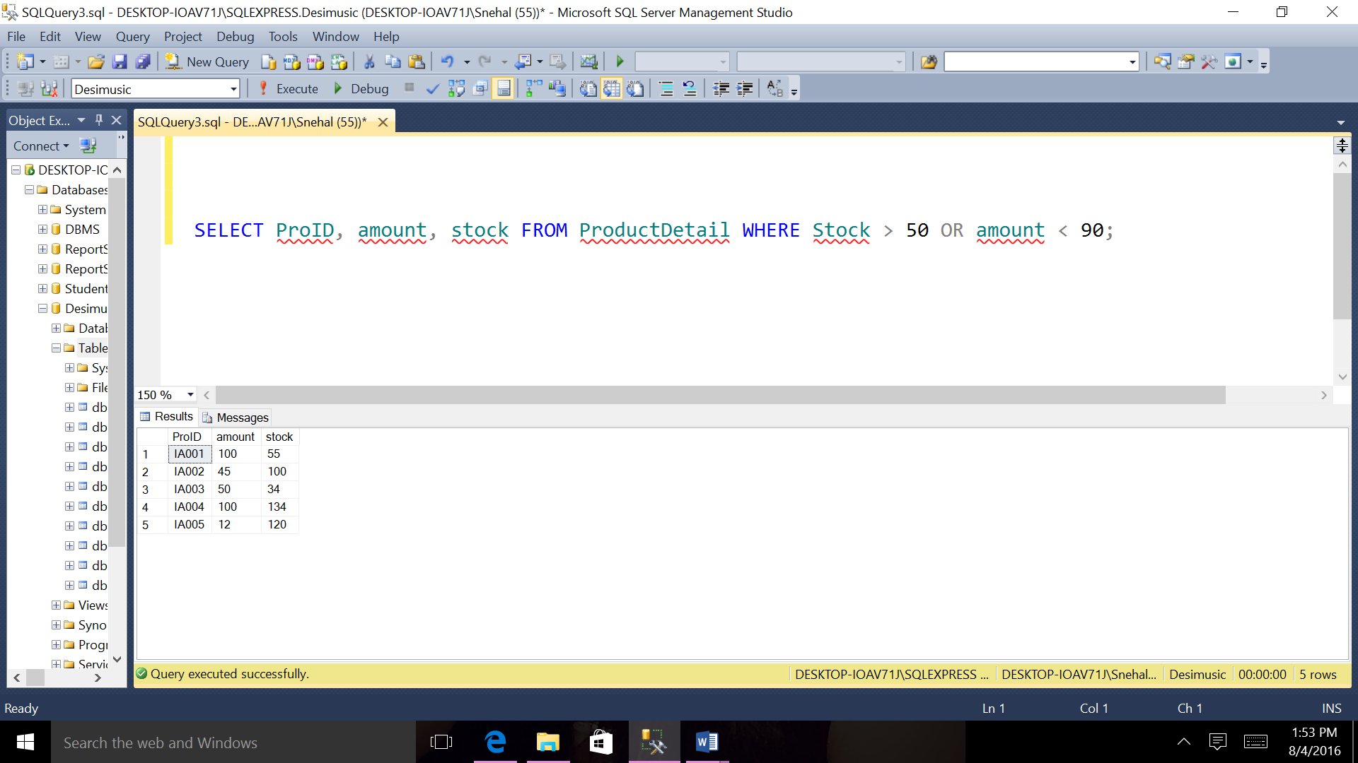

1. **Calculate average rate for all customer.**

SELECT AVG(rate) AS Averagerate From CustHistory;

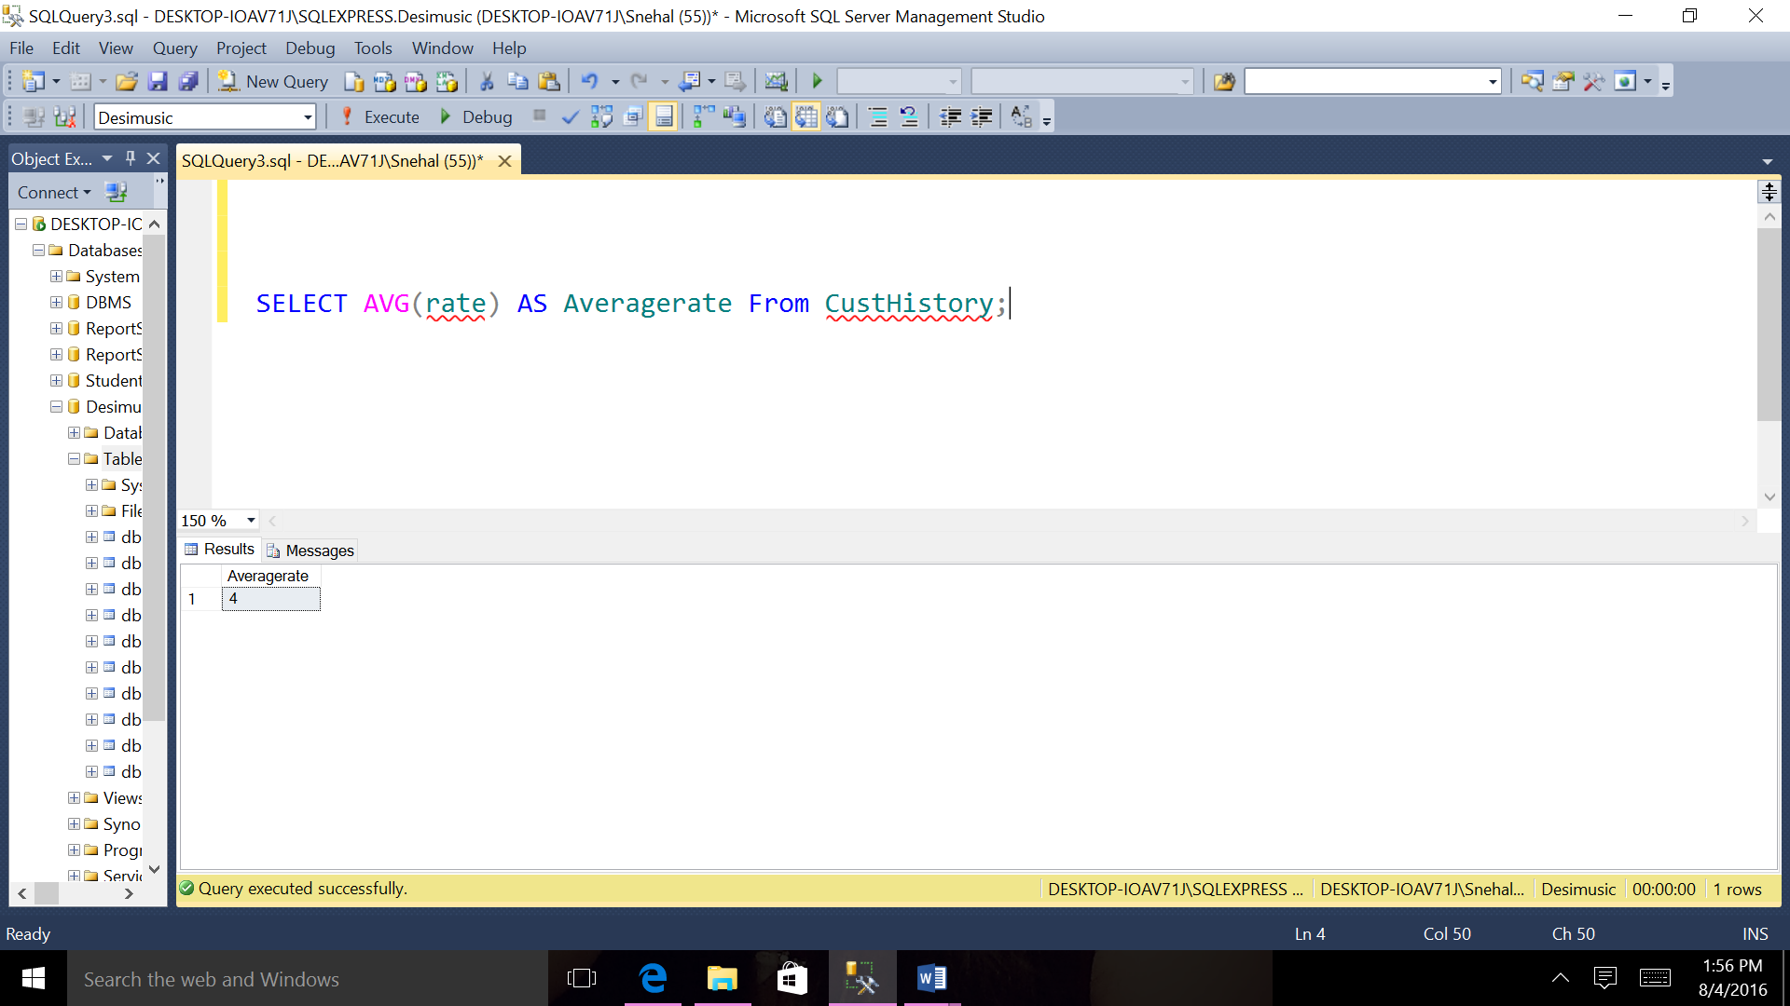

1. **List the order information ordered by date who has state texas.**

SELECT * FROM Ordert WHERE State='TX' ORDER BY OrdDate;

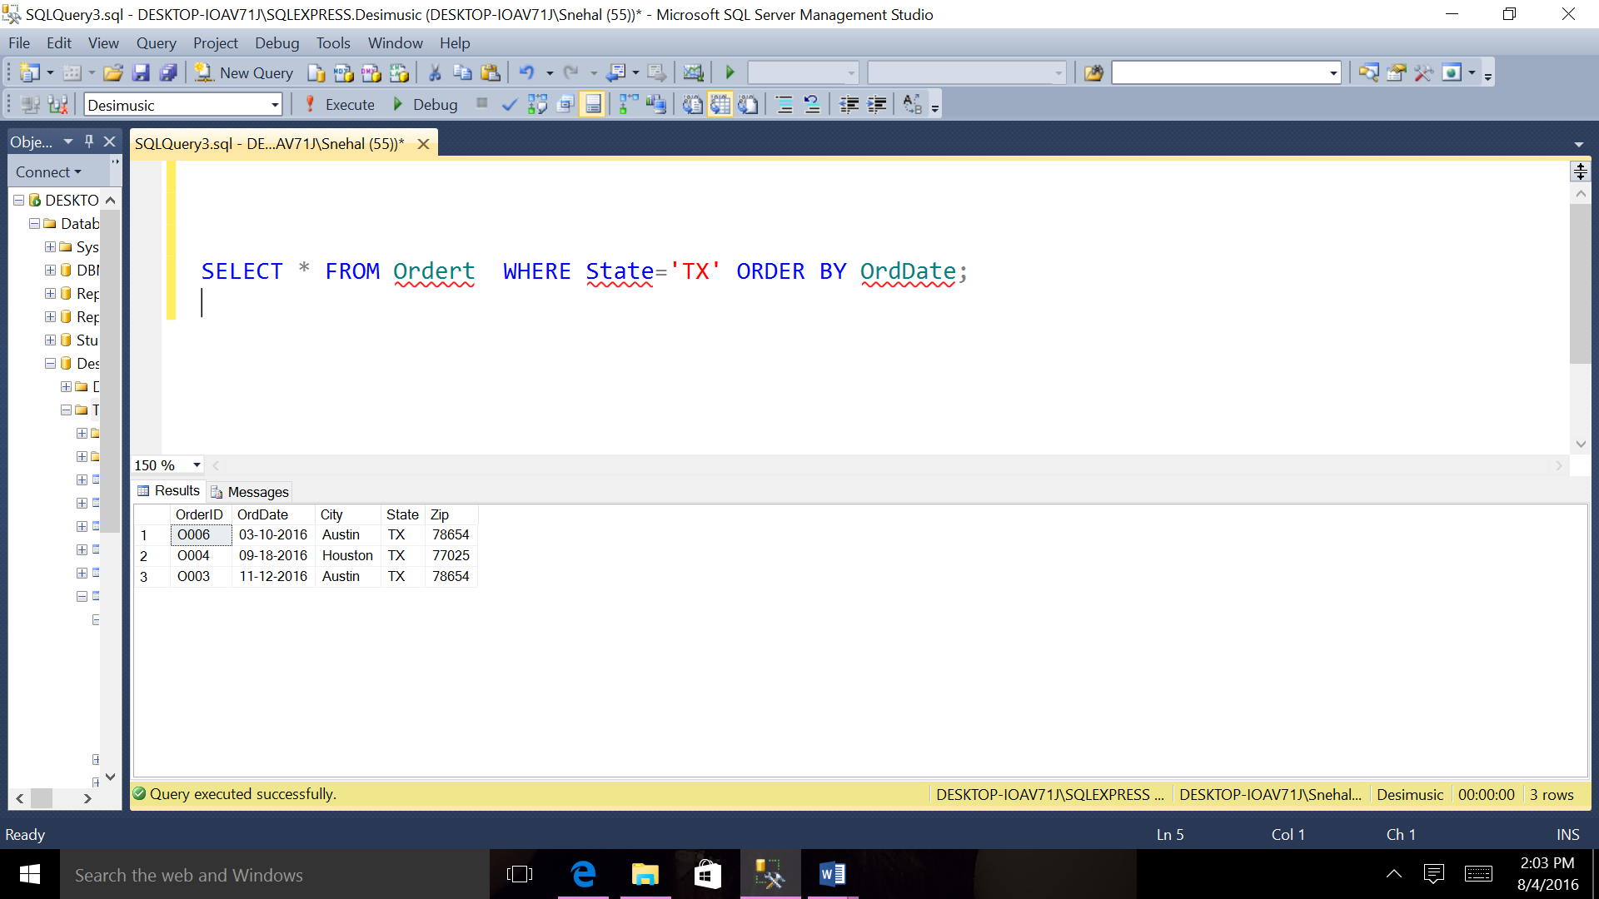

1. **List all the orders’ number which contain product IA003 or IA005**

SELECT OrderID FROM OrderDetail WHERE ProID IN('IA003', 'IA005') GROUP BY OrderID;

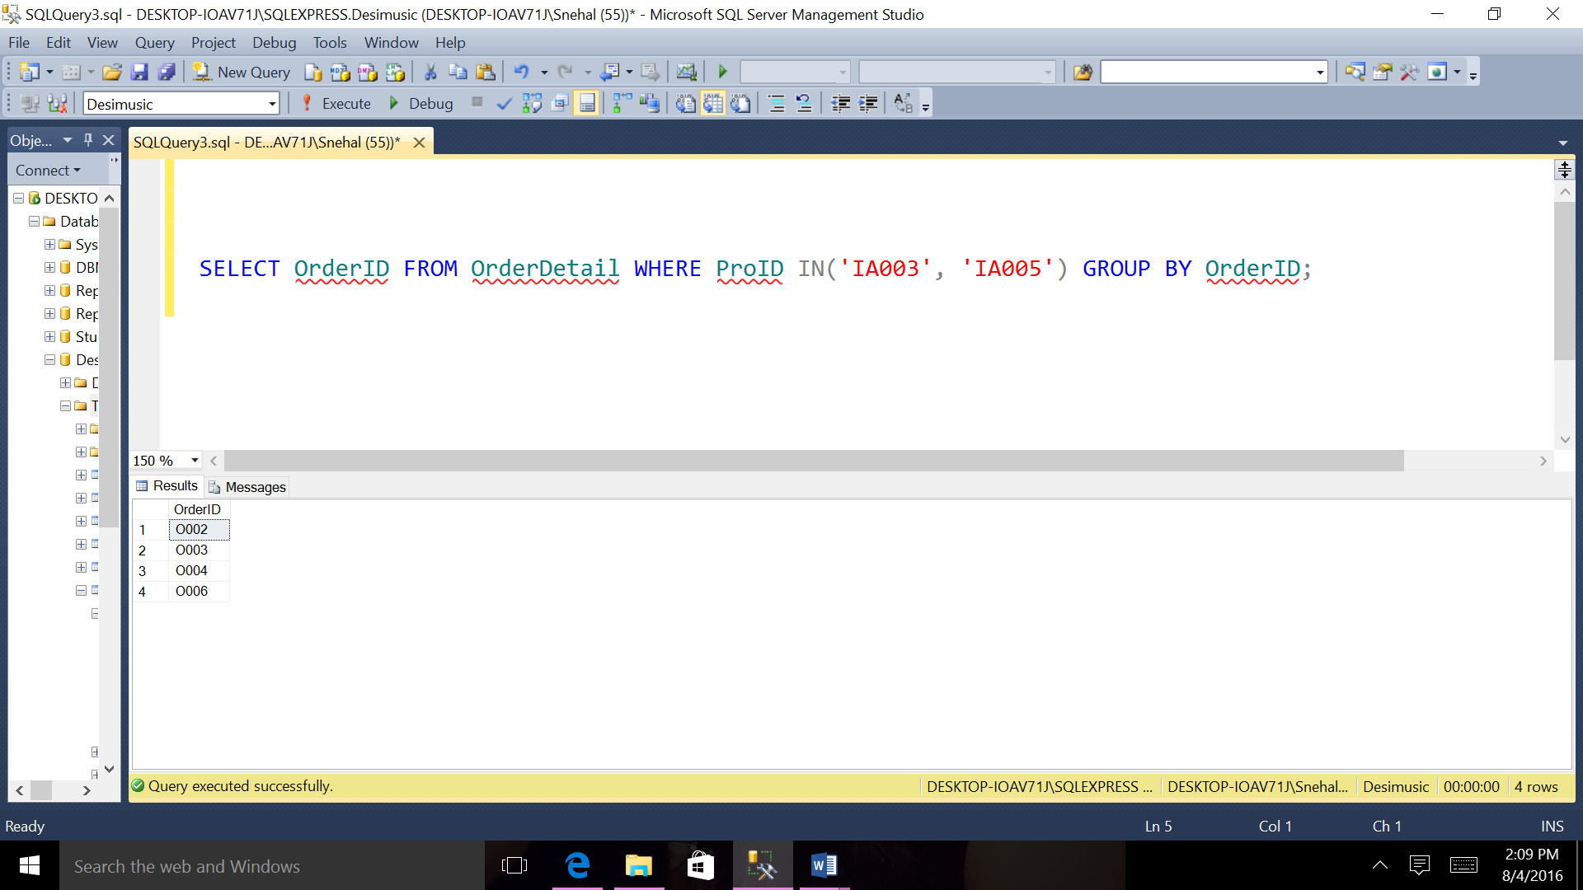

**Chapter 7 Queries with QBE or GUI for RDBMS System Implementation II**

**7.1 The Software, RDBMS and platform used to implement the relational database**

**ORACLE**

Oracle Database (commonly referred to as Oracle RDBMS or simply as Oracle) is an object-relational database management.

**TOOL USED**Oracle SQL Developer is an integrated development environment (IDE) for working with SQL in Oracle databases.

* 1. **Database creation or required commands**

**Create table statements:**

1. **Customer**

CREATE TABLE Customer(CustID VARCHAR(50), FName VARCHAR (50) , LName VARCHAR (50),City VARCHAR (50),State VARCHAR (50),Zip INTEGER,CONSTRAINT PK_cust PRIMARY KEY (CustID));

1. **Employee**

CREATE TABLE Employee(EmpID VARCHAR(50), FName VARCHAR (50), LName VARCHAR(50), Email VARCHAR (50), PhoneNo VARCHAR (50), EnrollDate VARCHAR(20), Salary INTEGER, Degree VARCHAR(50), Position VARCHAR(50), CONSTRAINT PK_emp PRIMARY KEY (EmpID) );

1. **Customer History**

CREATE TABLE CustomerHistory(CustID VARCHAR(50),PurchaseDate VARCHAR(50),Rate INTEGER ,Comment VARCHAR (50), CONSTRAINT PK_CUHI PRIMARY KEY (CustID),CONSTRAINT FK_CUHI FOREIGN KEY (CustID) REFERENCES Customer(CustID) ON DELETE NO ACTION ON UPDATE CASCADE);

1. **Courier Company**

CREATE TABLE CourierCompany (CourID VARCHAR(50),CustID VARCHAR(50),EmpID VARCHAR (50),Destination VARCHAR(50),Price INTEGER,DeliveryDate VARCHAR(50), CONSTRAINT PK_COURI PRIMARY KEY (CourID),CONSTRAINT FK_COUD FOREIGN KEY (CustID) REFERENCES Customer(CustID) ON DELETE NO ACTION ON UPDATE CASCADE,CONSTRAINT FK_COURI FOREIGN KEY (EmpID) REFERENCES Employee(EmpID) ON DELETE NO ACTION ON UPDATE CASCADE);

1. **Order**

CREATE TABLE Ordert (OrderID VARCHAR(50),CustID VARCHAR(50),EmpID VARCHAR(50), Name VARCHAR (50), OrdDate VARCHAR (50), City VARCHAR (50) , State VARCHAR (50),Zip INTEGER,CONSTRAINT PK_OR PRIMARY KEY (OrderID), CONSTRAINT FK_OR FOREIGN KEY (CustID) REFERENCES Customer(CustID) ) ON DELETE NO ACTION ON UPDATE CASCADE, CONSTRAINT FK_ORD FOREIGN KEY (EmpID) REFERENCES Employee(EmpID) ) ON DELETE NO ACTION ON UPDATE CASCADE);

1. **Product**

CREATE TABLE Product(ProID VARCHAR(50),ProDate VARCHAR (50),Amount VARCHAR(50),Stock INTEGER,CONSTRAINT PK_PRO PRIMARY KEY (ProID));

1. **OrderDetail**

CREATE TABLE OrderDetail(OrDetNo VARCHAR (20),OrderID VARCHAR(50),ProID VARCHAR(50),CourID VARCHAR(50), Quantity INTEGER, DeliveryFee INTEGER, TotalPrice INTEGER, ArrivalDate VARCHAR (50),CONSTRAINT PK_ORD PRIMARY KEY (OrDetNo,OrderID, ProID,CourID),CONSTRAINT FK_ORD1 FOREIGN KEY (OrderID) REFERENCES Ordert(OrderID) ON DELETE NO ACTION ON UPDATE CASCADE,CONSTRAINT FK_ORDTAI FOREIGN KEY (ProID) REFERENCES Product(ProID) ON DELETE NO ACTION ON UPDATE CASCADE,CONSTRAINT FK_OR1 FOREIGN KEY (CourID) REFERENCES CourierCompany(CourID) ON DELETE NO ACTION ON UPDATE CASCADE);

1. **Supplier**

CREATE TABLE Supplier(SupID VARCHAR(50),SupName VARCHAR (50), Phone VARCHAR (50), email VARCHAR (50),Destination VARCHAR (100),CONSTRAINT PK_Supp PRIMARY KEY (SupID));

1. **Product Detail**

CREATE TABLE ProductDetail(ProID VARCHAR(50),SupID VARCHAR(50),Description VARCHAR (50),Amount INTEGER,Stock INTEGER,PROTYPE VARCHAR(50), CONSTRAINT PK_Prod PRIMARY KEY (ProID, SupID),CONSTRAINT FK_PROD FOREIGN KEY (ProID) REFERENCES Product(ProID) ) ON DELETE NO ACTION ON UPDATE CASCADE, CONSTRAINT FK_PRODA FOREIGN KEY (SupID) REFERENCES Supplier(SupID) ON DELETE NO ACTION ON UPDATE CASCADE);

1. **Supplier Detail**

CREATE TABLE SupplyDetail(SupID VARCHAR(50),EmpID VARCHAR(50),ProID VARCHAR(50), email VARCHAR(50),Phone VARCHAR(50),CONSTRAINT PK_sup PRIMARY KEY (SupID, ProID),CONSTRAINT FK_sup FOREIGN KEY (SupID) REFERENCES Supplier(SupID) ON DELETE NO ACTION ON UPDATE CASCADE,CONSTRAINT FK_supI FOREIGN KEY (EmpID) REFERENCES Employee(EmpID) ON DELETE NO ACTION ON UPDATE CASCADE,CONSTRAINT FK_supa FOREIGN KEY (ProID) REFERENCES Product(ProID) ON DELETE NO ACTION ON UPDATE CASCADE);

**Insert table statements:**

1. **Customer**

INSERT INTO Customer (CustID , FName , LName ,City ,State ,Zip )VALUES ('CS45', 'John', 'Peters', 'San Jose', 'CA', '98076');

INSERT INTO Customer (CustID , FName , LName ,City ,State ,Zip)VALUES ('CS23', 'Tom', 'Edwards', 'New York', 'NY', '65890');

INSERT INTO Customer (CustID , FName , LName ,City ,State ,Zip)VALUES ('CS12', 'Ella', 'Jiang', 'Houston', 'TX', '77025');

INSERT INTO Customer (CustID , FName , LName ,City ,State ,Zip)VALUES ('CS10', 'Ann', 'Watsaon', 'Austin', 'TX', '78654');

1. **Customer History**

INSERT INTO CustomerHistory(CustID ,PurchaseDate ,Rate ,Comment) VALUES ('CS45', '09-12-2015', 5.0, 'Very good');

INSERT INTO CustomerHistory(CustID ,PurchaseDate ,Rate ,Comment)VALUES ('CS23', '09-11-2015', 4.5, 'good');

INSERT INTO CustomerHistory(CustID ,PurchaseDate ,Rate ,Comment)VALUES ('CS10', '09-10-2015', 4.5, 'good');

INSERT INTO CustomerHistory(CustID ,PurchaseDate ,Rate ,Comment)VALUES ('CS12', '09-18-2015', 5.0, 'Very good');

1. **Employee**

INSERT INTO Employee (EmpID , FName , LName, Email , PhoneNo , EnrollDate , Salary , Degree , Position)VALUES ('CR76', 'Sne', 'Dose', 'Sne23@gmail.com', '567-098-4567', '05-12-2003', 12000, 'master',' Manager');

INSERT INTO Employee (EmpID , FName , LName, Email , PhoneNo , EnrollDate , Salary , Degree , Position)VALUES ('CR89', 'Ank', 'Bread', 'Anks@gmail.com', '786-098-5676', '04-18-2012', 100000, 'bachelor', 'Coordinator');

INSERT INTO Employee (EmpID , FName , LName, Email , PhoneNo , EnrollDate , Salary , Degree , Position)VALUES ('CR09', 'George', 'Peters', 'g.peters@yahoo.com', '777-098-6789', '03-20-2011', 30000, 'master', ' Coordinator');

INSERT INTO Employee (EmpID , FName , LName, Email , PhoneNo , EnrollDate , Salary , Degree , Position)VALUES ('CR32', 'Sam', 'Jose', 'sam23@gmail.com', '123-908-4678', '07-18-2011', 20000, 'Master', 'Administrator');

INSERT INTO Employee (EmpID , FName , LName, Email , PhoneNo , EnrollDate , Salary , Degree , Position)VALUES ('CR1', 'Ann', 'Jose', 'Anni8@yahoo.com', '467-908-4678', '07-18-2014', 10000, 'bachelor', 'Coordinator');

INSERT INTO Employee (EmpID , FName , LName, Email , PhoneNo , EnrollDate , Salary , Degree , Position)VALUES ('CR2', 'Robert', 'Blank', 'blank@yahoo.com', '789-098-7654', '07-20-20145', 4000, 'master', 'supply coordinator');

1. **Courier Company**

INSERT INTO CourierCompany (CourID ,CustID ,EmpID ,Destination ,Price DeliveryDate) VALUES ('CO10', 'CS45', 'CR2', 'New York',200,'8-12-2016');

INSERT INTO CourierCompany (CourID ,CustID ,EmpID ,Destination ,Price , DeliveryDate)

VALUES ('CO11', 'CS12', 'CR1', 'New York',300, '5-3-2016');

INSERT INTO CourierCompany (CourID ,CustID ,EmpID ,Destination ,Price , DeliveryDate)

VALUES ('CO12', 'CS10', 'CR76','Houston', 150,'4-10-2016');

INSERT INTO CourierCompany (CourID ,CustID ,EmpID ,Destination ,Price , DeliveryDate)

VALUES ('CO13', 'CS23', 'CR89', 'Delaware',500, '10-5-2016');

1. **Order**

INSERT INTO Ordert(OrderID ,CustID,EmpID,Name,OrdDate ,City, State,Zip)VALUES ('O002', 'CS45','CR2','SAM','05-12-2016', 'Delaware', 'DS', '98076');

INSERT INTO Ordert (OrderID ,CustID,EmpID,Name,OrdDate ,City, State,Zip)VALUES ('O001' , 'CS23','CR1','SSs' ,'05-10-2016', 'New York', 'NY', '65890');

INSERT INTO Ordert (OrderID ,CustID,EmpID,Name,OrdDate ,City, State,Zip) VALUES ('O004', 'CS12','CR76','ANK','09-18-2016', 'Houston', 'TX', '77025');

INSERT INTO Ordert (OrderID ,CustID,EmpID,Name,OrdDate ,City, State,Zip)VALUES ('O003', 'CS10','CR89','SAMI','11-12-2016', 'Austin', 'TX', '78654');

1. **Product**

INSERT INTO Product (ProID ,Date ,Amount , Stock) VALUES ('IA001','8/7/2016', 500, 5);

INSERT INTO Product (ProID ,Date ,Amount, Stock)VALUES ('IA002','3/5/2016' , 200, 10);

INSERT INTO Product (ProID ,Date ,Amount , Stock) VALUES ('IA004','3/3/2016', 300, 6);

INSERT INTO Product (ProID ,Date ,Amount , Stock)VALUES ('IA005','5/4/2016', 250, 5);

INSERT INTO Product (ProID ,Date ,Amount , Stock)VALUES ('IA003','6/7/2016', 200,20);

INSERT INTO Product (ProID ,Date ,Amount, Stock)VALUES ('IA006','4/3/2016', 150, 12);

INSERT INTO Product (ProID ,Date ,Amount , Stock)VALUES ('IA007','2/14/2016', 600,8);

INSERT INTO Product (ProID ,Date ,Amount , Stock)VALUES ('IA008','5/24/2016', 600,15);

1. **OrderDetail**

INSERT INTO OrderDetail(OrDetNo ,OrderID ,ProID,CourID , Quantity , DeliveryFee ,TotalPrice , ArrivalDate)VALUES ('D001', 'O002', 'IA003', 'CO12', 2, 10, 50,'09-16-2016');

INSERT INTO OrderDetail(OrDetNo ,OrderID ,ProID,CourID , Quantity , DeliveryFee ,TotalPrice , ArrivalDate) VALUES ('D003', 'O001', 'IA002', 'CO10', 5,15,150, '09-15-2016');

INSERT INTO OrderDetail(OrDetNo ,OrderID ,ProID,CourID , Quantity , DeliveryFee ,TotalPrice , ArrivalDate) VALUES ('D004', 'O004', 'IA005', 'CO11', 3,10,200, '09-13-2016');

INSERT INTO OrderDetail(OrDetNo ,OrderID ,ProID,CourID , Quantity , DeliveryFee ,TotalPrice , ArrivalDate)VALUES ('D006', 'O004', 'IA002', 'CO12', 2, 10, 50, '09-21-2016');

INSERT INTO OrderDetail(OrDetNo ,OrderID ,ProID,CourID , Quantity , DeliveryFee ,TotalPrice , ArrivalDate)VALUES ('D005', 'O003', 'IA001', 'CO11', 3,10,200, '09-15-2016');

INSERT INTO OrderDetail(OrDetNo ,OrderID ,ProID,CourID , Quantity , DeliveryFee ,TotalPrice , ArrivalDate)VALUES ('D008', 'O002', 'IA004', 'CO10', 2, 10, 50, '09-15-2016');

INSERT INTO OrderDetail(OrDetNo ,OrderID ,ProID,CourID , Quantity , DeliveryFee ,TotalPrice , ArrivalDate)VALUES ('D007', 'O003', 'IA005', 'CO11', 3,10,200, '09-15-2016');

INSERT INTO OrderDetail(OrDetNo ,OrderID ,ProID,CourID , Quantity , DeliveryFee ,TotalPrice , ArrivalDate)VALUES ('D010', 'O004', 'IA002', 'CO10', 2, 10, 50, '09-15-2016');

1. **Supplier**

INSERT INTO Supplier (SupID ,SupName ,Phone , email ,Destination) VALUES ('S001', 'Sam', 'sam@hotmail.com', '239-976-3688','Austin');

INSERT INTO Supplier (SupID ,SupName ,Phone , email, Destination) VALUES ('S002','Sandi', 'sandi@yahoo.com', '249-976-3684','London');

INSERT INTO Supplier (SupID ,SupName ,Phone , email ,Destination) VALUES ('S003','Anks', 'anks@gmail.com', '908-567-9087','Houston');

INSERT INTO Supplier (SupID ,SupName ,Phone , email ,Destination) VALUES ('S004', 'Anshu', 'anshu@gmail.com', '908-567-9087','San Antonio');

1. **Product Detail**

INSERT INTO ProductDetail(ProID ,SupID,Description ,Amount ,Stock, PROTYPE) VALUES ('IA001','S001','INDIAN CLASSIC MUSIC', 500,5, 'CD');

INSERT INTO ProductDetail (ProID ,SupID,Description ,Amount ,Stock, PROTYPE)VALUES ('IA002','S002','GANASANGEET' ,10, 200, 'CD');

INSERT INTO ProductDetail (ProID ,SupID,Description ,Amount ,Stock, PROTYPE) VALUES ('IA004','S003','MARATHI LAVANI', 300, 50,'DVD');

INSERT INTO ProductDetail (ProID ,SupID,Description ,Amount ,Stock, PROTYPE)VALUES ('IA005','S004','MUSIC OF RAJASTAN', 250,30, 'CD');

INSERT INTO ProductDetail (ProID ,SupID,Description ,Amount ,Stock, PROTYPE)VALUES ('IA003','S002','DANDIYA', 200, 80,'CD');

INSERT INTO ProductDetail (ProID ,SupID,Description ,Amount ,Stock, PROTYPE)VALUES ('IA006','S004','GOD SONGS', 150,50, 'DVD');

INSERT INTO ProductDetail (ProID ,SupID,Description ,Amount ,Stock, PROTYPE)VALUES ('IA007','S001','FOLK MUSIC', 600,110, 'CD');

INSERT INTO ProductDetail (ProID ,SupID,Description ,Amount ,Stock, PROTYPE)VALUES ('IA008','S003','BOLLYWOOD', 600,120, 'CD');

1. **Supplier Detail**

INSERT INTO SupplyDetail (SupID, ProID, EmpID,email,Phone)VALUES ('S001', 'IA001', 'CR76','ssg44@gmail.com','512-665-2072');

INSERT INTO SupplyDetail (SupID, ProID, EmpID,email,Phone)VALUES ('S003', 'IA003', 'CR1','anks24@gmail.com','512-665-2123');

INSERT INTO SupplyDetail (SupID, ProID, EmpID,email,Phone)VALUES ('S002', 'IA002', 'CR1','sam44@gmail.com','512-665-2432');

INSERT INTO SupplyDetail (SupID, ProID, EmpID,email,Phone)VALUES ('S001', 'IA004', 'CR1','praj44@gmail.com','512-665-8123');

INSERT INTO SupplyDetail (SupID, ProID, EmpID,email,Phone)VALUES ('S004', 'IA001', 'CR2','suggu@gmail.com','512-665-2333');

INSERT INTO SupplyDetail (SupID, ProID, EmpID,email,Phone)VALUES ('S003', 'IA004', 'CR32','wea3@gmail.com','512-665-2909');

INSERT INTO SupplyDetail (SupID, ProID, EmpID,email,Phone)VALUES ('S002', 'IA008', 'CR32','sami44@gmail.com','512-665-2056');

**7.3 Fifteen Nontrivial queries in English with some complexity**

1. Find employee who has employee Id CR76 from Courier Company
2. list all the cities of the couriers( no repeat)
3. List the products whose stock is below 100.
4. List Customers’ numbers and names who is in Texas
5. List from order detail who has order detail number O002 and product Id IA002.
6. Order the products by their amount By descending order.
7. List all the employees’ numbers and salaries ordered by salaries
8. Order the products by their product Id By Ascending order.
9. Select OrderDetail for all Order where quantity are greater than 2.
10. Select ProductDetail for all Product where amount is greater than 200.
11. List all the employees’ numbers and the number of the supply projects they are in charge of this.
12. List the product numbers whose stocks are greather than 50 or the purchase price are less than 100.
13. Calculate average rate for all customer.
14. List the order information ordered by date who has state texas.
15. List all the orders’ number which contain product IA003 or IA005

**7.4 Required Screens or Programs for the implementation of queries and output for each query**

1. **Find employee who has employee Id CR76 from Courier Company.**

SELECT * FROM CourierCompany WHERE EmpId='CR76';

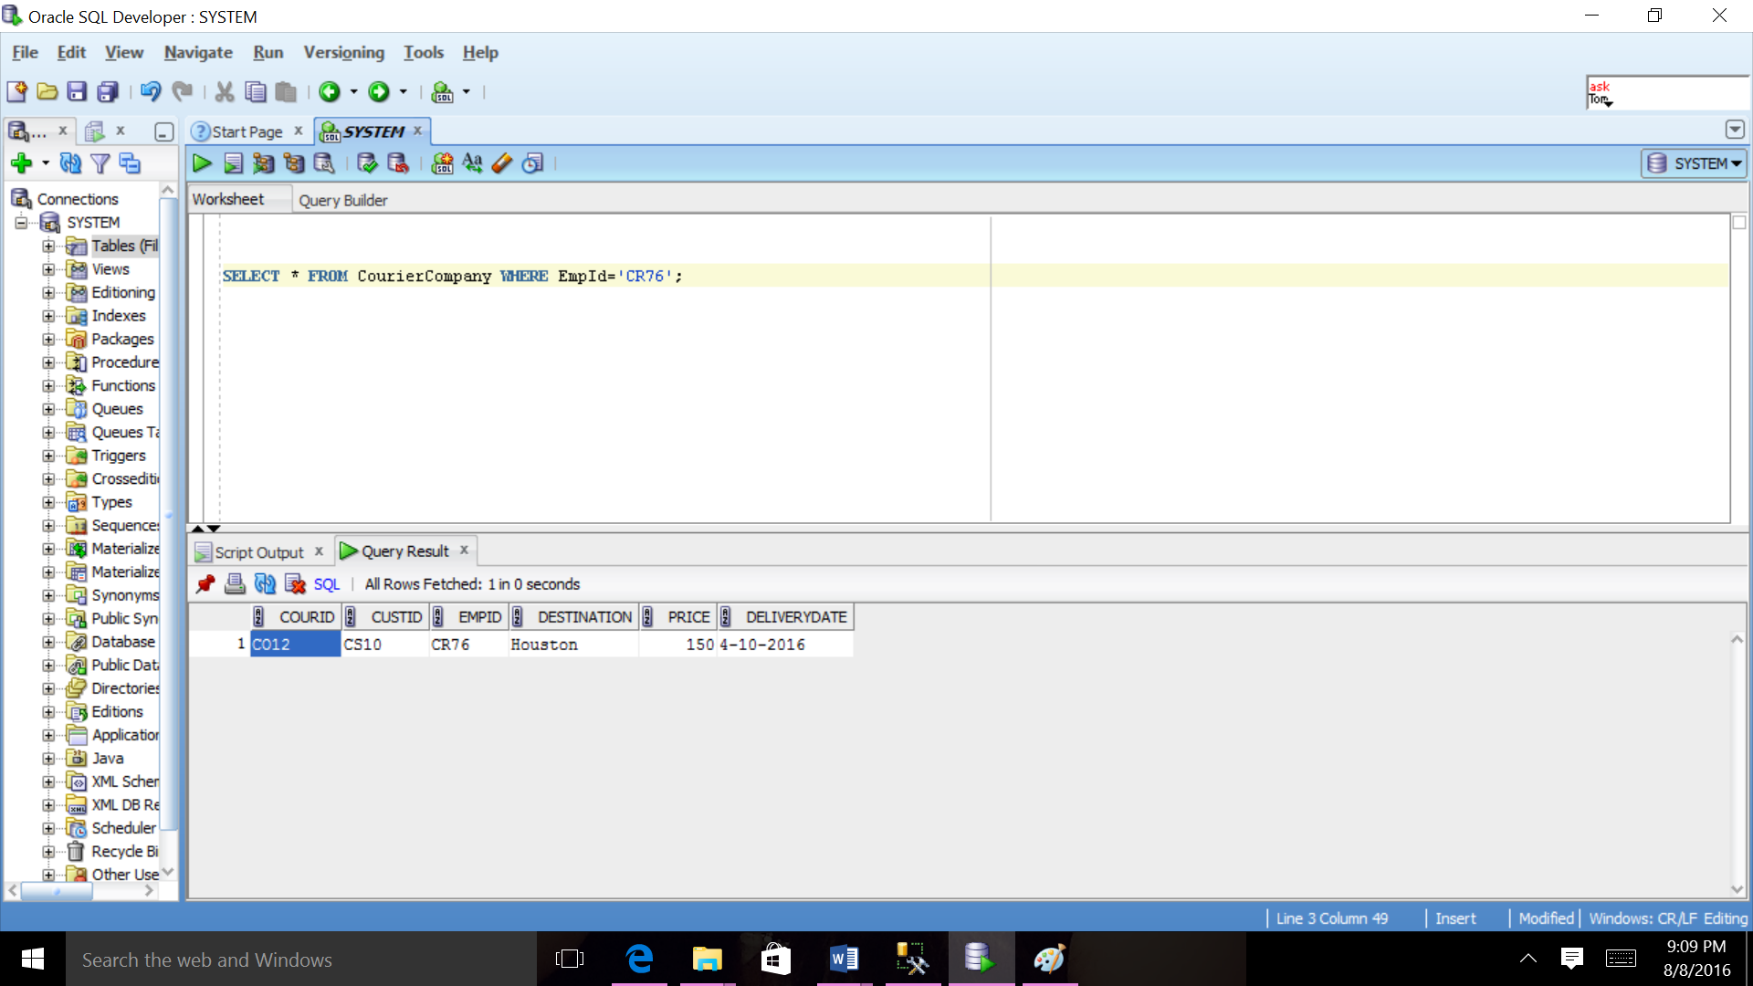

1. **List all the cities of the couriers( no repeat)**

SELECT City FROM Customer GROUP BY City;

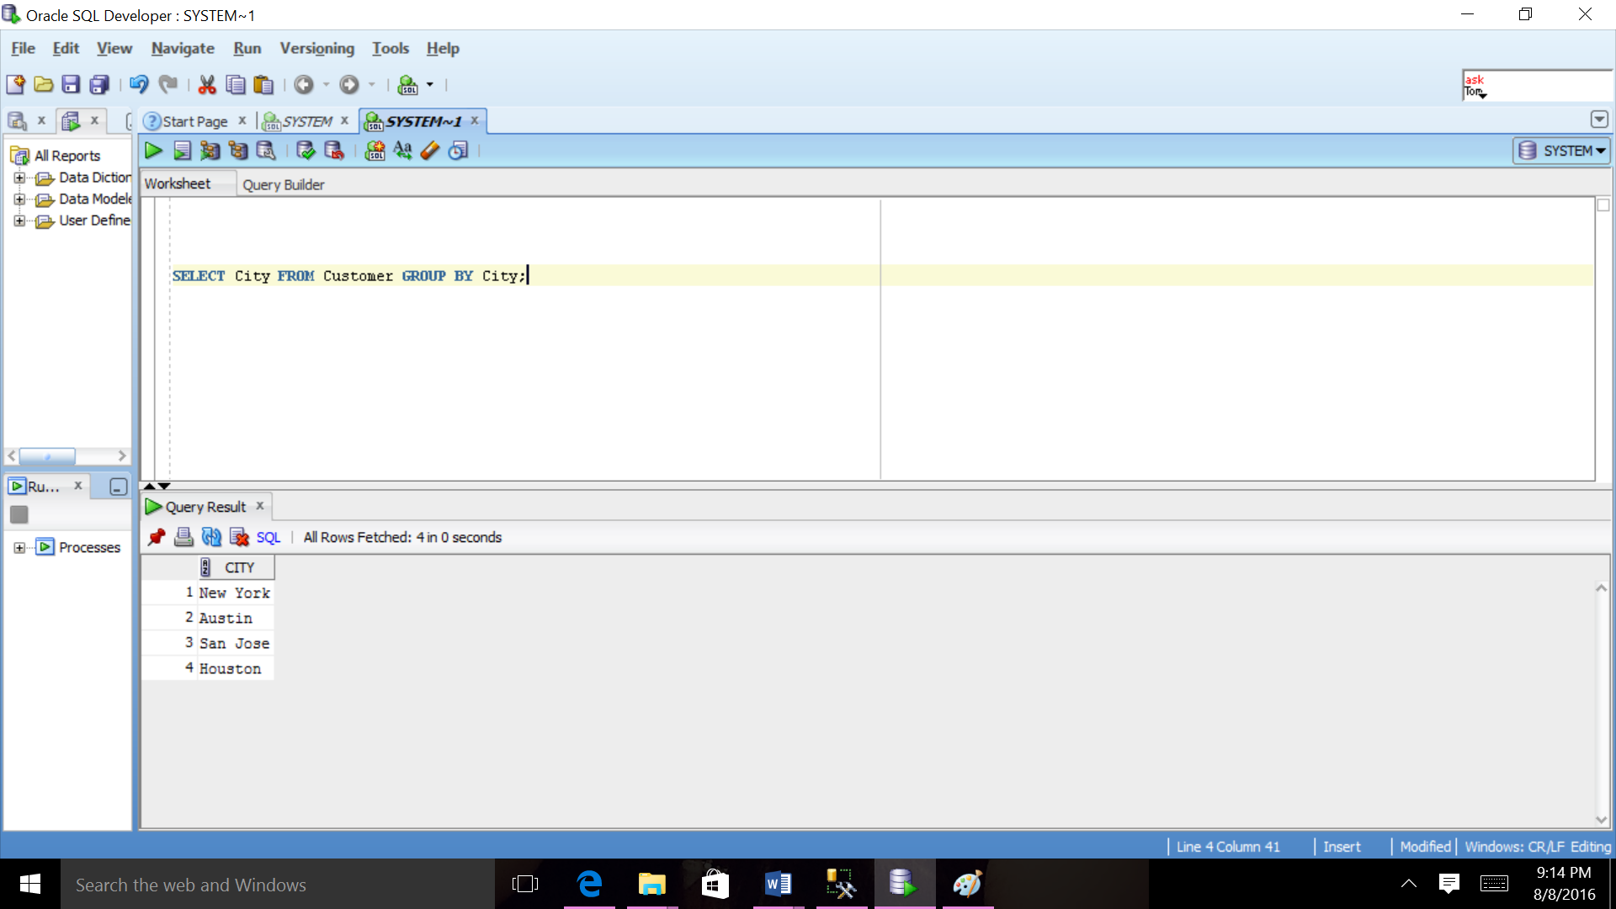

1. **List the products whose stock is below 100.**

SELECT ProID, Stock FROM ProductDetail

WHERE Stock < 100;

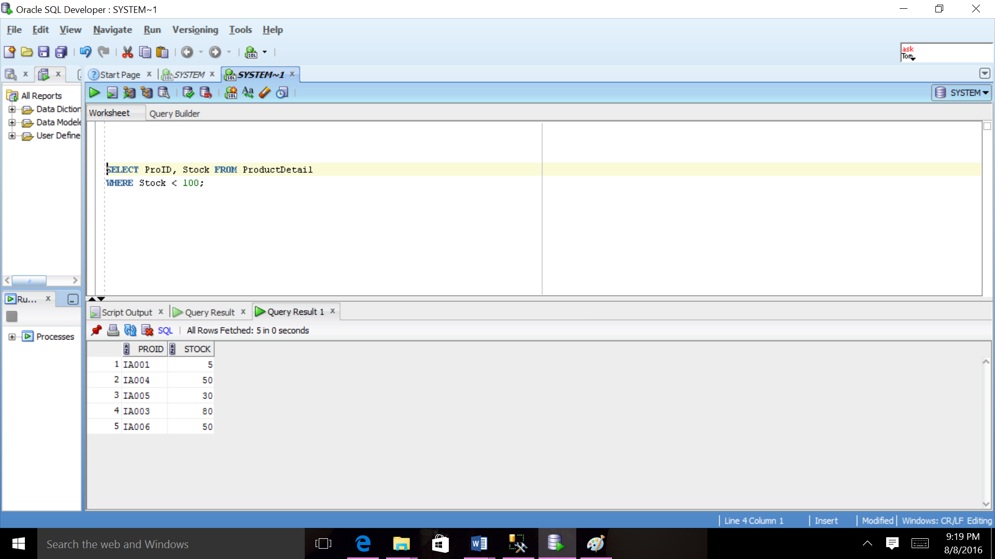

1. **List Customers’ numbers and names who is in Texas**

SELECT CustID, FName, LName FROM Customer WHERE State = 'TX';

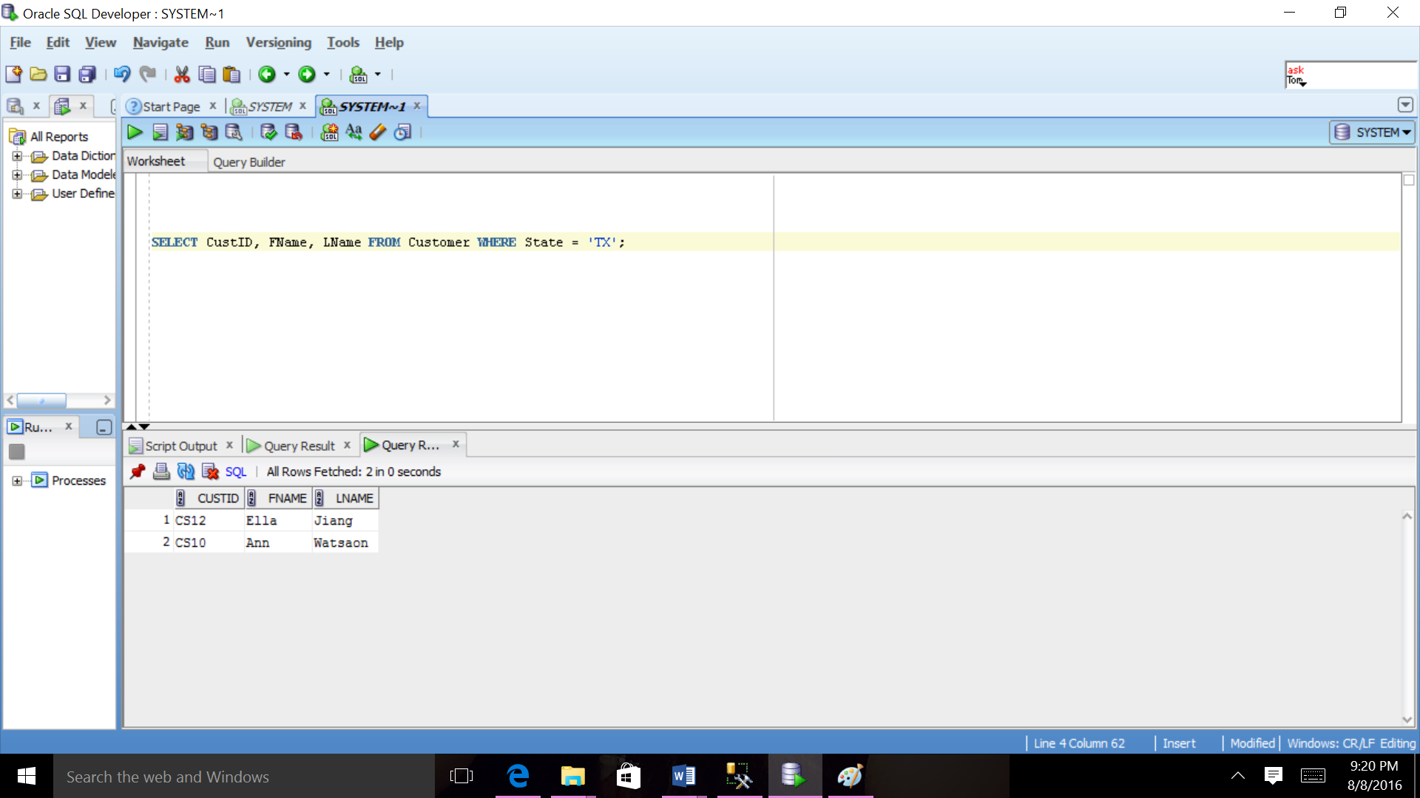

1. **List from order detail who has order detail number O002 and product Id IA002.**

SELECT * FROM OrderDetail WHERE OrDetNo='D002' AND ProID='IA002';

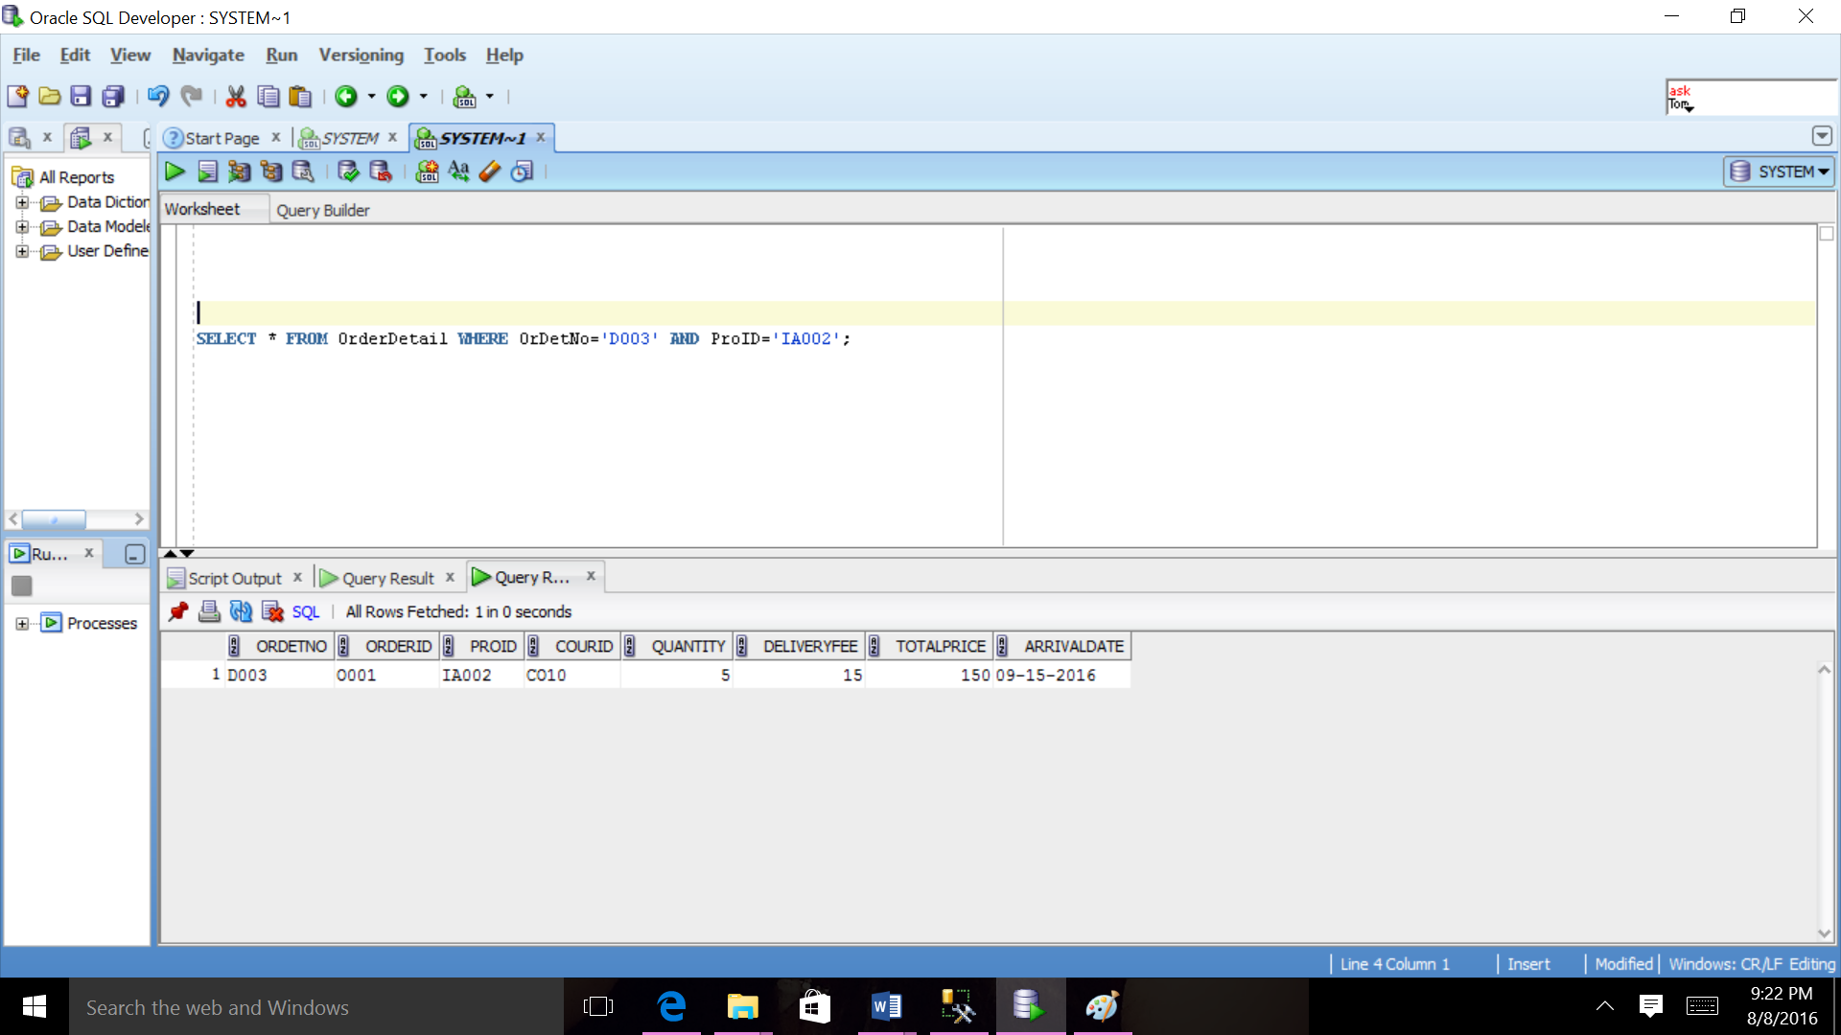

1. Order the products by their Amount By descending order.

SELECT * FROM Product ORDER BY Amount DESC;

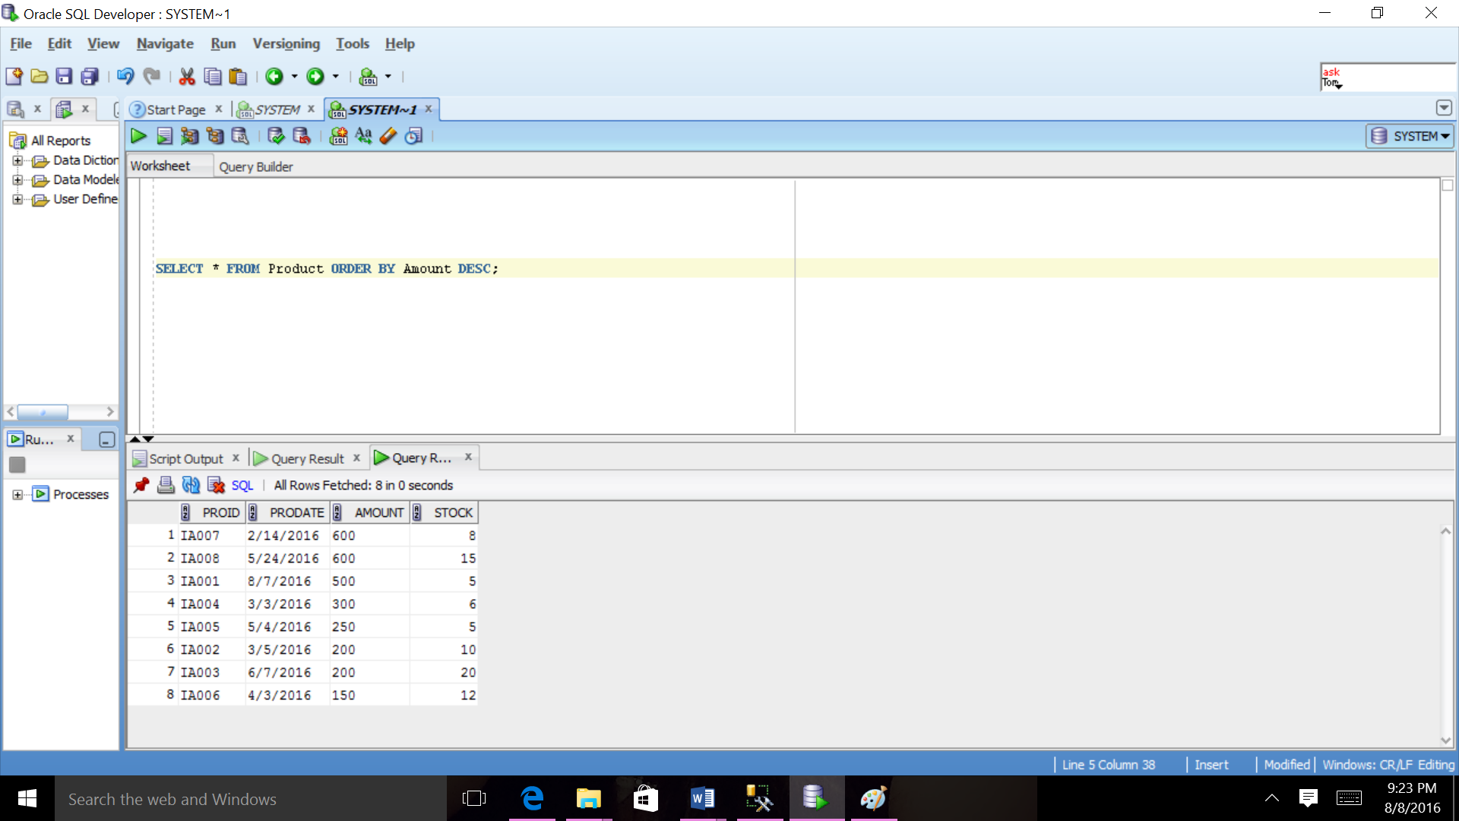

1. **List all the employees’ numbers and salaries ordered by salaries**

SELECT EmpID, salary FROM Employee ORDER BY salary;

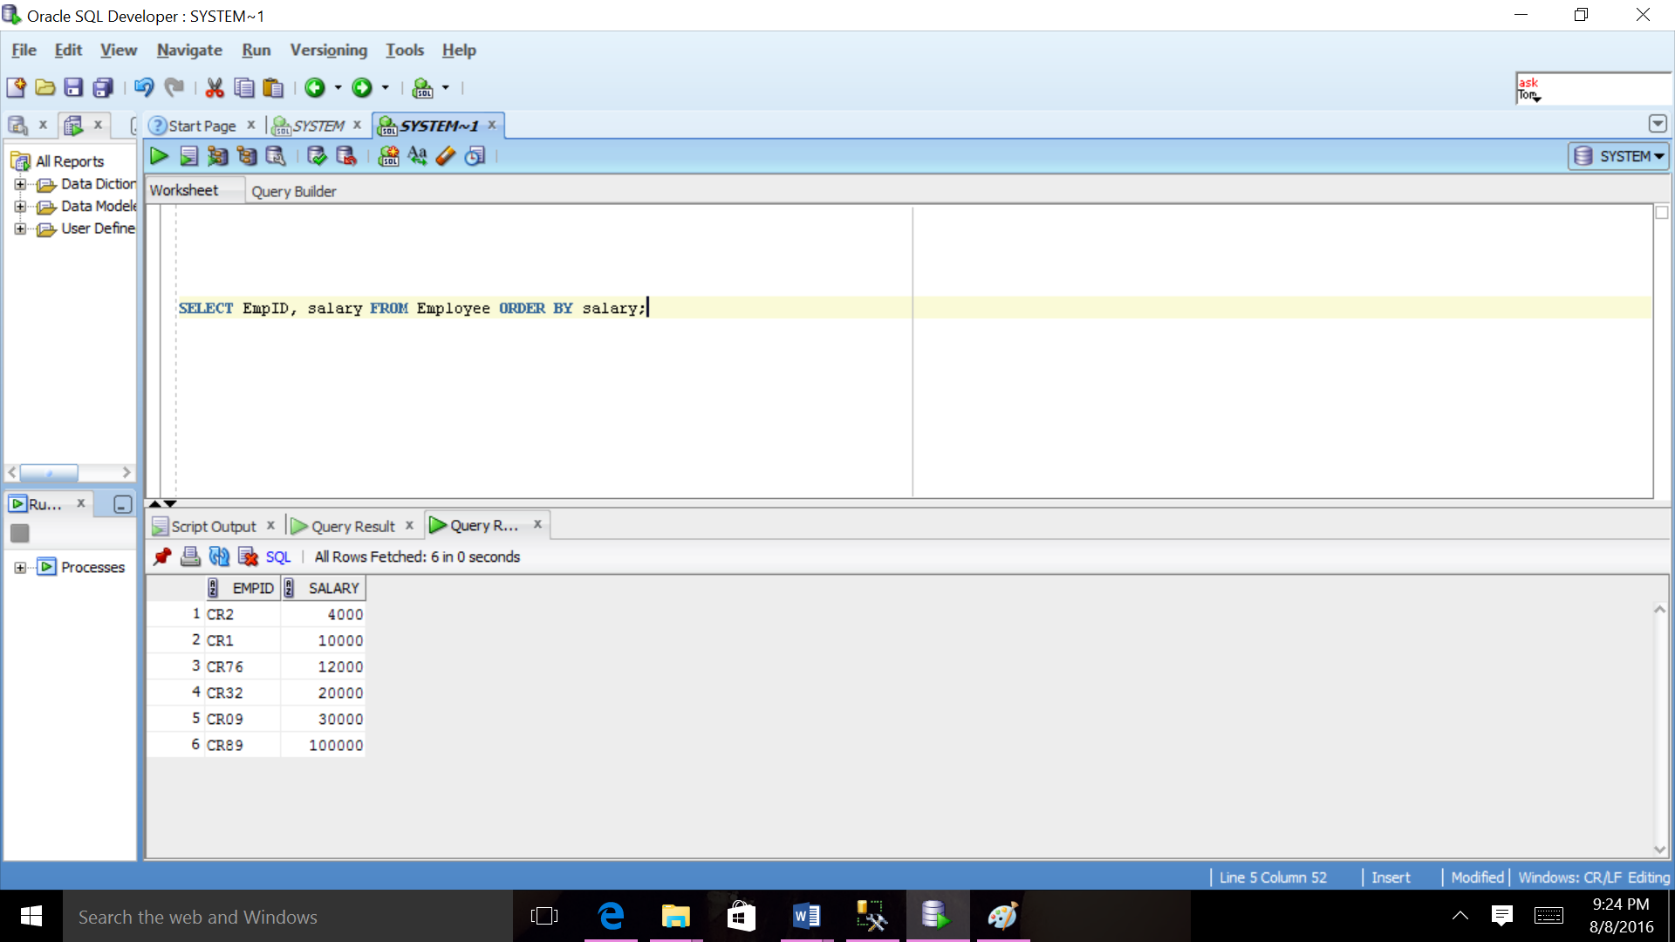

1. Order the products by their product Id By Ascending order.

SELECT * FROM Product ORDER BY ProID ASC;

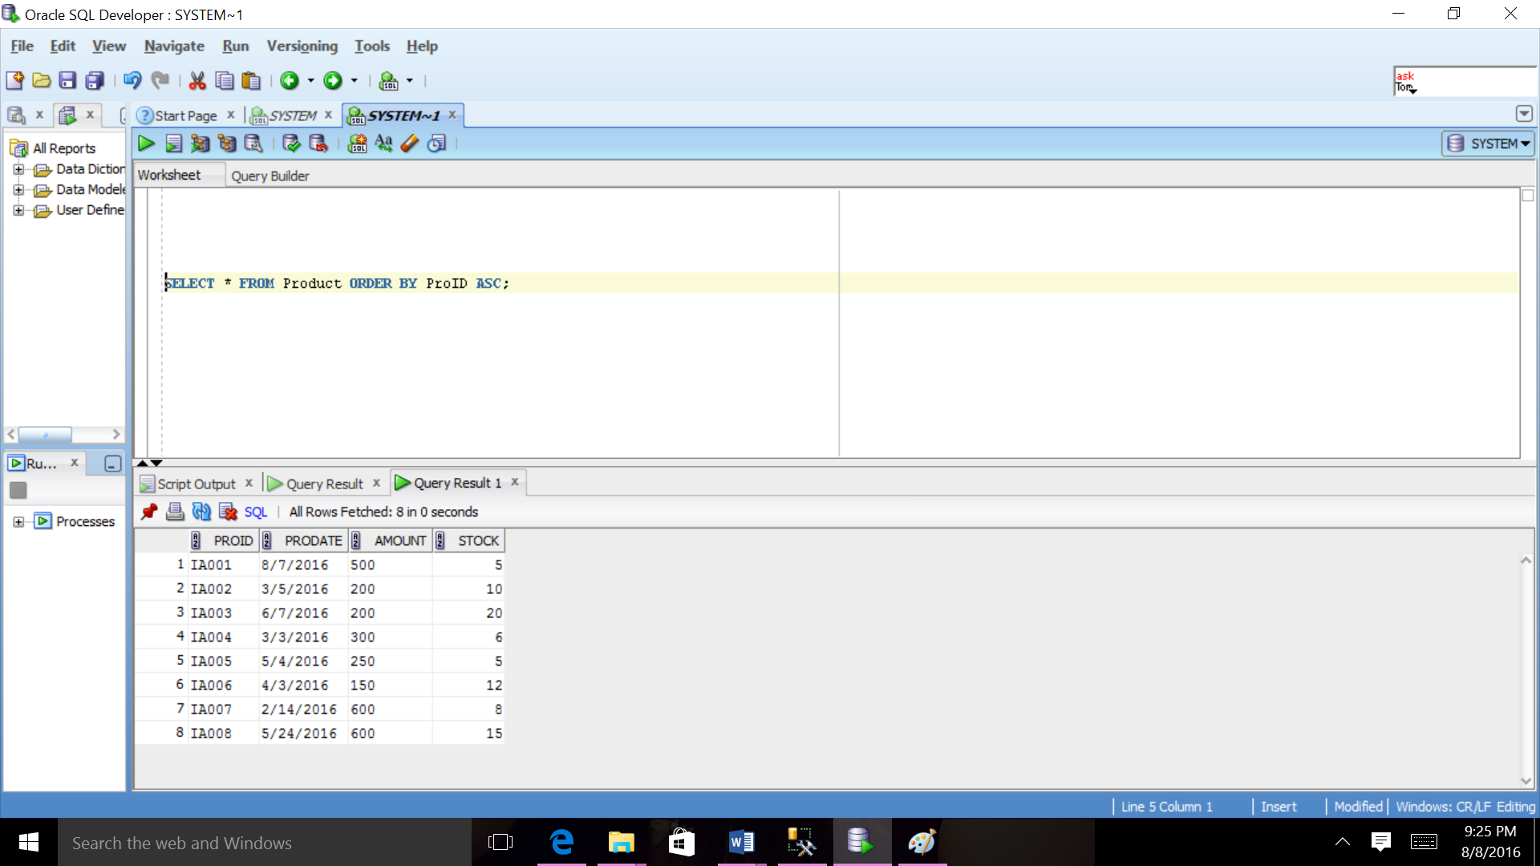

1. **Select OrderDetail for all Order where quantity are greater than 2.**

SELECT * FROM OrderDetail NATURAL JOIN Ordert WHERE Quantity>2;

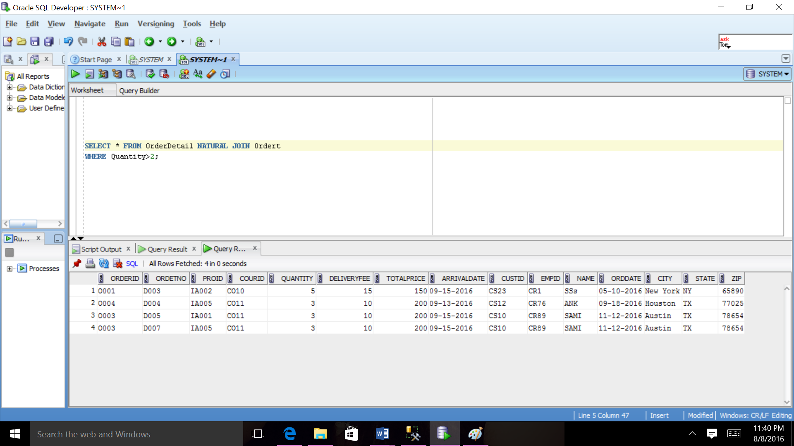

1. **Select ProductDetail for all Product where price is greater than 200.**

SELECT * FROM ProductDetail NATURAL JOIN Product WHERE Amount>200;

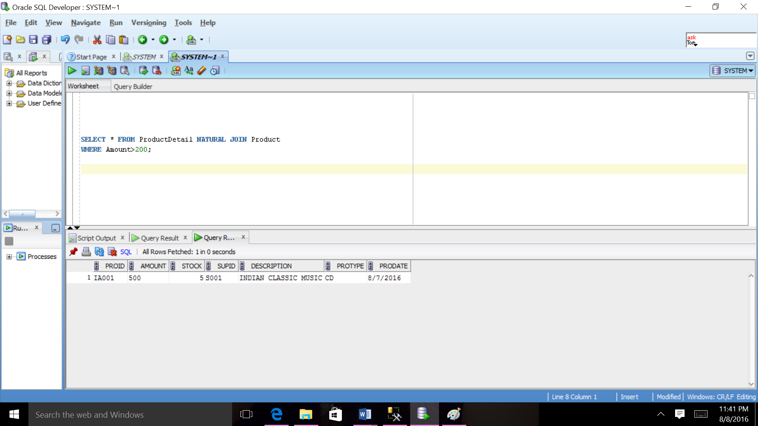

1. **List all the employees’ numbers and the number of the supply projects they are in charge of this.**

SELECT EmpID, COUNT(*)AS Mycount FROM SupplyDetail GROUP BY EmpID;

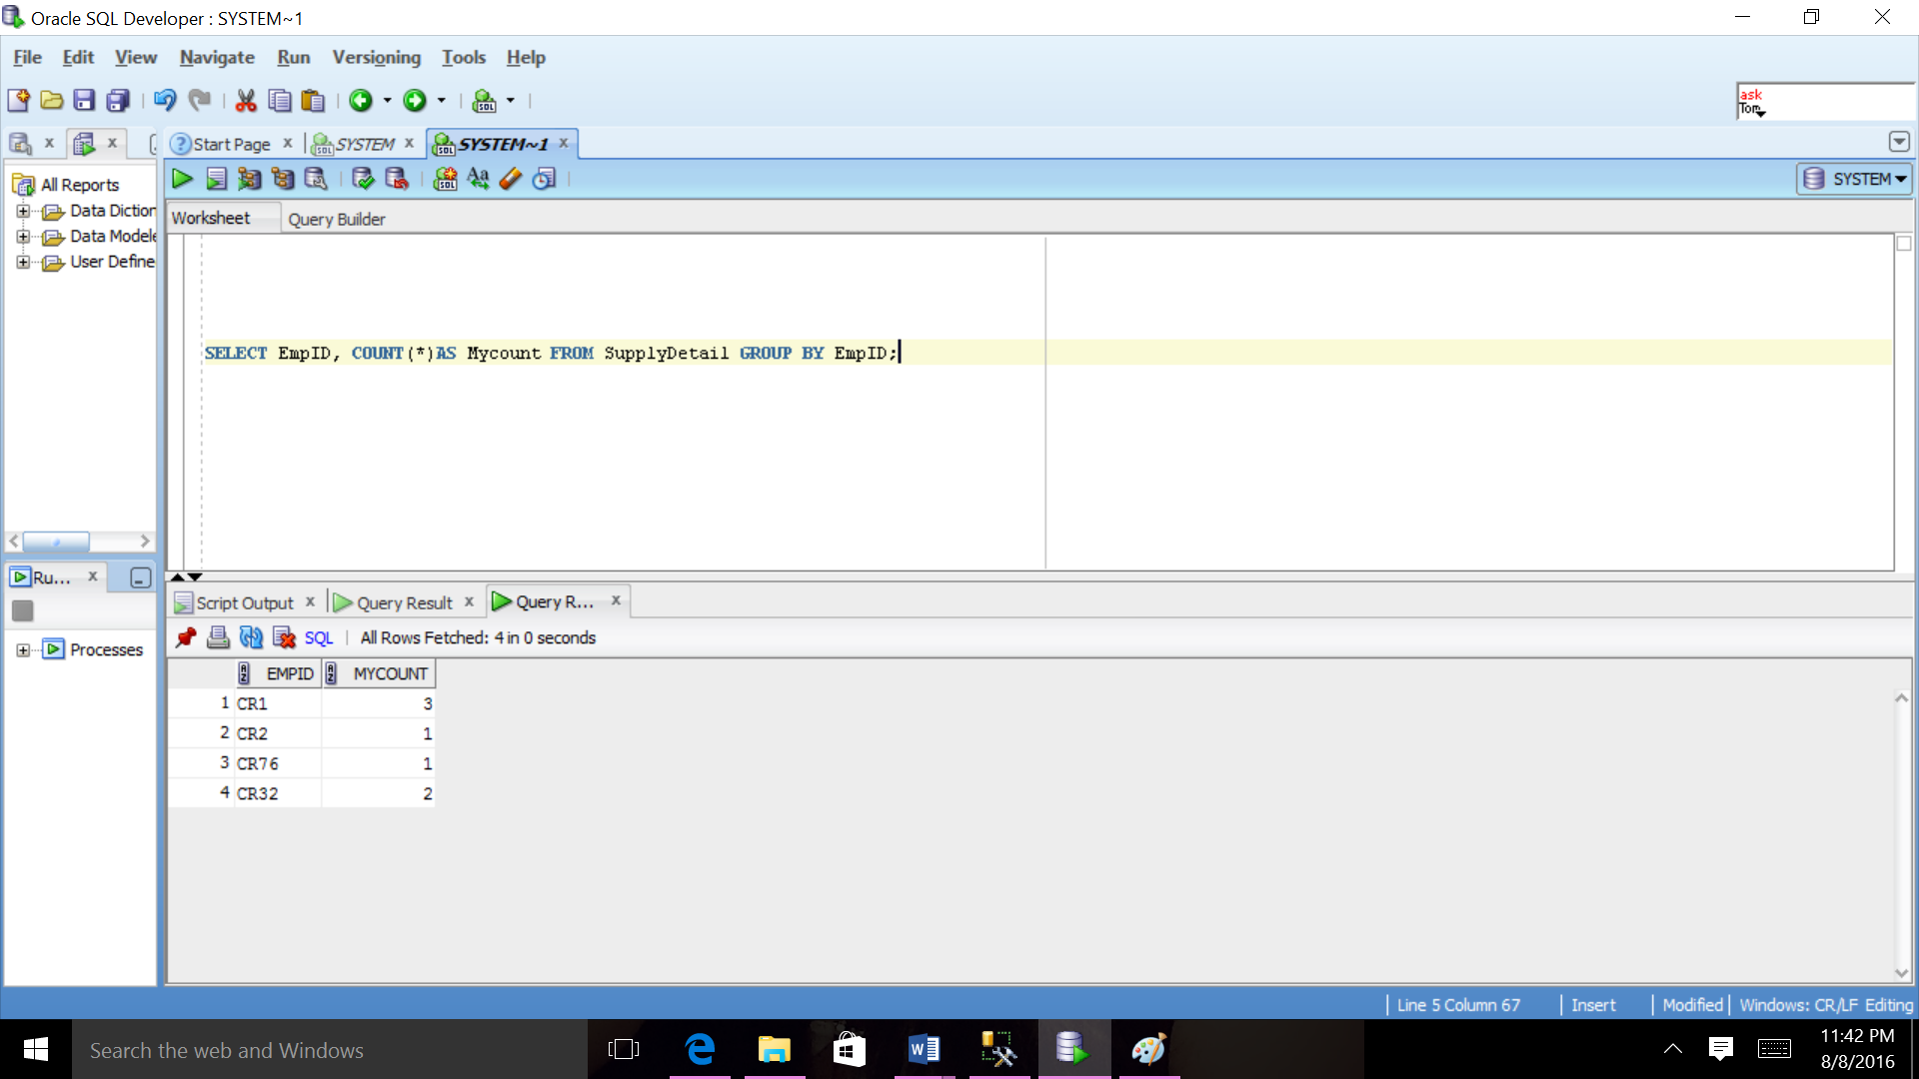

1. **List the product numbers whose stocks are greather than 50 or the purchase price are less than 100.**

SELECT ProID, amount, stock FROM ProductDetail WHERE Stock > 50 OR amount < 90;

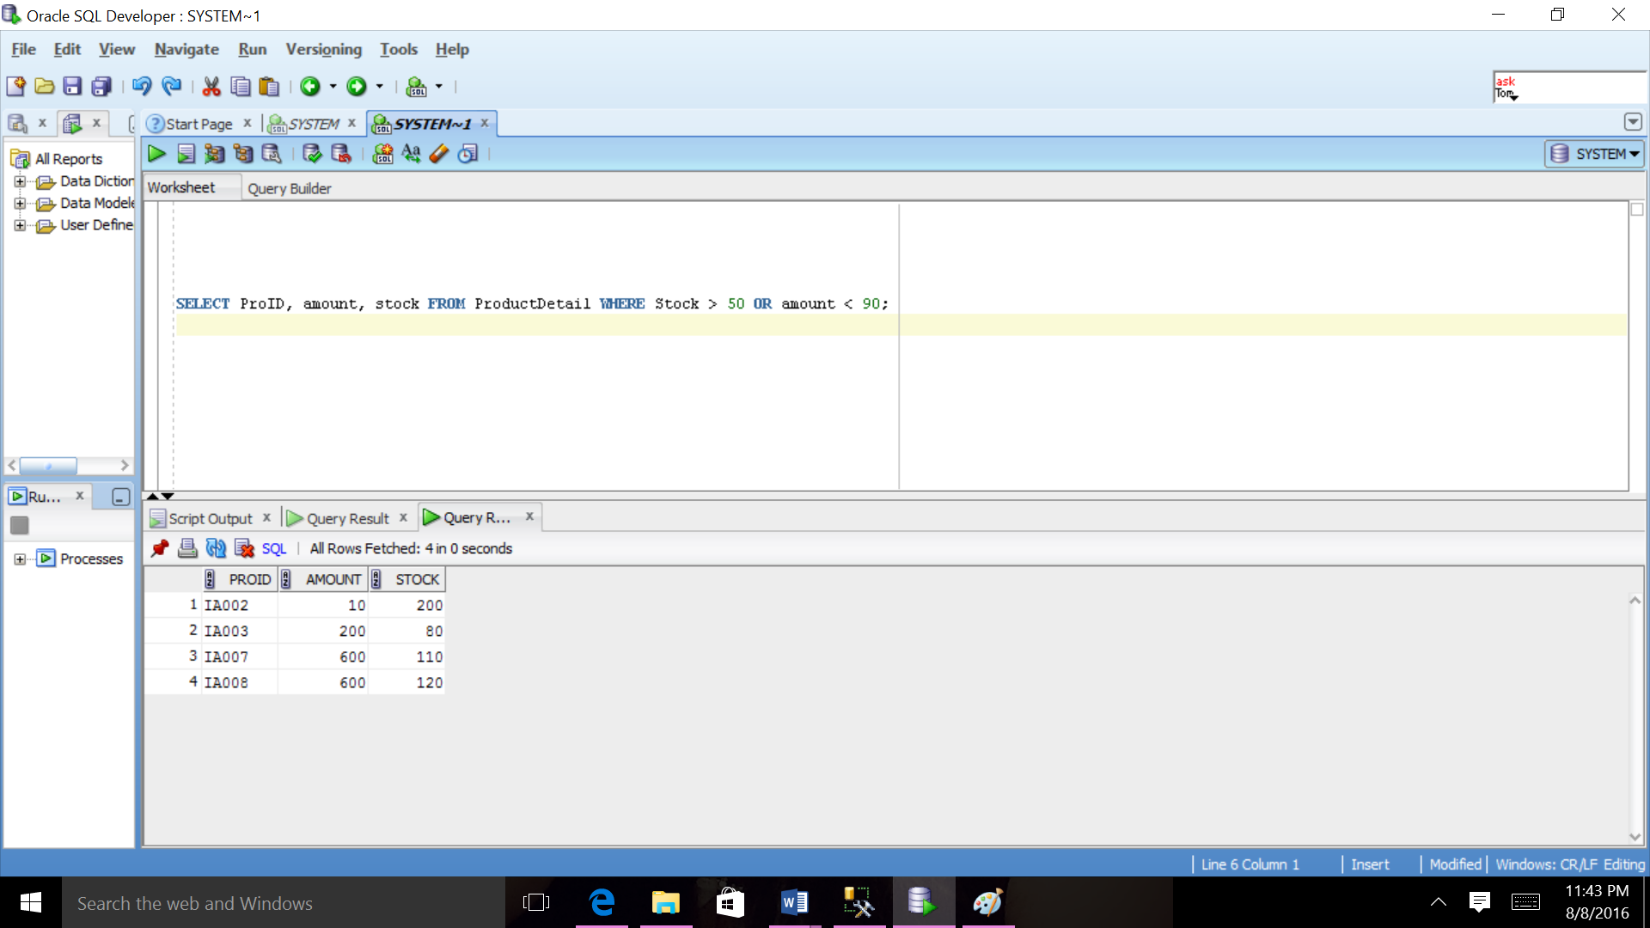

1. **Calculate average rate for all customer.**

SELECT AVG(rate) AS Averagerate From CustomerHistory;

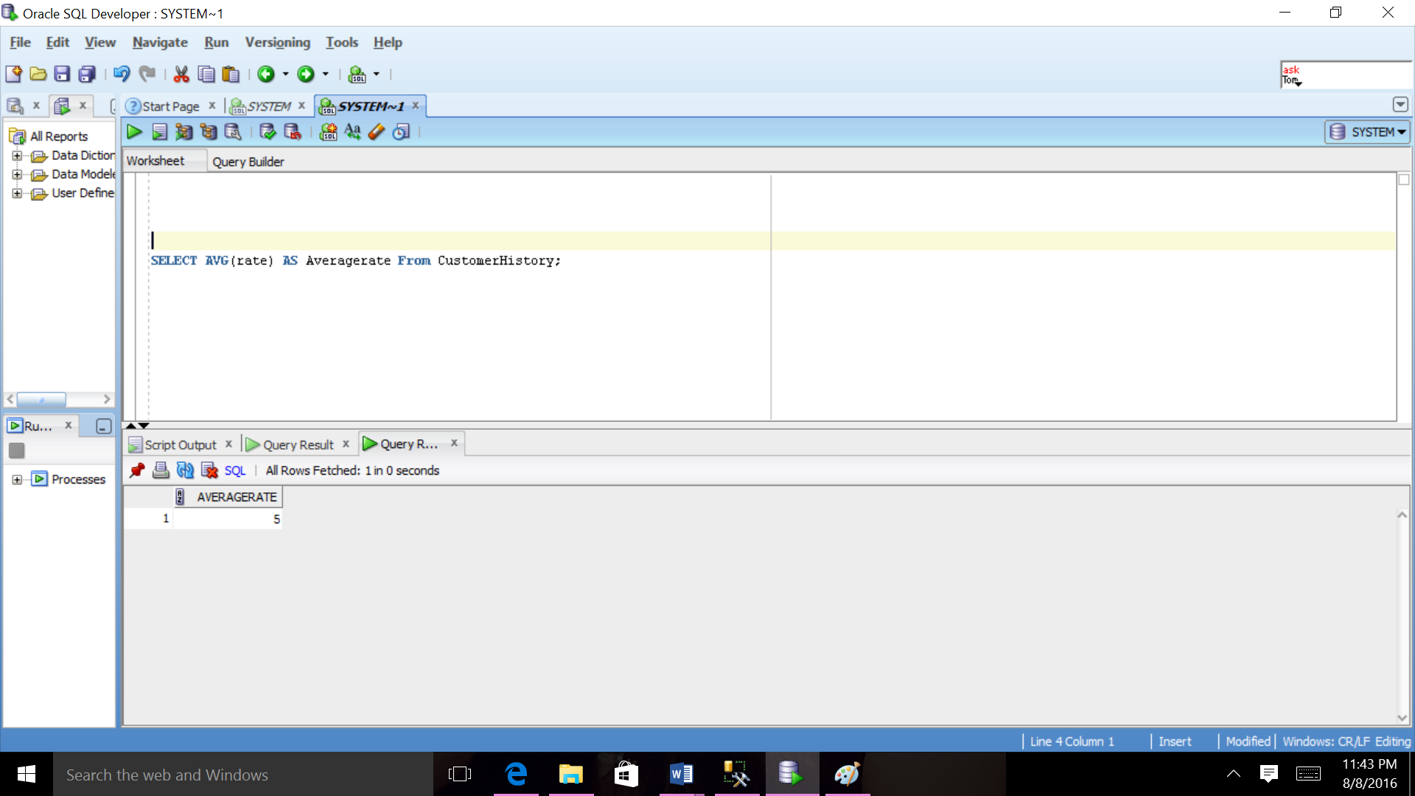

1. **List the order information ordered by date who has state texas.**

SELECT * FROM Ordert WHERE State='TX' ORDER BY OrdDate;

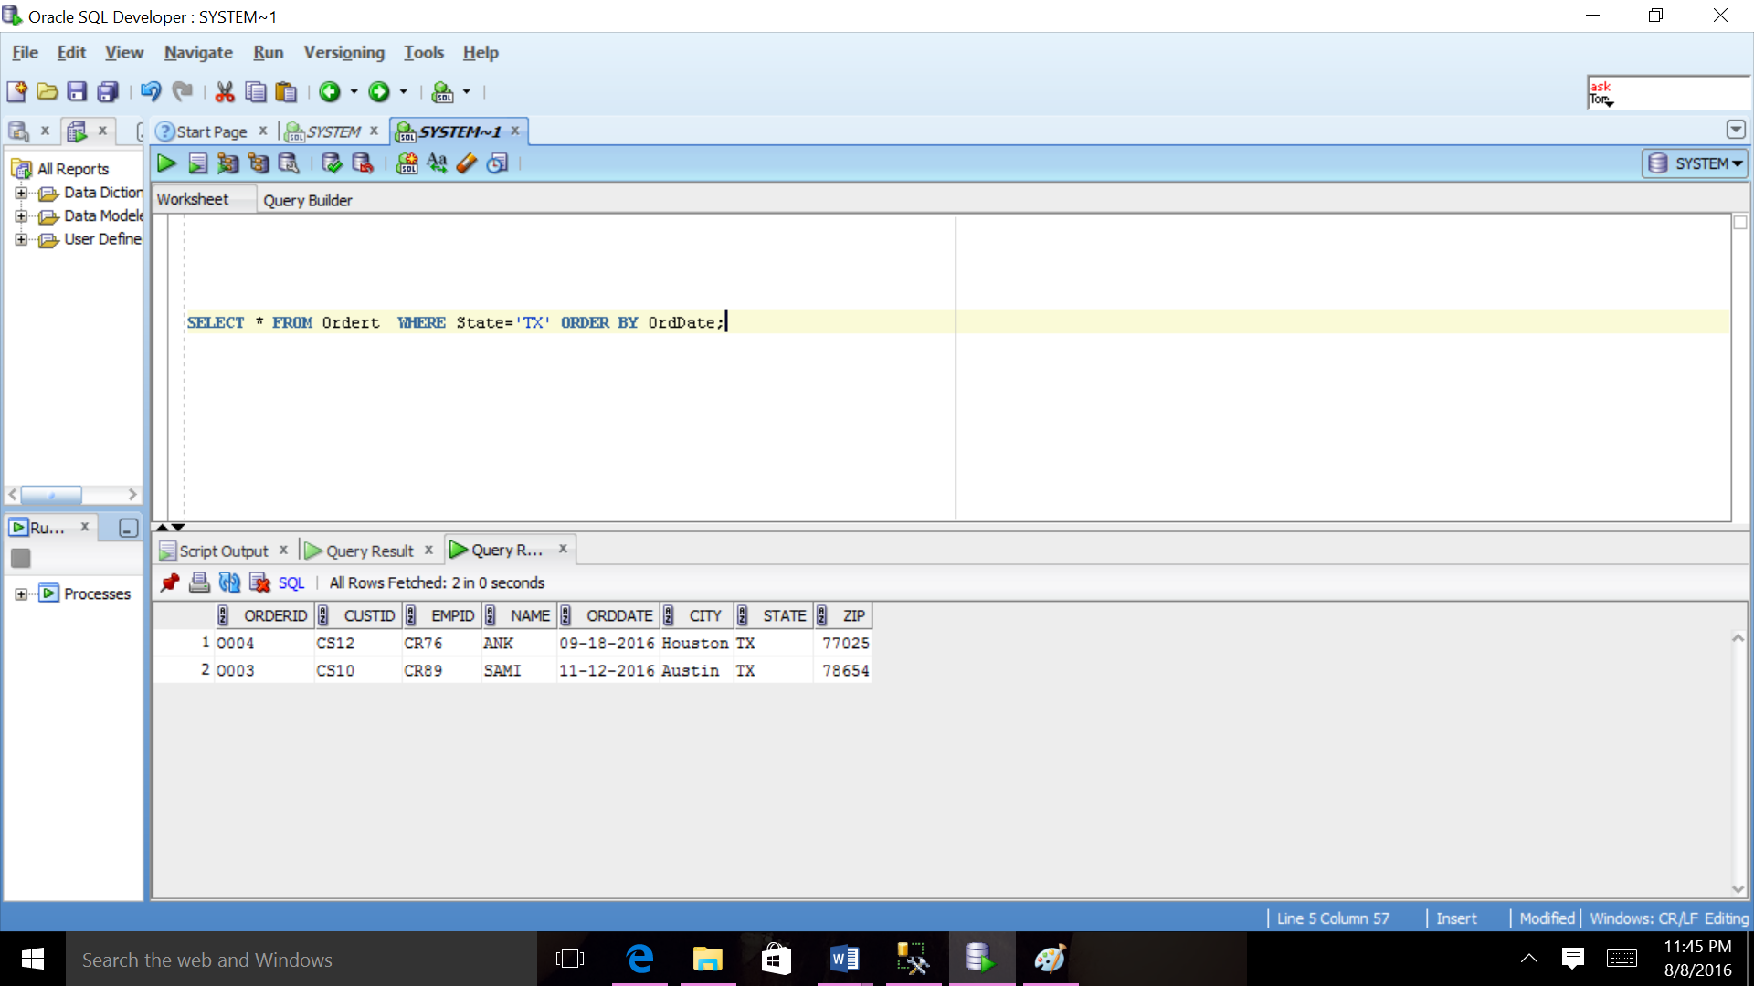

1. **List all the orders’ number which contain product IA003 or IA005.**

SELECT OrderID FROM OrderDetail WHERE ProID IN('IA003', 'IA005') GROUP BY OrderID;

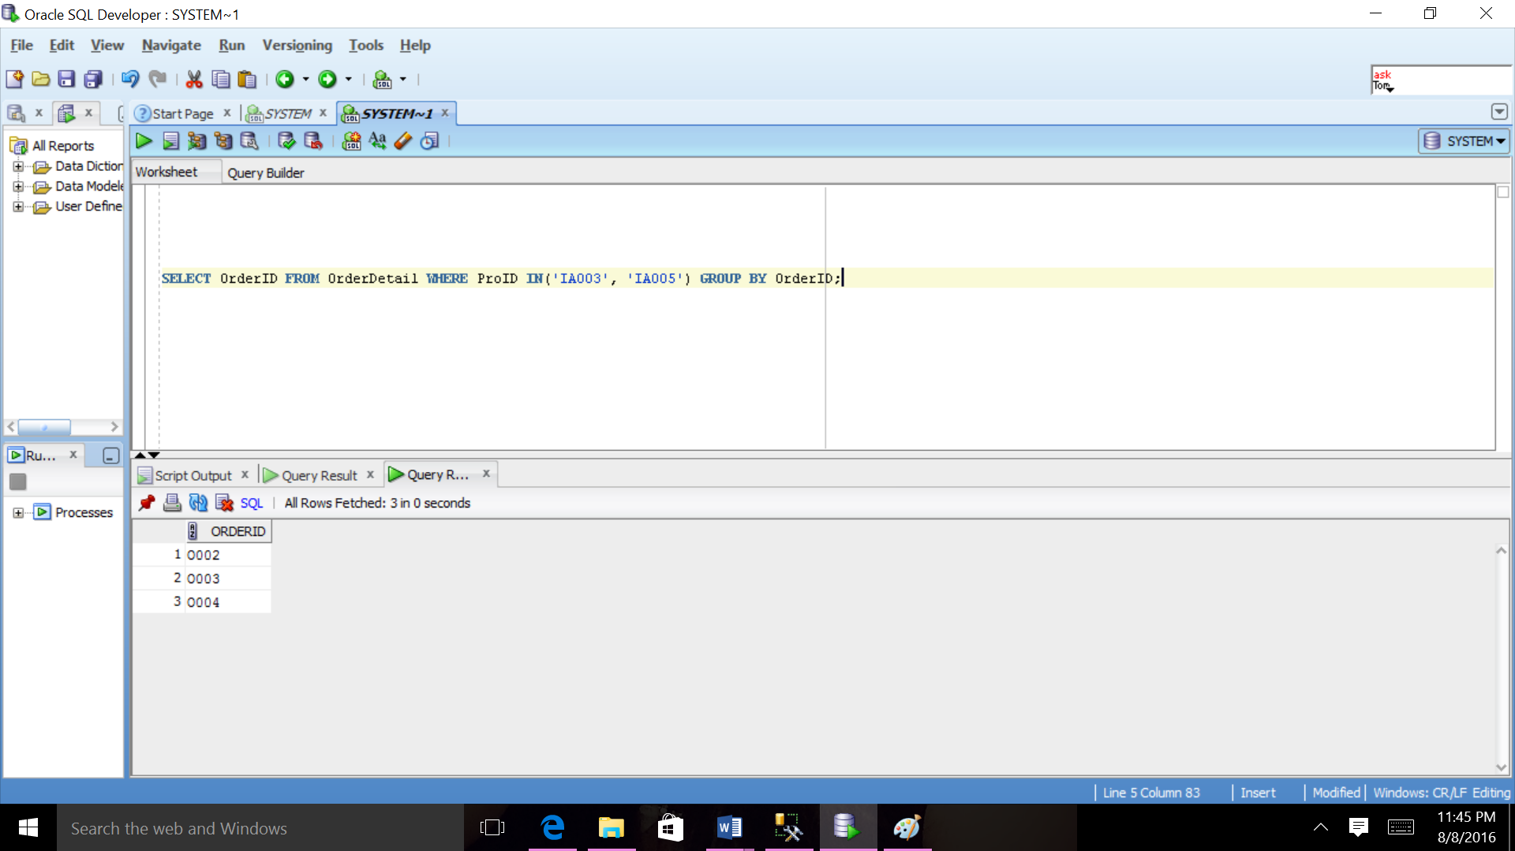

**Chapter 8 Conclusion**

The DesiMusic System’s core part is its Database. It stores huge amount of data relating to Customer, Employee, Product, Supplier and Courier Company. The key is to build successful application is to have a good database, which take care of all the redundancy issues. The DBMS, used was SQL Server and Oracle, which manages all the data and their transaction with the client.

The GUI of the application allow customer to register with application, view all product, supplier and Courier Company, cancel the product and view Customer History. It allow administrator to add and delete customer, employee, product, supplier and Courier Company. Though a real time DesiMusic system would have many more features, this application has been built with limited features given the time constraint.